**Space-Age DevOps**

Integrating ESA's

NanoSat MO Framework with Kubernetes

for Seamless Satellite Operations

 

**ABSTRACT:**

The ever-evolving field of space exploration demands innovative approaches to satellite mission operations. While developments within the “New Space” era offer unique advantages, including reduced cost and faster development cycles, they also present operational challenges that require system modernization and increased automation at par with advances in general software engineering. We address the operational limitations inherent in contemporary small satellite missions, which, despite leveraging standardized frameworks like the European Space Agency's (ESA) NanoSat MO Framework (NMF) under Consultative Committee for Space Data Systems (CCSDS) protocols, lack the agility and automation of modern terrestrial systems. In particular, this thesis presents a pioneering methodology that leverages the power of Kubernetes container orchestrator to transform satellite missions into agile and efficient endeavors, enabling edge computing capabilities directly in space. Driving principles entail modularizing functionalities and establishing standardized guidelines for software development and deployment.

To this end, this thesis presents a detailed methodology for integrating NMF with the Kubernetes container orchestration platform, thereby enabling a modern DevOps-driven approach to satellite mission operations. This transition represents not only an operational enhancement but also an architectural shift, from a traditional Service Oriented Architecture (SOA) to a fully containerized, microservice-based model.

Results obtained demonstrate a paradigm shift in satellite operations. Kubernetes-powered space missions utilizing the NanoSat MO Framework could exhibit improved flexibility, scalability, observability and reliability, all while complying with CCSDS standards. Importantly, this transformation also enables edge computing capabilities onboard satellites, allowing data to be processed in space rather than relying solely on ground-based infrastructure. This reduces communication latency, optimizes bandwidth usage, and supports more autonomous and resilient mission operations. In context, this thesis envisions a space-age DevOps era; the gap between traditional satellite operations and modern DevOps practices can be bridged, ushering in a new era of space exploration.

**Table of Contents**

**Ι. Introduction 6**

Problem Description 6

A. Background and context 6

B. Challenges of the study 7

Running Example 9

Thesis Contributions 11

i. Offer a new architectural proposal for the framework using microservices 11

ii. Containerization of Nanosat MO Framework microservices 12

iii. Documenting network configurations for containerized environment 13

iv. Provide the first working example of Nanosat MO Framework running into kubernetes in microservices 14

v. Standardized Production Deployment via Helm Packaging 14

vi. Enhanced Local Development Velocity with Container Tooling 15

vii. Novel CI/CD Strategy for Space Deployment Resilience 15

**II. Related Work 16**

K3s (SUSE RGS, Hypergiant) 17

Description 17

Evaluation 17

KubeEdge (Tiansuan constellation) 17

Description 17

Evaluation 18

KubeSat (IBM Space Tech Team) 19

Description 19

Evaluation 19

Akri Project 19

Description 19

Evaluation 20

F’ Prime 21

Description 21

Evaluation 21

Unikernel (SpaceOS, LynxElement) 21

Description 21

SpaceOS 22

LynxElement 22

Evaluation 23

**III. Background 23**

A. DevOps 24

What is DevOps? 24

a. CI/CD 26

b. Containers 28

c. Kubernetes 29

Control Plane Components 31

Worker Node Components 31

d. Helm Charts 32

e. Docker Compose 33

B. Space 34

a. Small Satellites (CubeSats, NanoSats) 34

b. CCSDS 37

c. NanoSat MO Framework 39

C. Edge Computing 42

Space Edge Computing 44

Space Edge 45

Ground Edge 45

Cloud 46

**IV. Architecture and Design 46**

Architecture 46

Current Nanosat MO Framework Architecture 46

Proposed Nanosat MO Framework Architecture 47

Proof Of Concept Architecture 48

Earth To Space Computational Continuum 50

Methodology 51

1. Deep-dive into NanoSat MO Framework 51

2. Containerize NMF Services 52

3. Initial Attempt For Local Kubernetes Deployment 52

4. Utilize Hardware From Containerized Apps Inside Kubernetes 53

Kubernetes Device Plugin 54

5. Run final Proof of Concept 55

Design Decisions 56

Kubernetes Flavor selection 56

Container runtime selection 58

Jenkins Pipeline: Scheduling, Tarballs & SCP 58

Raspberry Pi as the PoC infrastructure 59

E2E Space-Ground Proof Of Concept 59

JDK vs JRE 60

Implications and Discussions 60

**V. Implementation 62**

Enhance Platform Services: Implement Raspberry PI USB Camera Adapter 62

Enable Running NMF into Kubernetes: k3s, Device plugin & CICD pipelines 65

k3s setup 65

Enabling Device plugin to mount camera 67

CI/CD pipelines 68

Packaging and Standardization: Add dockerfiles and Kubernetes Helm Charts 69

Development Productivity: Improve Local Development Experience 75

End to end image capture, edge processing and ground storage: New NMF Space app & a NMF Ground app creation 78

**VI. Evaluation 82**

Resource Utilization and Performance Comparison to the Conventional Architecture 82

Collect metrics when no payload is running 84

Run NMF on k3s and collect metrics for the following scenarios with NMF module 88

Scenario: No Action 88

Scenario: Take a jpg snapshot with k3s on Raspberry Pi, with client running on workstation 91

Scenario: Run with containers only supervisor 94

Scenario: Run with containers only app (clock) without supervisor 97

Conventional NMF payload on JVM 100

Scenario: Only Supervisor Running 100

Scenario: Connect to camera provider and take snaps in jpg 104

Summary 108

**VII. Conclusion & Future Work 109**

Future Work 110

A. Expected Added Value of the Study 110

**IX. References 112**

# 

# Ι. Introduction

## Problem Description

In recent years, the field of space exploration has been revolutionized by the rise of small satellites, often termed "CubeSats" or "NanoSats". These compact, cost-effective spacecraft have made space more accessible than ever, leading to a surge in launches by governments, institutions, companies, and research groups. However, while building and launching these satellites has become easier, managing their operations once in orbit presents significant challenges. The software systems traditionally used for space missions are often rigid, require a lot of manual oversight, and have not kept pace with the rapid advances seen in software development on Earth.

To this end, this thesis was conceived around existing, but also rising, problems of space aviation, particularly from the software perspective. As the scope of space aviation expands, the computational needs get more complex. At the same time space projects adopt a different life cycle with the use of CubeSats, which enable cheaper and more frequent launches. This opens up new architectural possibilities, such as satellite clusters - constellations of small, cooperative satellites capable of distributed computation. However, space software development still relies heavily on traditional strategies and has yet to adopt modern software engineering practices.

In essence, the proposed solution to these operational limitations is bridging the gap between space systems and modern, efficient software practices from terrestrial industries, a movement known as "DevOps". The present thesis tries to put together the missing pieces of the modern space software puzzle and contribute with real world examples to the evolution of the field. In the following, we provide a more in-detail presentation of the context this thesis addresses, as well as the main challenges faced.

### Background and context

Space exploration has always been a testament to human ingenuity and ambition. Over the decades, our reach into the cosmos has expanded, and technological advancements have enabled increasingly complex missions. Among these missions, small satellites, or "CubeSats," have emerged as a revolutionary platform for space research, Earth observation, and telecommunications. Their relatively low cost and rapid development cycles make them an attractive choice for governmental, commercial and research entities.

However, deployment and management of small satellite missions poses unique challenges. Traditional methods of mission operations are often characterized by rigid protocols, limited scalability, and high operational costs. These limitations have prompted the exploration of innovative approaches that align with contemporary practices in software development and operations, commonly referred to as DevOps.

The Consultative Committee for Space Data Systems (CCSDS) plays a pivotal role in the space industry by developing standards for space data and information systems. These standards are designed to ensure interoperability, reliability, and efficiency in space missions. The adoption of CCSDS standards by space agencies and organizations worldwide underscores their significance in the field.

In this context, the integration of Kubernetes, a leading container orchestration platform, with NanoSat MO Framework, a sophisticated software framework designed for small satellites that implements CCSDS principles [1], presents an exciting opportunity. Kubernetes, known for its ability to manage application deployments at scale, can bring the principles of DevOps to the world of satellite missions. NanoSat MO Framework, with its focus on CCSDS Mission Operations services, provides a foundation for building highly efficient and standardized satellite operations.

The central tenet of this work is essentially to redesign NMF's architecture, transforming it from a traditional, monolithic system into a modern one based on microservices - small, independent, and containerized components orchestrated by Kubernetes. This innovative approach intends to bring the automation and agility of DevOps to satellite operations.

### Challenges of the study

The purpose of this study is multifaceted and addresses several significant challenges in the field of space exploration and small satellite missions. These challenges are rooted in the absence of a precedent for contributions to the NanoSat MO Framework, the limited exposure of space missions to DevOps methodologies, the distinct division between "upstream" and "downstream" segments in space missions, the scarcity of comprehensive documentation, and the relatively small NanoSat MO Framework community. In particular, we consider the main challenges to entail the following:

**1. Lack of Precedent in Contributions to NanoSat MO Framework**

One of the primary challenges this study seeks to address is the absence of a precedent for contributions to the NanoSat MO Framework. While the NanoSat MO Framework has garnered attention as a valuable resource for European Space Agency small satellite missions, there remains a lack of documented contributions and integration efforts. This void impedes the development and adoption of NanoSat MO Framework as a comprehensive and extensible solution for modern space missions.

**2. Limited Exposure of Space Missions to DevOps Methodologies**

In the domain of space exploration, the adoption of DevOps practices has been relatively limited. Space missions traditionally resorted to lower level software implementations, i.e., focusing on embedded systems, and lacked large scale automation. Recent developments across multiple technological fronts, have made it possible to include higher-level compute capabilities onboard, particularly as compute payloads.

**3. Facilitating Collaboration Between Upstream and Downstream Domains**

Within the realm of space missions, a noticeable division exists between the upstream and downstream sectors. The former concentrates on hardware development, while the latter primarily serves as service consumers. This can become an obstacle for the adoption of a unified approach and research on new software technologies and lead to slower progress in space software. This study seeks to facilitate collaboration and synergy between these traditionally separate entities, by highlighting the significance of end to end DevOps integration with space mission management.

**4. Scarcity of Comprehensive Documentation**

Another challenge facing the space community is the relative scarcity of comprehensive documentation for the NanoSat MO Framework and its integration with modern technologies like Kubernetes. Existing documentation may be fragmented, incomplete, or outdated, hindering the adoption and understanding of these technologies. This study seeks to contribute to a more robust body of documentation, making it easier for space agencies, researchers, and developers to utilize the NanoSat MO Framework effectively.

**5. Leveraging a Relatively Small Community**

Lastly, the NanoSat MO Framework community remains relatively small compared to other software development communities. This study acknowledges the importance of leveraging and growing this community to facilitate knowledge sharing, collaboration, and the collective improvement of NanoSat MO Framework.

In summary, the purpose of this study is to address these challenges by pioneering the integration of DevOps practices and Kubernetes into the NanoSat MO Framework, fostering collaboration between the upstream and downstream aspects of space missions, contributing to comprehensive documentation, and strengthening the NanoSat MO Framework community. By doing so, this study aims to advance the capabilities and efficiency of small satellite missions and contribute to the ongoing evolution of space exploration.

## Running Example

The primary objective of this thesis is to develop a novel *Earth-to-Space* computational continuum, aimed at enabling seamless and dynamic computation across distributed space platforms. This is achieved by implementing a clustered computing architecture, designed to facilitate the coexistence and interaction of multiple space-related software systems, regardless of their physical location or platform constraints.

Such computational power is increasingly feasible in space nowadays, moving away from embedded systems towards higher-level, more abstract (and more complex) capabilities on board, including GPUs, TPUs, CPUs or special purpose chips.

The central concept is the deployment of a cluster of CubeSats, each operating as a Kubernetes node. These satellite nodes are interconnected, forming a loosely coupled distributed system. A master node maintains an indirect connection to Earth-based edge infrastructure, allowing dynamic coordination and orchestration of computational tasks. Multiple interconnected applications running as a payload upon each satellite could be based in completely different programming languages and frameworks, such as Java, Python and F` prime. Based on relative distance and communication feasibility, the CubeSat nodes can further extend connectivity to deep space devices. These deep space components may or may not be Kubernetes-compatible, and their integration into the continuum is handled in a flexible manner. This way an “elastic arm” is created, a flexible and distributed architecture of compute nodes, extending from Earth-based infrastructure through CubeSats in orbit, and potentially reaching out to deep space devices.

## 

*Figure 1: Space Edge clustered Kubernetes architecture*

Τo bring a sample of this architecture to life, a well-known software framework already adopted in the space ecosystem is selected for managing onboard services and applications, the European Space Agency's (ESA) NanoSat MO Framework (NMF). NMF is primarily based on Service Oriented Architectures and was not originally designed for full-fledged distributed operations. So it is necessary to break its functionality and services into pieces, containerize them and design a Kubernetes-based deployment solution. This adaptation is essential to support scalable and fault-tolerant operations within a clustered satellite environment.

The OPS-SAT satellite mission is chosen as a proof-of-concept model for this implementation, due to its relevance, system requirements, and operational limitations. In order to prototype the proposed system and evaluate its feasibility, a Raspberry Pi device with comparable resources to the OPS-SAT onboard computer is utilized in the context of this thesis. This serves as a proof of concept, facilitating the deployment of the Kubernetes-based NMF solution under constrained hardware conditions. We note that from a software perspective, hardware can be abstracted, and its relevance to the key tenets of this thesis is minimal. In essence, we require a compute environment, capable of accommodating our workload specs in terms of resources and also have access to external devices used for sensing (for example a camera).

## Thesis Contributions

This thesis is taking place in a rather uncharted territory. Thus some contributions can be fundamental, while others might have less impact in the current time frame, but will pave the ground for future added value.

#### i. Offer a new architectural proposal for the framework using microservices

The foundational technical contribution from this thesis is the architectural redesign of the Nanosat MO Framework from Service Oriented Architecture (SOA) to microservice architecture [2]. While SOA provided a foundation for modularizing business logic into reusable services, it often resulted in tightly coupled components, complex integration layers and semi-independent deployments. Each application could be deployed, undeployed and managed by the Supervisor. By adopting microservices, the system is decomposed into independently deployable, loosely coupled services. Every application along with the supervisor is now deployed, undeployed and managed by a technology agnostic platform, Kubernetes. This transition enables greater scalability, resilience, and agility, allowing teams to develop, deploy, and maintain services autonomously. The microservices architecture also facilitates continuous delivery and rapid innovation, addressing many of the limitations inherent in monolithic or SOA-based systems.

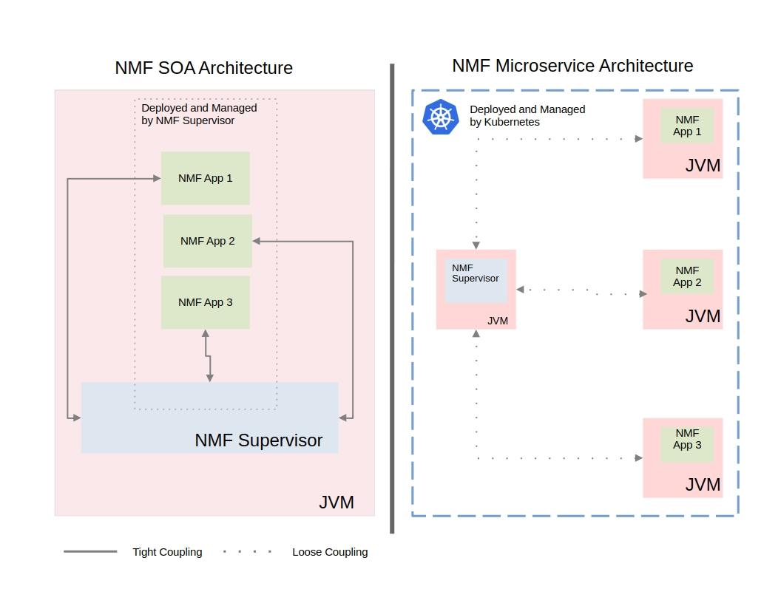

*Figure 2: NMF SOA & Microservice Architecture Comparison*

#### ii. Containerization of Nanosat MO Framework microservices

The architectural shift to microservices also introduces the important role of containerization. In the previous NMF deployment model, all Java libraries and services were executed within a single JVM instance. While this approach somewhat minimized runtime overhead, it also created challenges, such as classpath conflicts, version-locking of libraries, and the inability to tune JVM parameters for individual components.

Containerization addresses these challenges by enabling each NMF service to operate in its own isolated runtime. This design allows services to run with tailored Java runtimes, JRE or JDK, while also supporting the concurrent use of different Java versions (e.g., Java 8 for legacy compatibility and Java 17 for newer features). In addition, container-level isolation eliminates dependency collisions and provides a mechanism for fine-grained JVM tuning, including heap sizing, garbage collection strategies, and startup optimizations, all configured per service rather than globally [3][4].

Beyond the Java runtime itself, containerization also decouples services from a single operating system baseline. Each container can run on a distribution and version best suited to its workload, such as Ubuntu for general-purpose services or Alpine Linux for lightweight, memory-constrained deployments. Resource allocation becomes more precise as well, with CPU shares, memory limits, and I/O quotas enforced at the container level [5]. This ensures predictable performance and efficient utilization of underlying hardware, even when services have heterogeneous workload characteristics.

Overall, containerization transforms NMF application deployment by combining runtime flexibility, OS-level independence, and fine-grained resource control. These properties not only reduce operational friction but also enhance maintainability and scalability in a microservices-based environment.

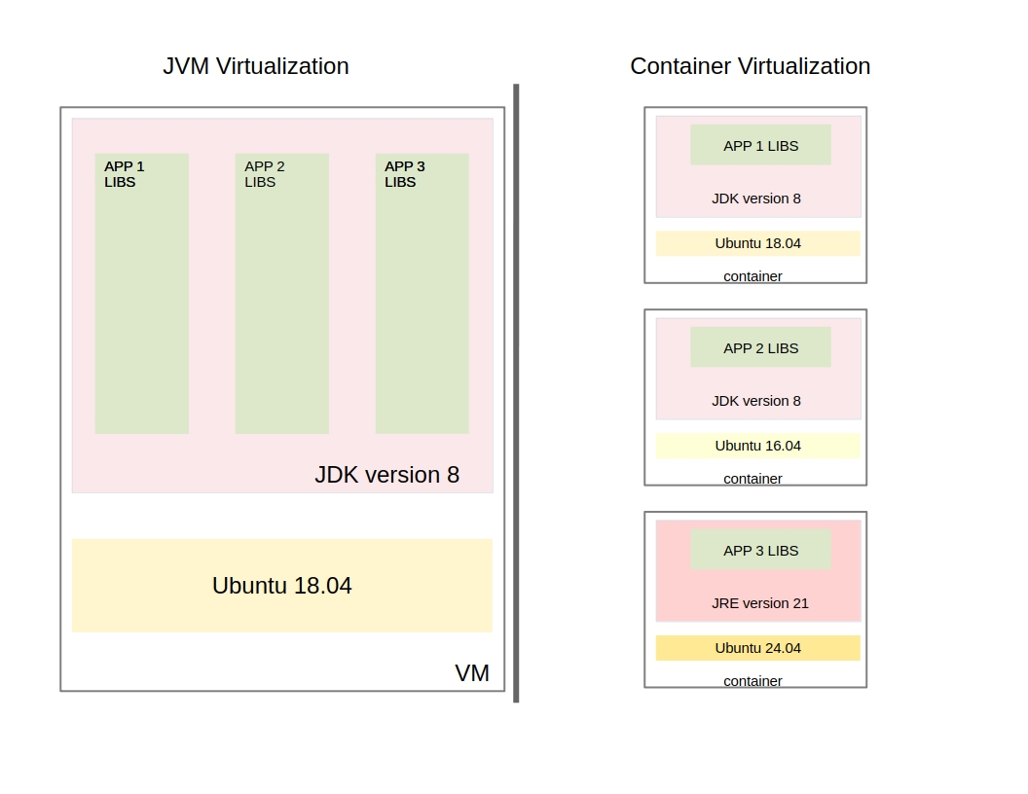

*Figure 3: Single JVM & Container Virtualization Comparison*

#### iii. Documenting network configurations for containerized environment

During the transition from a setup with all services hosted on a single machine, to a distributed environment where services operate independently, difficulties arise in configuring the framework’s network connections. Although various configuration options existed beforehand, they were not clearly documented, requiring thorough examination of the source code to determine the appropriate settings. To address this limitation, an alternative example configuration is developed and documentation is provided to facilitate its use. [6]

#### iv. Provide the first working example of Nanosat MO Framework running into kubernetes in microservices

As part of this thesis the first documented deployment of Nanosat MO Framework apps in Kubernetes (k3s) is accomplished. We leverage Kubernetes manifests in order to foster the deployment of the apps and maintain their functionality. We also handle the special networking that Nanosat MO Framework requires within the design of our Kubernetes infrastructure. Finally, access to devices (such as cameras, sensors, etc.) is granted from within each pod-app by using and provisioning Kubernetes Device plugin.

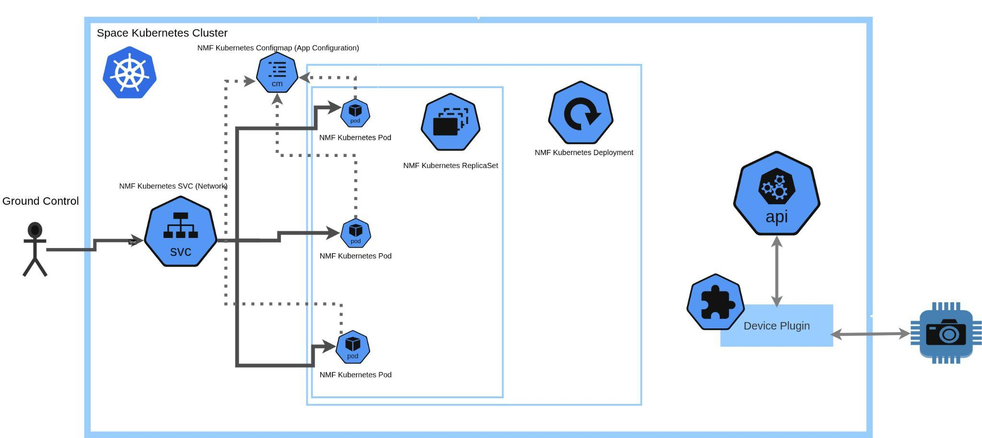

*Figure 4: NanoSatMO service integration with Kubernetes*

#### v. Standardized Production Deployment via Helm Packaging

A **Helm Chart package** is designed and implemented for the Nanosat MO Framework services. This contribution transforms raw Kubernetes manifests into a repeatable, version-controlled Infrastructure-as-Code (IaC) solution. It establishes a **standardized deployment pattern**, significantly improving operational velocity, maintainability, and management of complex services. Crucially, the Helm design addresses service dependencies by abstracting and segregating shared components, such as the central Supervisor service, enabling efficient, modular deployment across environments.

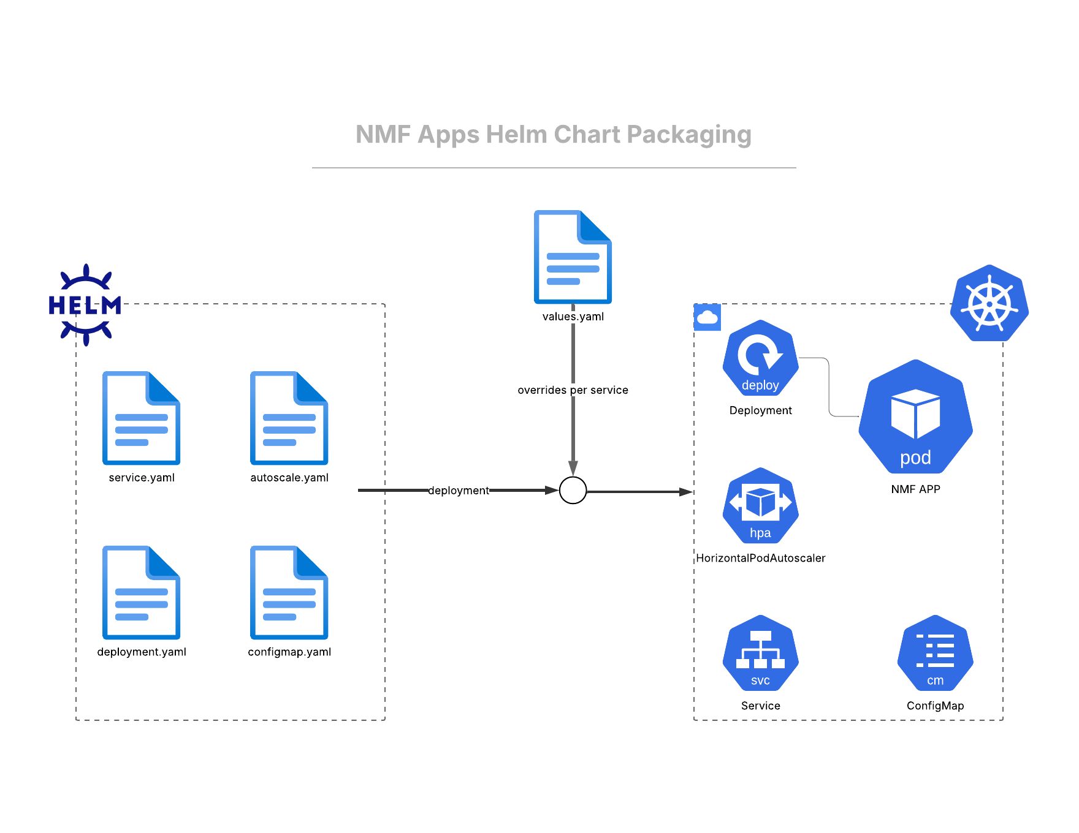

*Figure 5: NMF Apps Helm Chart Packaging*

#### vi. Enhanced Local Development Velocity with Container Tooling

To maximize developer productivity and onboard new contributors quickly, a complete **Docker and Docker Compose environment** is provided for use in local development workstations. This tooling simplifies the entire setup process, allowing the full Nanosat MO Framework stack to be initialized with a single command and while being Operating System independent it requires only a Docker installation. This effort validates the work's practical utility and establishes a modern, low-friction entry point for local code development and debugging.

#### vii. Novel CI/CD Strategy for Space Deployment Resilience

We devised and demonstrated a **resilient Continuous Integration/Continuous Deployment (CI/CD) pipeline** tailored for the unique challenges of space and edge computing. Utilizing Jenkins on a lightweight microK8s cluster, this pipeline specifically addresses the hypothesis of deploying services in highly latency-bound and connectivity-disrupted environments. The core innovation is the **pre-deployment image staging mechanism**, which bypasses the unreliable Container Runtime Interface (CRI) download process by copying the new image directly to the node and uploading it to a local registry. This method ensures successful and deterministic deployments despite intermittent connectivity issues.

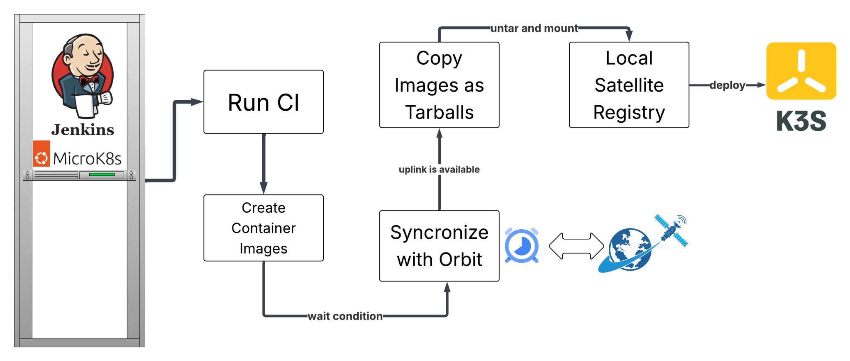

*Figure 6: Jenkins CI/CD pipeline for NMF apps*

vii. Camera adapter for RaspberryPi & image processing app

An NMF camera adapter/platform service is implemented to enable seamless integration and operation of imaging payloads on Raspberry Pi-based nanosatellite hardware. The service provides standardized interfaces for camera initialization and image acquisition.

A new NMF space application was developed to preprocess images acquired in orbit using various techniques, such as Sobel filtering and K-means unsupervised clustering. This application demonstrates the advantages of space edge computing by performing onboard data reduction, extracting and downlinking only the most relevant image features, thereby optimizing bandwidth usage and improving mission efficiency.

# II. Related Work

The initial phases of this research are guided by a comprehensive review of existing work in the fields of space systems, edge computing, DevOps and cloud infrastructure. The combination of these technological fields has garnered significant attention in recent years, judging by the quantity and quality of the related real world projects. This chapter presents key initiatives and frameworks that form the foundation of this thesis, highlighting their relevance, influence, or contrast with the final approach.

## K3s (SUSE RGS, Hypergiant)

### Description

K3s is a highly available, certified Kubernetes distribution designed for production workloads in unattended, resource-constrained, remote locations or inside IoT appliances.

A notable adoption of k3s is found in the collaboration between SUSE Rancher Government Services (SUSE RGS) and Booz Allen Hamilton association, detailed in their report "Advancing the Tactical Edge with K3s and SUSE RGS." This partnership focuses on deploying K3s, a lightweight Kubernetes distribution, to enhance edge computing capabilities in remote and resource-constrained environments. By leveraging K3s, their solution allows battalions to make real-time, data-driven decisions which dramatically improve operational outcomes and increase the probability of mission success. [7]

Another initiative involves SUSE RGS collaborating with Hypergiant Industries to deploy Kubernetes clusters on military satellites. This project utilizes K3s to automate the creation of repeatable workloads in orbit, addressing challenges like limited connectivity and the need for rapid software updates in space environments. ​[8]

### Evaluation

These projects established k3s as a suitable lightweight and reliable Kubernetes flavour both in space and edge environments.

## KubeEdge (Tiansuan constellation)

### Description

KubeEdge is an open source system for extending native containerized application orchestration capabilities to hosts at Edge. It is built upon Kubernetes and provides fundamental infrastructure support for network, application deployment and metadata synchronization between cloud and edge. [9]

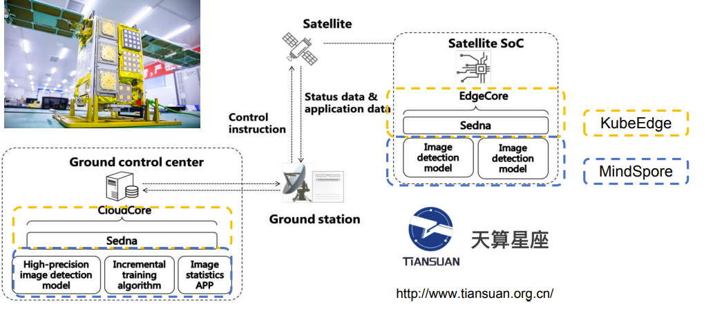

*Figure 7: Tiansuan constellation architecture integrated with KubeEdge & MindSpore* *[10]*

In 2022, at the main forum of KubeCon and CloudNativeCon European Summit, a high-profile conference in the cloud native field, Huawei published the first open source cloud native AI satellite application solution [10]. They had already launched Tiansuan-1 satellite in September 2021, joining the open satellite research Tiansuan constellation, shipped with CNCF KubeEdge and MindSpore to address the challenges of:

* On-orbit computation to minimize orbit-earth communication for better life span
* Edge-cloud real time inference and incremental deep learning for SAR type task

### Evaluation

Traditional satellites are closed architectures, with satellites customized for specific tasks, payloads tailored for specific satellites, and software designed for specific payloads. One satellite, one mission, one launch defining its entire lifecycle. This closed system architecture necessarily leads to hardware and software incompatibility, inability to interchange and reuse, and very slow technological iteration.

To address these issues, satellite manufacturers proposed software-defined satellites, which are a new type of intelligent satellite centered on space-based computing, adopting an open system architecture that supports plug-and-play payloads and on-demand application loading.

The KubeEdge project has demonstrated the feasibility of this new cloud-native edge computing paradigm in space.

## KubeSat (IBM Space Tech Team)

### Description

KubeSat is an open-source project, developed by IBM Space Tech Team, for building a cognitive, autonomous framework for satellite constellations and swarms. It provides the framework needed to develop and operate tasks to be performed on Satellite. Also, it allows for the simulation and optimization of multi-satellite communications. [11]

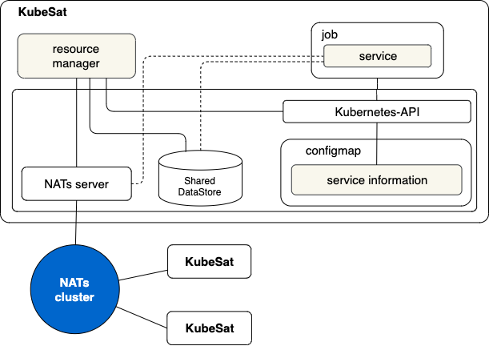

*Figure 8: IBM KubeSat internal structure* *[12]*

It utilizes the Kubernetes API along with NATs server to cluster different KubeSats running on different satellites.

### Evaluation

This github project [12] was archived in 2024 and the stack hasn’t grown in a mature production-ready state. However, it laid some solid foundations for the adoption of DevOps approach especially for satellite constellations.

## Akri Project

### Description

Akri is a Cloud Native Computing Foundation (CNCF) Sandbox project. It lets you easily expose heterogeneous leaf devices (such as IP cameras and USB devices) as resources in a Kubernetes cluster, while also supporting the exposure of embedded hardware resources such as GPUs and FPGAs. Akri continually detects nodes that have access to these devices and schedules workloads based on them.

At the edge, there are a variety of sensors, controllers, and MCU class devices that are producing data and performing actions. For Kubernetes to be a viable edge computing solution, these heterogeneous “leaf devices” need to be easily utilized by Kubernetes clusters. However, many of these leaf devices are too small to run Kubernetes themselves. Akri is an open source project that exposes these leaf devices as resources in a Kubernetes cluster. [13]

Akri’s solution consists of five components: two custom resources, Discovery Handlers, an Agent (device plugin implementation), and a custom Controller. The first custom resource, the Akri Configuration, is where you name the leaf device that it should look for. At this point, Akri finds it! Akri's Discovery Handlers look for the device and inform the Agent of discovered devices. The Agent then creates Akri's second custom resource, the Akri Instance, to track the availability and usage of the device. Having found your device, the Akri Controller helps you use it. It sees each Akri Instance (which represents a leaf device) and deploys a ("broker") Pod that knows how to connect to the resource and utilize it.

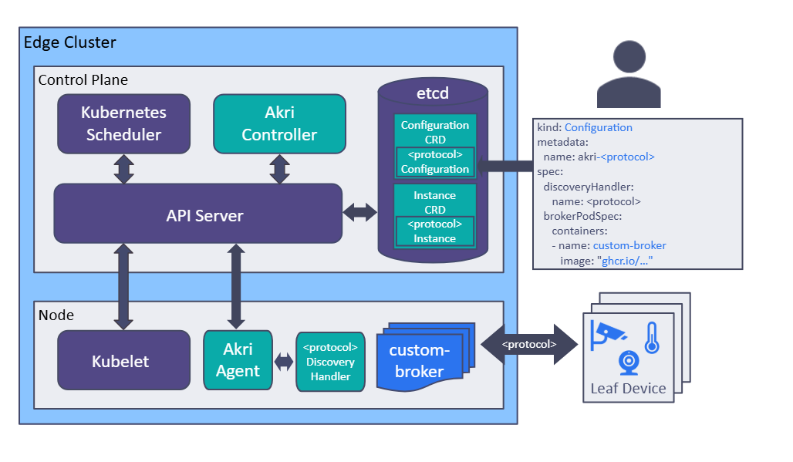

*Figure 9: Akri Project as device discovery extension to Kubernetes* *[13]*

### Evaluation

Akri is highly useful in making IoT Devices accessible to Edge Kubernetes Clusters. [14] There is no prior adoption of the Akri project in space, but for sure it would be really intriguing to integrate it in a Space Edge Kubernetes cluster. For example, in a space topology with some satellites that comprise the Kubernetes cluster, Akri could be utilized to harness the functionality of some smaller IoT devices, pico or femto satellites with sensors, GPUs or cameras, deployed even in deep space. Thus deepening the space edge computing capabilities or even enabling a ground to deep space computational continuum.

## F’ Prime

### Description

F´ (or F Prime) is a software framework for the rapid development and deployment of embedded systems and spaceflight applications. Originally developed at NASA’s Jet Propulsion Laboratory, F´ is open-source software that has been successfully deployed for several space applications. It has been used for but is not limited to, CubeSats, SmallSats, instruments, and deployables. [15]

### Evaluation

The use of diverse programming languages, frameworks, and network protocols, such as NASA’s F Prime, highlights the need for a technology-agnostic approach to space software and infrastructure. This is where containerization and orchestration become essential, offering solutions that are not tightly coupled to any specific language or technology stack, thus providing support for even cross-organization software implementations.

## Unikernel (SpaceOS, LynxElement)

### Description

A unikernel is a specialized, single-purpose virtual machine image that combines an application with only the minimal operating system components it requires to run. Unlike traditional operating systems, which support multiple applications and users, a unikernel is compiled into a single binary and runs a single application in isolation. [16]

Unikernels differ from virtual machines and containers in that they eliminate the need for a separate guest operating system or container runtime. Instead, they compile the application together with just the essential OS libraries into a lightweight and highly optimized executable.

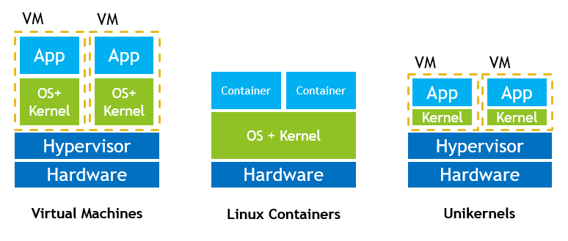

*Figure 10: Virtual Machine, Container & Unikernel comparison* *[17]*

#### SpaceOS

SpaceOS is a next-generation operating system built specifically for satellite payloads, using unikernel architecture to reduce size, increase security, and optimize performance.

Each application runs with only the code it truly needs, yielding a platform that is extremely lightweight (up to 20× smaller than traditional systems) and Secure by Design from the ground up.

With SpaceOS, satellites become more adaptable and reliable – able to run multiple applications or receive updates seamlessly – all while drastically reducing security risks.

In 2025, SpaceOS will fly on its maiden space mission aboard Clustergate-1 (SpaceX's Transporter-13 rideshare) [18]

#### LynxElement

Lynx Software Technologies (Lynx), a specialist in Mission Critical Edge, released LynxElement, the industry’s first unikernel to be POSIX compatible and available for commercial use.

LynxElement unikernel works best for applications requiring speed, agility, and a small attack surface for increased security and certifiability such as aircraft systems, autonomous vehicles and critical infrastructure. The use of Unikernels, which allow pre-built applications using libraries, reduces the attack surface. Unikernels are also very well suited as a component for mission-critical systems with heterogeneous workloads that need the coexistence of RTOS, Linux, Unikernel and bare-metal guests. [19]

### Evaluation

Unikernels lead to extremely small, fast-booting, and secure deployments, making them particularly well-suited for environments with strict resource constraints—such as embedded systems, cloud microservices, and satellites.

Containers are larger than unikernels. They rely on a host OS, adding some overhead. However, modern space systems (especially LEO and CubeSats) are gaining more compute capacity, making this tradeoff acceptable. Also, containers are characterised by much bigger maturity and ecosystem support, broader familiarity in the developer community, multi-process & multi-language support and portability.

Concluding, unikernels are a paradigm that should be considered seriously in space edge computing. [20] It could be the ideal candidate especially for the deployment of lighter applications in very resource restrictive satellites. However, on a broader scale its utilization could be cumbersome with limited tooling compared to the full-featured containerization ecosystem, thus not preferred for this thesis.

# III. Background

In order to comprehend deeper the background of this study and understand the methodology implemented, we firstly need to expand on the foundational knowledge, definitions and technologies used.

In the context of deploying services using the NanoSat MO Framework and integrating Kubernetes into space missions, the literature can be broadly categorized into three distinct domains: DevOps-specific literature, space-specific literature, and edge computing literature. These categories collectively bridge the gap between DevOps principles, edge computing paradigms, and the unique requirements of space missions within the NanoSat MO Framework, contributing to a new frontier of research and innovation at the intersection of these domains.

The DevOps-specific literature encompasses research and studies related to DevOps principles, practices, and methodologies. It delves into the application of automation, continuous integration, and continuous delivery in software development and operations. This literature examines how DevOps has transformed various industries, particularly in the realm of information technology.

On the other hand, space-specific literature primarily focuses on the unique challenges and intricacies of space missions, satellite operations, and space data systems. It charts the evolution of small satellite technologies, space standards like CCSDS, and mission-specific case studies.

Finally, what binds Space and DevOps together is the concept of Edge Computing. Space and “Edge” share a lot in common, since they both refer to locations that are not easily reached by humans. Similarly to how more and more computing is shifted to the edge, this thesis is an example of how we can achieve greater computing in space.

## DevOps

### What is DevOps?

DevOps is a collection of practices, philosophies, and tools designed to enhance the velocity of software development, shorten the time to market, and improve both software quality and system reliability [21]. It fosters collaboration between development (Dev) and operations (Ops) teams, enabling faster delivery through automation, cooperation, quick feedback loops and iterative improvement. Rooted in Agile methodologies, DevOps extends the cross-functional approach to accelerate the building and deployment of applications in a more iterative and efficient way.

The DevOps lifecycle includes a series of stages and activities that integrate development and operations seamlessly [22]. Its goal is to promote continuous integration, delivery, and improvement, ensuring the rapid release of high-quality software. In contrast to conventional methods to the development lifecycle, this model assumes that each stage will be repeated as necessary. The main stages of the DevOps lifecycle include:

1. **Plan**: In this phase, teams outline the project’s requirements, scope, and goals. Collaboration among development, operations, and other stakeholders ensures alignment and a shared understanding of the objectives. This stage also involves prioritizing features, setting milestones, and estimating resources. The DevOps workflow is planned with the likelihood of future iterations and likely prior versions in mind.
2. **Code**: During the coding phase, developers write and commit code changes to a common version control system like Git. The code is collaboratively reviewed to ensure compliance with coding standards, best practices, and proper documentation, maintaining both code quality and consistency.
3. **Build**: In the build phase, the code is compiled, tested, and packaged into deployable artifacts. Continuous integration ensures that every code change is automatically built and tested upon being committed. Automated pipelines help ensure thorough testing and smooth integration of the code.
4. **Test**: Testing is crucial for verifying the software’s reliability and quality. Automated tests, including unit, integration, regression, performance, and security tests, are run to validate that the code works as intended and is defect-free.
5. **Release**:The release phase occurs when the code has been verified as ready for deployment and a last check for production readiness has been performed. The project will subsequently enter the deployment phase if it satisfies all requirements and has been thoroughly inspected for bugs and other problems.
6. **Deploy**: The deployment phase releases the software across various environments like development, staging, and production. Automated deployment pipelines manage the process, including infrastructure setup, service configuration, and deployment of code artifacts, ensuring consistent, error-free releases.
7. **Operate:** The operation phase dictates that the operations team ensure that infrastructure components stay online and grow with demand as needed. This may mean scaling up or down resources as needed. Cloud environments simplify this by providing methods to monitor the load on your system and automatically spinning up new nodes to properly balance the load.  
   User feedback is also gathered in this phase to be used to drive future development efforts, leading to a better system for the individuals or companies using the product.
8. **Monitor:** During the monitoring phase, product usage, as well as any feedback, issues, or possibilities for improvement, are recognized and documented. This information is then conveyed to the subsequent iteration to aid in the development process. This phase is essential for planning the next iteration and streamlines the pipeline’s development process.

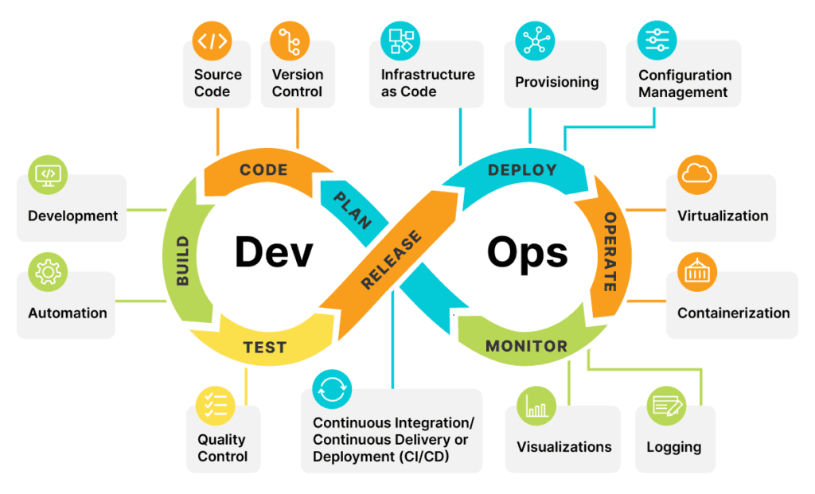

*Figure 11: DevOps lifecycle* *[21]*

Following, some of the core principles and established tools coupled with the DevOps world are further presented:

### CI/CD

CI stands for Continuous Integration, while CD can either stand for Continuous Delivery or Continuous Deployment. The CI-CD concept describes the process of writing and merging code, testing and packaging it, as well as deploying it to production in small rapid cycles.

**Continuous Integration** is the practice of integrating code changes from multiple contributors into a centralized repository in an automated manner, while running tests and checks to ensure code quality.

A characteristic CI example for an application based on Java and Maven technologies would be:

A software engineer develops the code on his local machine, pushes it to a remote Github repository shared with the rest of the team and opens a Pull Request asking for a code review. The maven project is then compiled, unit tests are run and the app is built into the required package (war, jar, ear). SonarQube tool performs code quality reviews where it will measure the quality of source code and generate a report. An artifact repository is used for storing the build artifacts and this whole process is achieved by using a Continuous Integration tool Jenkins.

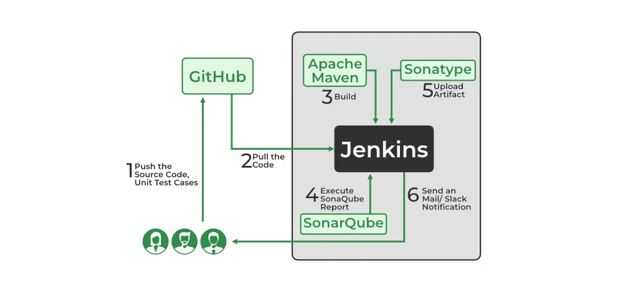

*Figure 12: Continuous Integration real world scenario* *[22]*

**Continuous Delivery** is the practice of ensuring that the code is deployment ready by creating deployment artifacts and packages and also deploying it to a staging environment for further quality assurance processes (integration testing, end to end testing etc).

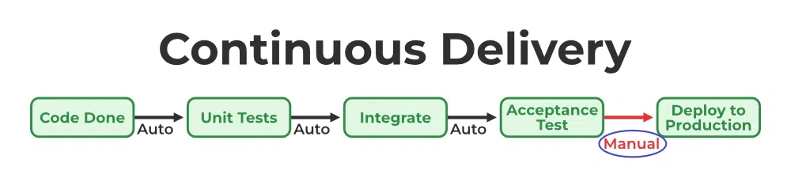

*Figure 13: Continuous Delivery process* *[22]*

**Continuous Deployment** is the practice of deploying code to production right after a new release is made in an automated manner. Basic requirement for applying continuous deployment is a great coverage for all types of test to ensure that bugs will not be deployed to production. Also Continuous Deployment needs great monitoring to detect and troubleshoot or rollback errors in production.

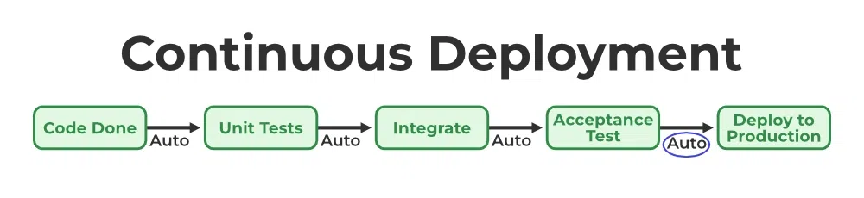

*Figure 14: Continuous Deployment process* *[22]*

For reference, some of the well-known CI/CD Tools, amongst others, are: Git, Jenkins, Github Actions, Gitlab CI, Argo CD.

### Containers

Containerization is the process of packaging software code with the underlying operating system (OS) libraries and dependencies required to run the code. The output is a single lightweight executable—called a container—that runs on any infrastructure.

A container is a standard unit of software that packages up code and all its dependencies so the application runs quickly and reliably from one computing environment to another. This makes it easy to move the contained application between the environments(dev, staging/test, prod, etc) while retaining full functionality. A container image is a lightweight, standalone, executable package of software that includes everything needed to run an application: code, runtime, system tools, system libraries and settings.

The container shares the kernel of the host OS with other containers, and the shared part of the OS is read-only. Therefore, the containers are lightweight, so you can deploy multiple containers on a single server (or a VM)—no more dedicating an entire server to a single application.

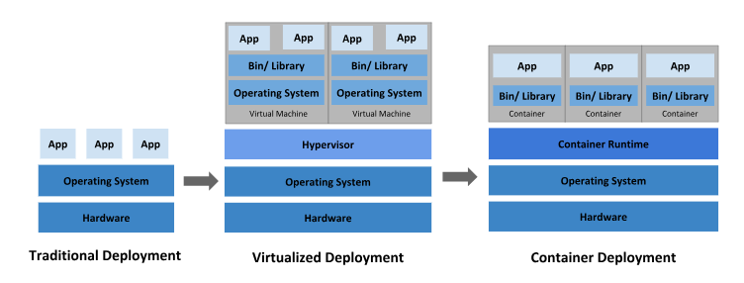

*Figure 15: Traditional, Virtualized & Container deployment comparison* *[23]*

Application containerization enables DevOps teams to automate the build, test, and deployment, which in turn results in faster release cycles and shortened time-to-market.

Additionally, containerization makes it possible to use microservices architecture where applications are built as services loosely coupled that can be developed, deployed, and scaled independently.

Essentially, containerised microservices are a more efficient and effective way to implement DevOps than a monolithic application.

### Kubernetes

Kubernetes is an open-source platform designed, with container orchestration in mind, to automate deploying, scaling, and operating application containers [24]. It simplifies the developer’s task of managing containerized applications. Kubernetes is all about optimization - automating many of the DevOps processes that were previously handled manually and simplifying the work of engineers.

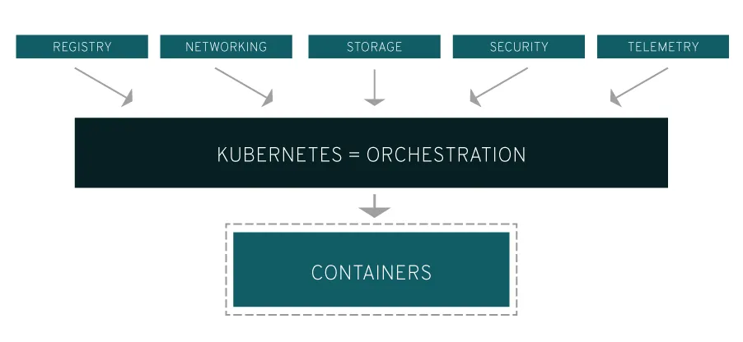

*Figure 16: Kubernetes container orchestration* *[25]*

Manually managing containers in a production environment without Kubernetes, would require multiple actions by the application owners. It would become a cumbersome process especially as the need for software quality and volume increases [25]. For example -without using Kubernetes or a container orchestrator in general-, every time a container fails or more containers are needed to cater for increasing traffic, then an ssh connection to a server and commands to launch new containerized apps would be needed. On the contrary, the same incidents would be handled automatically in a Kubernetes environment. Kubernetes is the ideal system that provides this and similar functionalities out of the box in an automated way.

Kubernetes provides an interface to run distributed systems smoothly, while taking care of scaling and failover for applications, providing deployment patterns, and more.

Kubernetes provides, amongst others, the following critical functionalities [26]:

* **Service discovery and load balancing:** Kubernetes can expose a container using the DNS name or using their own IP address. If traffic to a container is high, Kubernetes is able to load balance and distribute the network traffic so that the deployment is stable.
* **Storage orchestration:** Kubernetes allows you to automatically mount a storage system of your choice, such as local storages, storages from public cloud providers, and more.
* **Automated rollouts and rollbacks:** You can describe the desired state for your deployed containers using Kubernetes, and it can change the actual state to the desired state at a controlled rate. For example, you can automate Kubernetes to create new containers for your deployment, remove existing containers and adapt all their resources to the new container.
* **Automatic bin packing:** You provide Kubernetes with a cluster of nodes that it can use to run containerized tasks. You tell Kubernetes how much CPU and memory (RAM) each container needs. Kubernetes can fit containers onto your nodes to make the best use of your resources.
* **Self-healing:** Kubernetes restarts containers that fail, replaces containers, kills containers that don't respond to your user-defined health check, and doesn't advertise them to clients until they are ready to serve.
* **Secret and configuration management:** Kubernetes lets you store and manage sensitive information, such as passwords, OAuth tokens, and SSH keys. You can deploy and update secrets and application configuration without rebuilding your container images, and without exposing secrets in your stack configuration.
* **Horizontal & Vertical scaling**: Scale your application up/down and out/in with a simple command, with a UI, or automatically based on CPU usage.

In general, most of the administration actions in a Kubernetes cluster are handled by the control plane, which presents an API and is in charge of scheduling and replicating groups of containers named Pods. Kubectl is the command line interface that facilitates the interaction with the API to share the desired application state or gather detailed information on the infrastructure’s current state.

Each node that hosts part of your distributed application does so by leveraging Docker or a similar container technology. The nodes also run two additional pieces of software: kube-proxy, which gives access to your running app, and kubelet, which receives commands from the k8s control plane. Nodes can also run flannel, an etcd backed network fabric for containers.

Kubernetes consists of two basic types of nodes:

* Control Plane nodes: the Kubernetes control plane is the management layer inside a Kubernetes cluster. It’s a collection of components that work together to manage the cluster’s state, coordinate your Nodes, and provide the API server that lets you interact with the cluster. [27]
* Worker nodes: the Kubernetes worker nodes handle the application workload.

Each of those node types runs a different set of kubernetes components. [28]

#### Control Plane Components

* **API Server (kube-apiserver):** the core server of Kubernetes serving the HTTP API and enabling user-facing tool and access to the cluster. Thus, it is very important that is remains up and running
* **etcd:** this is the “brain” of Kubernetes. It is a distributed key-value datastore. The data regarding the Kubernetes cluster ( Kubernetes objects, the current state of each object, configs etc) are all stored in the etcd.
* **Scheduler (kube-scheduler):** watches over newly created pods that have not been assigned to a node and selects a node for them to run on.
* **Controller Manager:** controllers are a fundamental feature of Kubernetes. A controller is a component that watches over the cluster and when changes are applied, the controller may perform corresponding actions if needed. So the controller manager runs all the necessary controllers.

Some examples are:

* Node Controller: responsible for noticing and responding when a node goes down
* Deployment Controller: creates new pods based on the specs of the Deployment object
* Cronjob Controller: enables the periodic creation of Kubernetes Job objects
* Cloud Controller Manager: this controller manager is required for managed Kubernetes running on cloud providers and its purpose is to provide access to the provider’s API for the control plane.

#### Worker Node Components

* **Kube Proxy:** it implements the Kubernetes networking layer. In other words it acts like a network abstraction over the nodes, by maintaining network rules on the host and performing connection forwarding.
* **kubelet:** it is the primary kubernetes agent on the node. It registers the node to the kubernetes control plane and watches over pods assigned to the pod by regularly polling the kubernetes API for new pod specs and makes sure they will be implemented.
* Container Runtime: it is essential for a kubernetes worker node to be running a kubernetes runtime ( docker, container-d etc) so that containers can be created for pods.

*Figure 17: Kubernetes cluster architecture* *[29]*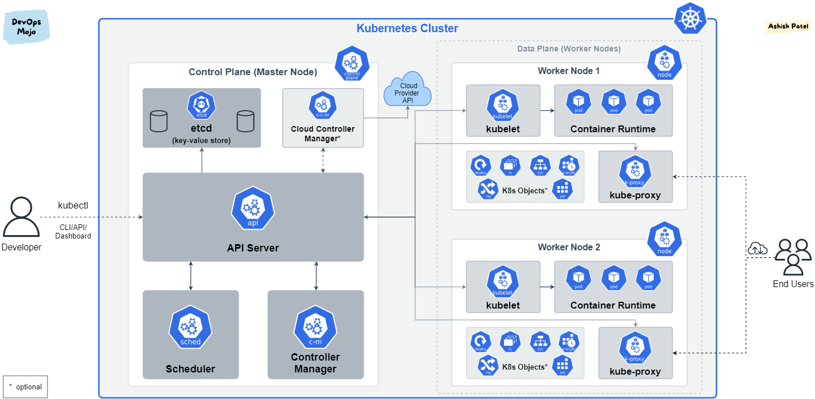

The control plane itself runs the API server (kube-apiserver), the scheduler (kube-scheduler), the controller manager (kube-controller-manager) and etcd, a highly available key-value store for shared configuration and service discovery implementing the Raft consensus Algorithm.

### Helm Charts

Helm charts, a package manager for Kubernetes releases, focuses on the simplified automated management and deployment of Kubernetes applications. A Helm Chart is a collection of files that describe a set of Kubernetes resources like deployments, services, and config maps, along with the necessary configuration values. When a chart is deployed, Helm processes these templates with user-provided or default values, rendering Kubernetes manifests. It then communicates with the cluster to create, update, or delete resources.

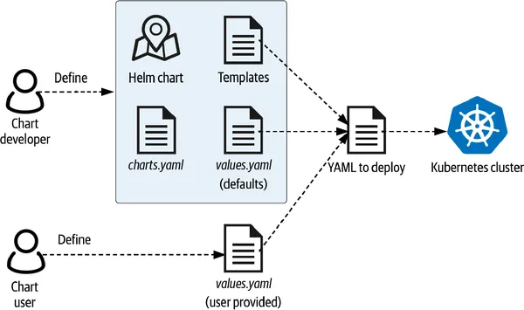

*Figure 18: Helm charts dynamic configuration* *[30]*

Without helm charts every single yaml configuration file bound to each Kubernetes resource would need to be defined manually. This way, the management of a massive and constantly growing application ecosystem would become progressively inconvenient with increasing complexity.

In order to make the process of Kubernetes configuration simpler and faster, Helm charts are used to preconfigure applications and automate the processes of development, testing and production [31]. Instead of manually writing and managing tons of YAML files, a helm chart is used to install, upgrade, or delete your app release with simple commands.

### Docker Compose

Docker Compose is a tool that’s used to build and run multi-container applications with Docker, the most popular containerization solution [32]. Compose simplifies the control of an entire application stack, making it easy to manage services, networks, and volumes in a single, comprehensible YAML configuration file. Then, with a single command, you create and start all the services from your configuration file.

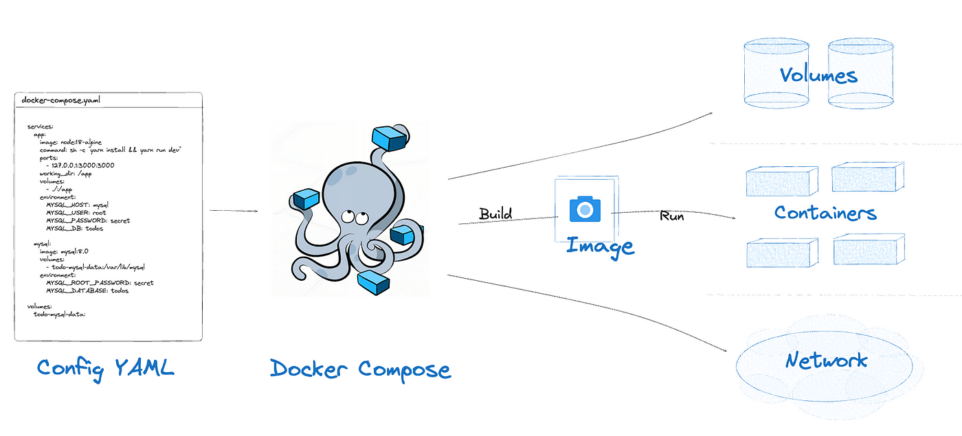

*Figure 19: Docker Compose for multi-container application management* *[33]*

A very common use case for Docker Compose is to set up local development environments quickly with all required dependencies, like databases, message queues, caches, web service APIs, configurations, etc.

## Space

### Small Satellites (CubeSats, NanoSats)

​Small satellites, commonly referred to as smallsats, are spacecraft characterized by their relatively low mass and compact size, typically weighing less than 500 kilograms. This category encompasses various subtypes, including minisatellites (100–500 kg), microsatellites (10–100 kg), nanosatellites (1–10 kg), picosatellites (0.1–1 kg), and femtosatellites (less than 0.1 kg). ​

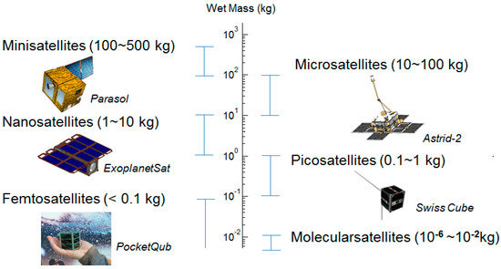

*Figure 20: Small satellites categories based on mass* *[34]*

The emergence of smallsats in space missions is largely attributed to advancements in miniaturization, in-space propulsion, onboard processing, and communication systems [35]. These technological developments have enabled smallsats to perform complex tasks previously reserved for larger spacecraft. Their affordability and shorter development cycles make them accessible to a wide range of organizations, fostering innovation and expanding participation in space activities. ​

One notable subclass of smallsats is the CubeSat, nanosatellites that use a standard size and form factor. The standard CubeSat size uses a “one unit” or “1U” measuring 10x10x10 cms and is extendable to larger sizes; 1.5, 2, 3, 6, and even 12U [36].

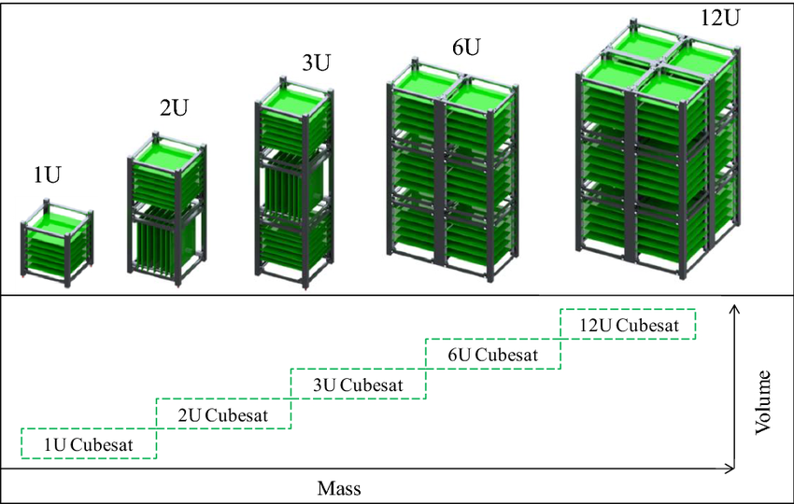*Figure 21: CubeSat standard unit measurement* *[37]*

They use **commercial off-the-shelf (COTS)** components for their electronics and structure. CubeSats are deployed into orbit from the International Space Station, or launched as secondary payloads on a launch vehicle. One such well known CubeSat is OPS-SAT by the European Space Agency (ESA), intended to demonstrate the improvements in mission control capabilities that will arise when satellites can fly more powerful on-board computers.

The proliferation of smallsats has revolutionized the space industry by enabling satellite constellations that provide enhanced coverage and data collection capabilities. As seen in the following diagram, smallsats comprise the vast majority of spacecraft launches over the past years, leaving a large gap between them and the traditionally larger satellites. Broadband smallsats have dominated the market since 2020, while earth observation and remote sensing smallsats are steadily increasing.

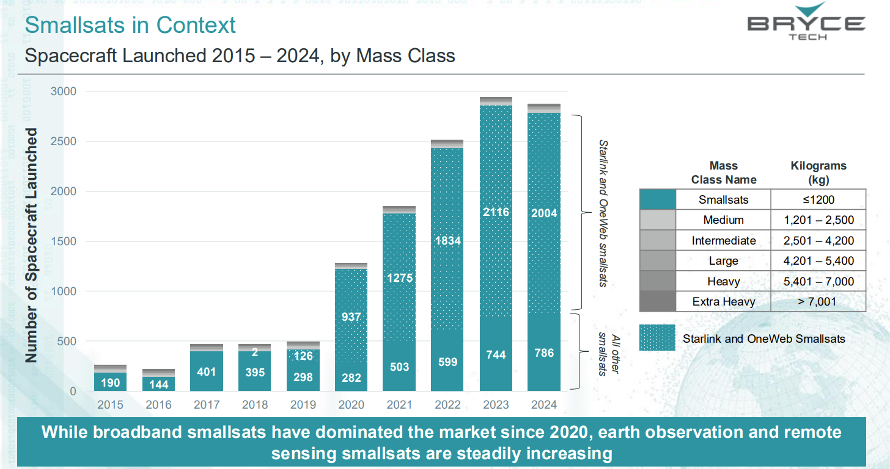

*Figure 22: Spacecraft Launched 2015-2024, by Mass Class* *[38]*

However, this rapid increase also presents challenges, such as potential overcrowding in low Earth orbit and regulatory concerns regarding frequency allocation and collision avoidance. Addressing these issues requires international cooperation and the development of sustainable practices to ensure the long-term viability of space activities. ​

In summary, small satellites have become integral to modern space missions, offering cost-effective and versatile solutions for a wide array of applications. Their continued evolution promises to further democratize access to space and drive innovation across multiple sectors.​

Key small satellite missions that demonstrate this shift in this new era of faster development and deployment cycles along with more computing power are:

* OPS-SAT [39]: Acting as a flying laboratory, ESA’s OPS-SAT mission was the first of its kind, with the sole purpose of testing and validating new techniques in mission control and on-board satellite systems. OPS-SAT demonstrated drastically improved mission control capabilities that will arise when satellites can fly more powerful on-board computers. The 3U Cubesat was only 30cm high, but it contained an experimental computer ten times more powerful than any current ESA spacecraft.
* Φsat-2 [40]: The ESA Φsat-2 mission combines on-board processing capabilities (including AI) and a medium to high resolution multispectral instrument from Visible to Near Infra-Red able to acquire 8 different bands including a panchromatic one. This satellite hosts a multispectral Imager and six AI applications designed to turn images into maps, detect clouds in the images, classify them and provide insight into cloud distribution, detect and classify vessels, compress images on board and reconstruct them in the ground reducing the download time, spot anomalies in marine ecosystems and do wildfire detection.

### CCSDS

Founded in 1982 by the major space agencies of the world, the Consultative Committee for Space Data Systems (CCSDS) is a multi-national forum for the development of communications & data systems standards for spaceflight. The goal is to enhance governmental & commercial interoperability & cross-support, while also reducing risk, development time & project costs [41].

A major milestone was achieved by the Spacecraft Monitoring & Control (SM&C) Working Group of CCSDS, which defined a service-oriented architecture for mission operations of future space missions, referred to as CCSDS Mission Operations (MO) services. Legacy standards that did not fully exploit the capabilities of modern technologies could finally be decommissioned, paving the way for more advanced and efficient operations. Such an example is the replacement of the Packet Utilisation Standard (PUS) previously used for information exchange. [42]. This new architecture consists of a set of standardized end-to-end services linking functions on board a spacecraft with those on the ground, all of which are responsible for mission operations. [43]

The architecture allows mission operation services to be specified in an implementation and communication agnostic manner. The MO services are specified in compliance to a reference service model, using an abstract service description language, the MAL. This is similar to how Web Services are specified in terms of Web Services Description Language, WSDL. For each concrete deployment, the abstract service interface must be bound to the selected software implementation and communication technology.

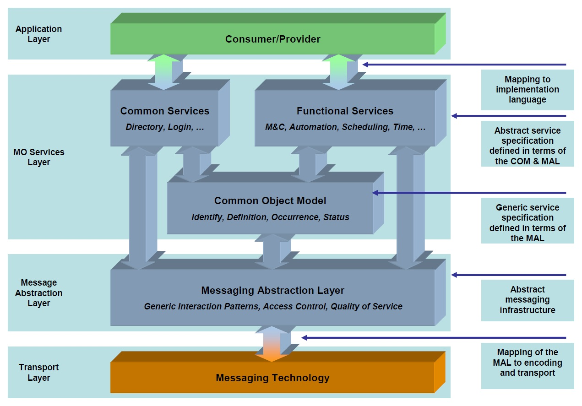

*Figure 23: CCSDS architecture layers* *[44]*

Standardization of a Mission Operations Service Framework offers a number of potential benefits for the development, deployment and maintenance of mission operations infrastructure:

* Increased interoperability between agencies
* Re-usage between missions
* Reduced costs
* Greater flexibility in deployment boundaries
* Increased competition and vendor independence
* Improved long-term maintainability

The deployment of standardized interoperable interfaces between operating Agencies, the spacecraft and internally on-board would in itself bring a number of benefits. Each organization would be able to develop or integrate their own multi-mission systems that can then be rapidly made compliant with the spacecraft. It does not preclude the reuse of legacy spacecraft, simply requiring an adaptation layer on the ground to support it, rather than many mission-specific bespoke interfaces. In the on-board environment, where software development costs are considerably higher due to platform constraints and reliability requirements, software reuse can bring immense savings.

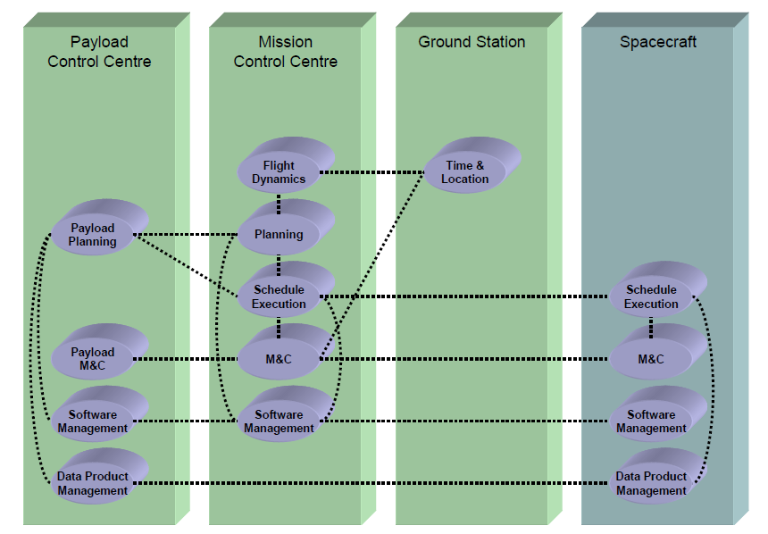

*Figure 24: Mission operations activities distributed between a Spacecraft and three separate Ground Segment facilities* *[44]*

### NanoSat MO Framework

The NanoSat MO Framework [45][46] is an open-source software framework for nanosatellites based on CCSDS Mission Operations services.

It introduces the concept of apps in space that can be started and stopped from ground. Apps can retrieve data from the platform through a set of well-defined MO services. The NanoSat MO Framework supports missions by facilitating the development, distribution, and deployment of apps on satellite missions. The NanoSat MO Framework facilitates the monitoring and control of the satellite and also provides a set of services for software management, enabling the onboard apps to be installed, uninstalled and upgraded remotely from ground. Many possibilities for extensions are available due to its modular and flexible design approach which is not limited to the space segment but extends down to ground by providing all the building blocks for a complete and free end-to-end solution.

The NMF ecosystem was an ideal candidate to harness the improved computational capabilities of the new era of small satellites. So, it was first launched on 18 December 2019 with ESA's OPS-SAT mission [47][48], which provided a fast experiment service for European and Canadian industry and academia, and completed its mission on 22-23 May 2024. Currently, it is flying on-board ESA's Φsat-2 (phisat-2), a 6U cubesat that will further demonstrate the benefits of using Artificial Intelligence (AI) for innovative Earth observation.

A fundamental module of the NMF installation is the “Supervisor” module. The NanoSat MO Supervisor is an NMF Composite that acts as a supervisor and it is intended to be deployed on the NanoSat segment for an on-board deployment with multiple applications. It supports the discoverability of the providers available on-board and allows different applications to interact with the peripherals on-board via a set of Platform services.

Additionally, it includes software management capabilities such as: starting, stopping, installing, updating and uninstalling applications on-board of the spacecraft. This component must be extended to the specific platform and particular mission use case.

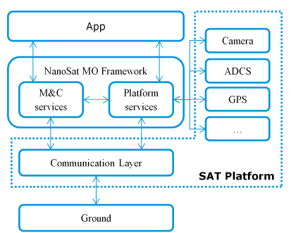

*Figure 25: Overview of NanoSat MO Framework components* *[49]*

This component includes the Central Directory service that provides discoverability functionality by holding the connections information about all the providers running on-board. Specifically, the NanoSat MO Supervisor provider and the set of registered running provider applications with their respective services.

The implementation of the Platform services to the platform peripherals on the NanoSat MO Supervisor allows multiple consumers to interact with the peripherals available on-board. The connection between a consumer and a provider of a Platform service is expected to occur via Inter-Process Communication (IPC) [50].

The NanoSat MO Supervisor is able to install packages carrying applications or libraries via the Package Management service. After an application is installed, the Apps Launcher service can be used to start the application and afterwards stop it. The Package Management is able to update a certain package which allows, for example, new features or bug fixes to be ported into an application. Lastly, a package can be uninstalled by the NanoSat MO Supervisor. To give a more specific example of how supervisor works: if we needed to install a new service, then a package java application would be sent to the supervisor and the supervisor would have the responsibility to run that code and monitor the health of the application. Both supervisor and the services are running in the same JVM, as separate processes.

Another useful module of the NMF ecosystem is the Simulator module. The Software Simulator is not an actual service used in mission, rather than a test implementation of the Supervisor. It was developed as part of the NMF SDK in order to mock hardware devices and test services for usage in space missions.

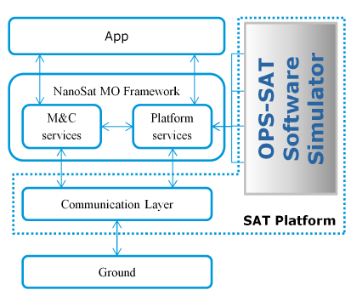

*Figure 26: NanoSat MO Framework integrated Supervisor-Simulator* *[49]*

Furthermore, the Communication Testing Tool (CTT) is a diagnostic and validation utility within the European Space Agency’s Network Management Framework (NMF), developed to support the testing of space software applications. CTT enables developers to simulate and verify interactions between onboard applications and ground systems from a user-friendly interface. It provides a Graphical User Interface (GUI) to invoke service operations, exchange telemetry and commands, and validate protocol compliance across the Mission Abstraction Layer (MAL).

In implementation terms, it uses the Ground MO Adapter for the connection to the providers. Although CTT is provided as a “ready to be used” application, its source code is also available for developers to learn and get an example of how a client-server architecture could be implemented in NMF.

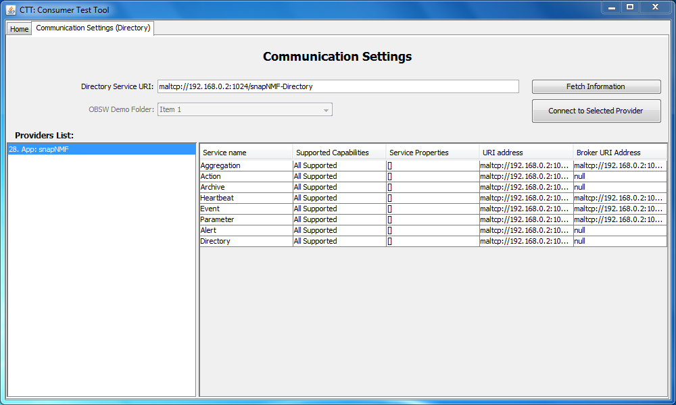

*Figure 27: Communication Testing Tool GUI* *[44]*

CTT was designed to support the connection to multiple NMF Apps simultaneously via a tabbed view mechanism. Amongst others, it can list registered services and applications, invoke operations (“actions”) exposed by the services (such as commanding an onboard camera to take a snapshot), monitor events and status updates and apply configurations to the services.

## Edge Computing

Edge computing represents a paradigm shift in distributed computing, wherein data processing occurs in close proximity to the physical location of data generation, such as sensors and devices, rather than relying solely on centralized servers or cloud infrastructures. This architecture typically integrates edge servers and connected devices (e.g., laptops, smartphones) into a local network, enabling secure, real-time data processing directly at the source.

The concept of edge computing originated in the 1990s, initially referring to content delivery networks (CDNs) that aimed to reduce latency by distributing website and video content through geographically dispersed servers. In the early 2000s, the functionality of these networks expanded to support application hosting capabilities, thereby giving rise to early edge computing services. These services facilitated a variety of tasks, such as locating dealerships, managing e-commerce operations (e.g., shopping carts), collecting real-time data, and delivering targeted advertising.

The evolution of edge computing has been closely associated with the rise of the Internet of Things (IoT), a wide network of interconnected smart devices and sensors. The explosive growth and increasing computing power of IoT devices has resulted in massive volumes of data. This data scale-up has been further accelerated by the advent of 5G networks, which significantly increase the number and mobility of connected devices.

In the past, the promise of cloud and AI was to automate and speed up innovation by driving actionable insight from data. However, the scale and complexity of data generated by connected devices have begun to exceed the capabilities of conventional network and infrastructure systems. Transmitting all device-generated data to centralized data centers or cloud platforms introduces considerable bandwidth constraints and latency issues.

Edge computing addresses these challenges by enabling data processing and analysis to occur closer to the point of origin. This localized approach significantly reduces latency and alleviates the burden on network bandwidth, enhancing system responsiveness. Particularly in the context of mobile edge computing facilitated by 5G networks, this model supports rapid and extensive data analysis, thereby fostering deeper insights, reduced response times, and enhanced user experiences

.

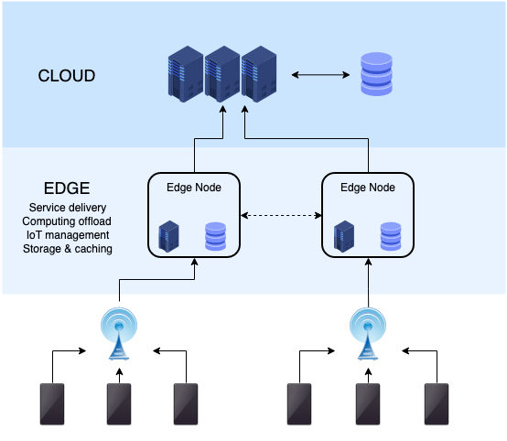

*Figure 28: The edge computing infrastructure* *[51]*

### Space Edge Computing

Data generated in space is growing rapidly. A typical commercial imaging constellation collects more than 100 terabytes of data per day. Space data traffic is expected to reach 566 exabytes over the next decade, according to NSR (global market research and consulting firm focused on the satellite and space sectors), with satcom accounting for over 90% of that total.[52]

As space missions grow more autonomous and data-intensive, they increasingly rely on computing systems capable of functioning independently of centralized ground control. In response to this shift, space edge computing has emerged as a foundational approach, enabling real-time processing directly at the site of data generation. Rather than routing all data to Earth for analysis, edge computing reduces latency, minimizes bandwidth usage, and supports autonomous decision-making in remote or delay-prone environments such as deep space.

Long communication delays, high radiation levels, and limited energy budgets render traditional cloud-based models insufficient for space applications. Edge computing enables spacecraft, satellites, and planetary rovers to analyze sensor data in real time, make decisions locally, and respond to their environment without waiting for remote instructions.

Scientific missions that venture into deep space, including among others Mars landers, asteroid rendezvous missions, or icy moon probes, face significant communication delays, often ranging from several minutes to over an hour each way. In these environments, transmitting every data packet to Earth for analysis is neither practical nor efficient.

Edge computing allows spacecraft to process scientific data onboard, evaluate its significance, and prioritize transmissions accordingly. For example, an onboard spectrometer analyzing rock samples on a Martian surface can distinguish between ordinary regolith and material with unusual mineral content. Only the latter needs to be flagged for high-resolution analysis or downlinked for further study.

#### Space Edge

A satellite can be considered the quintessential edge device in many respects. It operates remotely, is often disconnected from terrestrial data centers, and generates vast amounts of data. Equipping a satellite with local computing capabilities enables a range of operational advantages, including reduced latency, enhanced security, and lower data transmission costs.

The concept of space-based edge-hosted payloads aims to minimize the need for data to make repeated round trips to Earth stations or cloud infrastructure on the ground. Given the significant distance from Low Earth Orbit (LEO), Medium Earth Orbit (MEO), or Geostationary Orbit (GEO) to Earth, and the additional time required for analysts to process raw data and return results to the satellite, onboard processing offers a more efficient solution.

#### Ground Edge

In the ground segment, the edge of a satellite network typically refers to the terminal and in some cases, the teleport or gateway. This edge may be located on a plane, boat, vehicle, or other remote site. It generally sits at the outermost point of the network, closest to where data is generated.

Similar to the space-based edge, implementing edge computing at the terminal enhances network performance by bringing workloads closer to the end user. This approach reduces latency, strengthens security, and helps alleviate the costs and bandwidth demands associated with transmitting data to a centralized network.

#### Cloud

The cloud enables two-way communication with the edge, creating an environment that supports easier collaboration across locations, applications, and network functions. Data sent back to the cloud can be processed, stored, or accessed by authorized users within that ecosystem. Additionally, the cloud can send commands, such as software updates or configuration changes, back to edge devices.

As technology continues to advance, many enterprises are increasingly adopting edge cloud solutions (compact versions of centralized cloud infrastructure) and edge servers (essentially micro data centers). These options provide faster data analysis and enhanced processing power without the need to connect to traditional, centralized cloud data centers.

# IV. Architecture and Design

## Architecture

### Current Nanosat MO Framework Architecture

The current NanoSat MO Framework runs on a JVM tightly coupled architecture.

On the satellite, the framework hosts multiple space applications (e.g., Space App 1, Space App 2) and a Supervisor component, all running within a single Java Virtual Machine (JVM). The Supervisor manages app lifecycle and interactions with onboard devices.

On the ground segment, one or more NanoSat MO Framework instances provide Ground Services that communicate with the satellite using standardized CCSDS MO protocols, enabling telecommand, telemetry, and data handling.

## 

*Figure 29: Current NanoSat MO Framework Architecture*

### Proposed Nanosat MO Framework Architecture

The proposed architecture replaces the JVM-based setup with a lightweight Kubernetes (k3s) environment on the satellite.

Each space application, supervisor, and NanoSat MO Framework instance runs as an independent container, improving isolation, scalability, and deployment flexibility. A Kubernetes Device Plugin layer interfaces directly with the satellite’s hardware devices, allowing containerized apps to access and manage onboard systems efficiently.

Ground stations continue to operate NanoSat MO Framework services, maintaining standardized communication with the satellite.

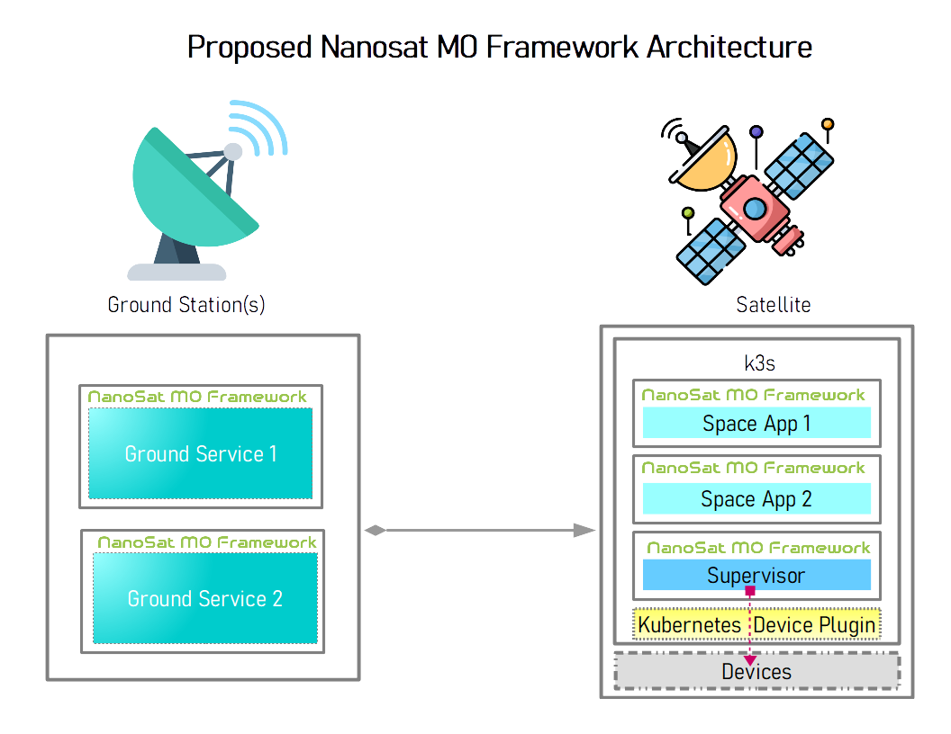

*Figure 30: Proposed NanoSat MO Framework*

### Proof Of Concept Architecture

The end to end proof of concept architecture for this thesis comprises three basic elements: the space node, the ground workstation node and the ground CI/CD node.

Space node: Consists of a RaspberryPi, with an attached camera and similar resources as OPS-SAT’s computational payload, in which a lightweight k3s cluster [53] is set up and running. A camera acquisition app and Supervisor/platform service is deployed inside this cluster.

Ground workstation node: It consists of a development workstation with a ground photo storage app running in a local JVM, which receives preprocessed photos from the space camera acquisition app and stores them locally.

Ground CI/CD node: It consists of a VM with Jenkins setup [54] inside a mikrok8s cluster [55][56]. Jenkins is utilized to build container images for the space applications and push them as compressed tarballs in the k3s space cluster in a scheduled manner. Ansible is used to set up the microk8s cluster from scratch. Ansible is an open source, command-line IT automation software application that can configure systems, deploy software, and orchestrate advanced workflows to support application deployment, system updates, and more [57].

## 

*Figure 31: Proof of Concept NMF App Architecture*

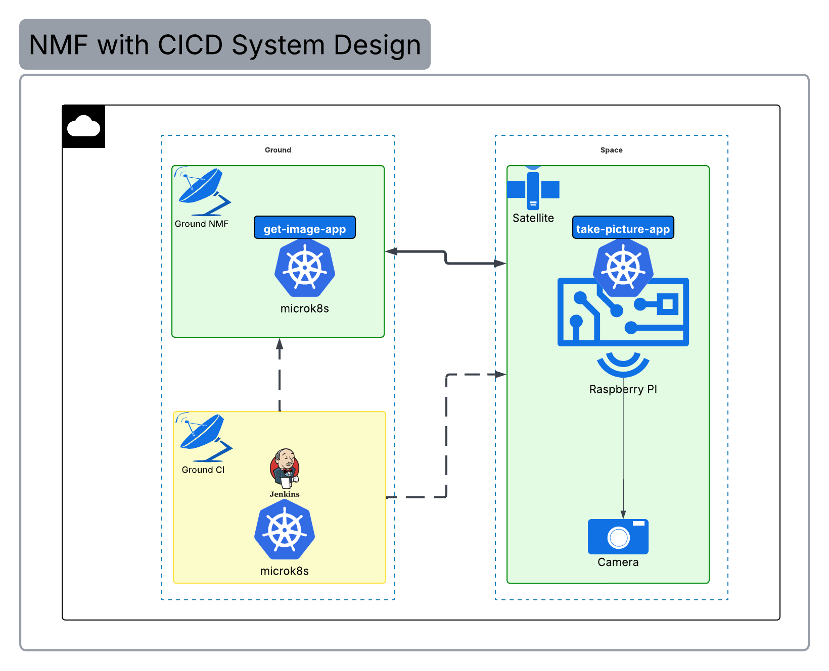

*Figure 32: Proof of Concept NMF with CICD System Design*

### Earth To Space Computational Continuum

By integrating DevOps practices, Kubernetes-based orchestration, and the NanoSat MO Framework (NMF) across satellites, ground stations, and the cloud, it becomes possible to create a seamless Earth-to-Space computing continuum.

In this model, spacecraft operate as edge nodes within a distributed system, running containerized applications close to the data source (e.g., sensors, payloads). Ground segments and cloud infrastructures handle large-scale processing, coordination, and analytics. Using Kubernetes and DevOps pipelines, applications and updates can be deployed, monitored, and managed consistently across all layers, from the cloud to orbiting nanosatellites and even deep-space nodes.

This unified architecture enables real-time data processing, autonomous operations, and scalable mission management, bridging Earth and space into a single adaptive digital ecosystem.

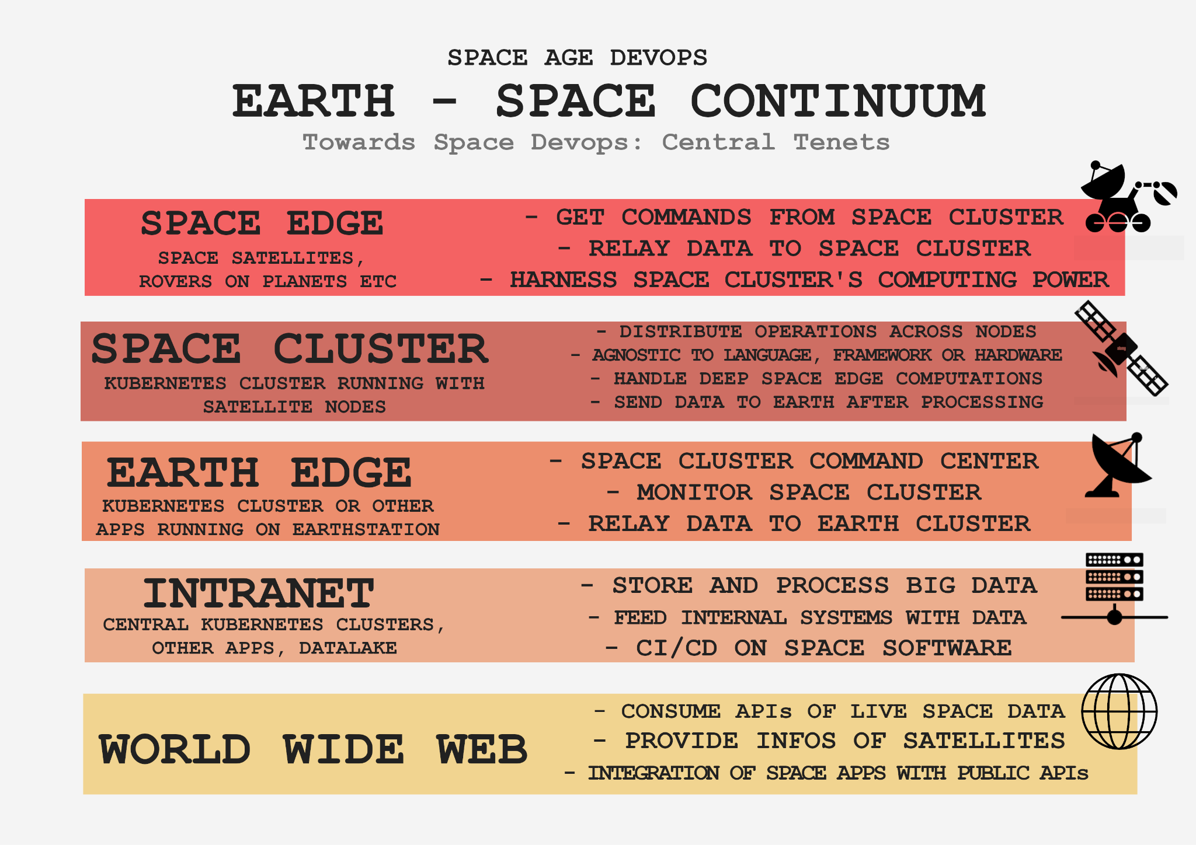

*Figure 33: Towards Space Devops: Central Tenets*

## Methodology

Τhis part of the thesis describes the methodological approach to the resolution of the problem initially formulated. It essentially consists of a breakdown of the path towards converging NanoSat MO Framework with Kubernetes.

### Deep-dive into NanoSat MO Framework

The first important step is to get a greater understanding of the NanoSat MO Framework, digging deeper into the CCSDS principles, reviewing all relative available code on ESA’s public repositories [58][59][60][61] and observing the actual functionalities of running NMF services.

Thus, in a local workspace the Supervisor service is initially used to start and stop existing NMF services, while getting a grasp of the core functionality provided. Afterward, a custom test application is created based on the NanoSatMO framework. Once it is successfully compiled and deployed, the final step in this stage of the research is to explore the interoperability between ground and space services.

Throughout these steps, all actions and observability are performed using the Consumer Test Tool (CTT). During investigation and initial development, the Supervisor is operated in simulator mode to mock the required underlying infrastructure.

To maintain an organized working environment and follow good development practices, the ESA’s public repository is forked into a private workspace, in which branch and commit policies are applied.

### Containerize NMF Services

The next major step, after gaining a solid understanding of the NanoSat MO Framework, is the containerization of the services. This requires a detailed investigation of how services are originally compiled and executed, as well as an analysis of the scripts and conventions involved, in order to adapt them for containerized environments.

Best practices for containerization are applied, including the use of common base images where possible, like in the case of common libraries. Existing conventions, such as directory structures and paths, are maintained to ensure backward compatibility.

To validate interoperability, testing progresses in stages: first with uncontainerized instances only, then by mixed uncontainerized and containerized instances, and finally between only containerized instances. At each step, functionality is verified using the Consumer Test Tool (CTT), the Supervisor, and the ground/space services. To automate deployment of multiple containers, a Docker Compose file is introduced.

From this stage onward, the Supervisor no longer directly manages the service lifecycle (start/stop). Instead, services are started independently, using docker runtime, and register themselves in the Supervisor. Supervisor remained as a way to interact in a backwards compatible way with those services.

### Initial Attempt For Local Kubernetes Deployment

In this step we attempt to create a local Kubernetes deployment, for the NMF ecosystem. Minikube [62] Kubernetes flavour is chosen for the local infrastructure, as it is the ideal lightweight choice for development purposes. Helm charts are created to automate and standardize the deployment of the newly containerized services in the minikube cluster. NMF space and ground apps along with the Supervisor, using simulator mode with mocked underlying hardware.

A significant troubleshooting part of this step is the adaptation of NanoSat MO Framework to Kubernetes networking. The framework uses MALTCP protocol, which is based on TCP. Kubernetes has a great adaptability regarding communication protocols, however, it is usually hosting apps and services using the application layer TCP/IP network suite [63], for HTTP, SOAP, gRPC transports. A Kubernetes cluster can still accommodate incoming TCP-based traffic from the public network and route it to apps using NodePort Kubernetes Services and binding public static ports to each internal service.

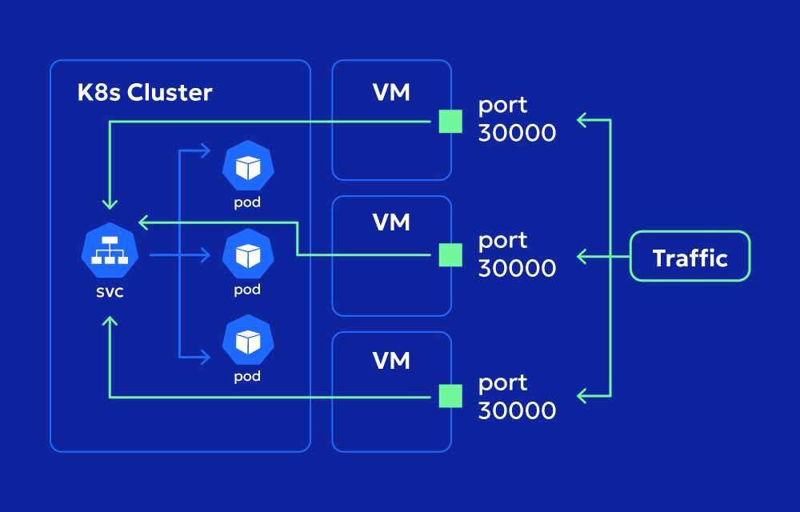

*Figure 34: NodePort exposes apps on each Node’s IP at a static port* *[64]*

Also, the NanoSat MO Framework services exhibit stiff connection requirements. Additional application configurations for host and IP resolution are necessary, after reverse engineering the code and bringing together details from the initial documentation. This process is documented, from now on, in a NMF Kubernetes Networking Guide [[6]](https://docs.google.com/document/d/1Smc-PKWU6f6aiMEq3Thkji_85pr9Zaxau-o7KRi5gYI/edit?pli=1&tab=t.0#bookmark=id.bw5dyttcsak).

### Utilize Hardware From Containerized Apps Inside Kubernetes

At this stage of the research, all NMF services not dependent on hardware (e.g., ground services) could run within Kubernetes. However, since the framework's primary goal is to deploy services on satellites and utilize onboard hardware (e.g., sensors, cameras, GPS), the next step is to explore effective methods for enabling hardware access from within Kubernetes containers. As containers are largely isolated from the host via Linux namespaces and cgroups, special configurations are required to grant them access to underlying hardware resources.

An early design consideration is the use of elevated container privileges within a Kubernetes pod to enable access to host hardware. Kubernetes manages container security through Pod Security Standards [65], which define three policy levels: Privileged, Baseline, and Restricted. The “Privileged” policy represents the least restrictive configuration, allowing a pod to bypass most of the isolation mechanisms normally enforced by the container runtime, including direct access to the node’s host network, mount host file systems, and directly interact with hardware devices. While this configuration may be appropriate for system-level workloads, such as infrastructure services managed by trusted administrators, it is generally discouraged for application-level workloads due to the significant security risks it introduces. So other approaches need to be investigated also.

#### Kubernetes Device Plugin

Historically, host hardware access in Kubernetes was initially implemented through ad hoc, vendor-specific solutions. For instance, NVIDIA developed a custom integration through a “device plugin” to expose GPUs to containers [66], but such approaches lacked standardization and scalability.

Fortunately, recent Kubernetes versions introduced the Device Plugin framework, providing an official API for developing vendor or hardware specific plugins for mounting devices into Kubernetes, such as GPUs, NICs, FPGAs [[67]](https://docs.google.com/document/d/1Smc-PKWU6f6aiMEq3Thkji_85pr9Zaxau-o7KRi5gYI/edit?pli=1&tab=t.0#bookmark=id.3phgquwc6cp). This way, there was no longer a need to customize the Kubernetes core code in order to make a device available inside Kubernetes.

The Device Plugin framework was introduced in the Kubernetes v1.8 release as a vendor independent framework to enable discovery, advertisement and allocation of external devices. The feature graduated to Beta in v1.10. With the recent release of Kubernetes v1.26, Device Manager is now generally available (GA) [68].

Within the kubelet, the Device Manager facilitates communication with device plugins using gRPC through Unix sockets. Device Manager and Device plugins both act as gRPC servers and clients by serving and connecting to the exposed gRPC services respectively.

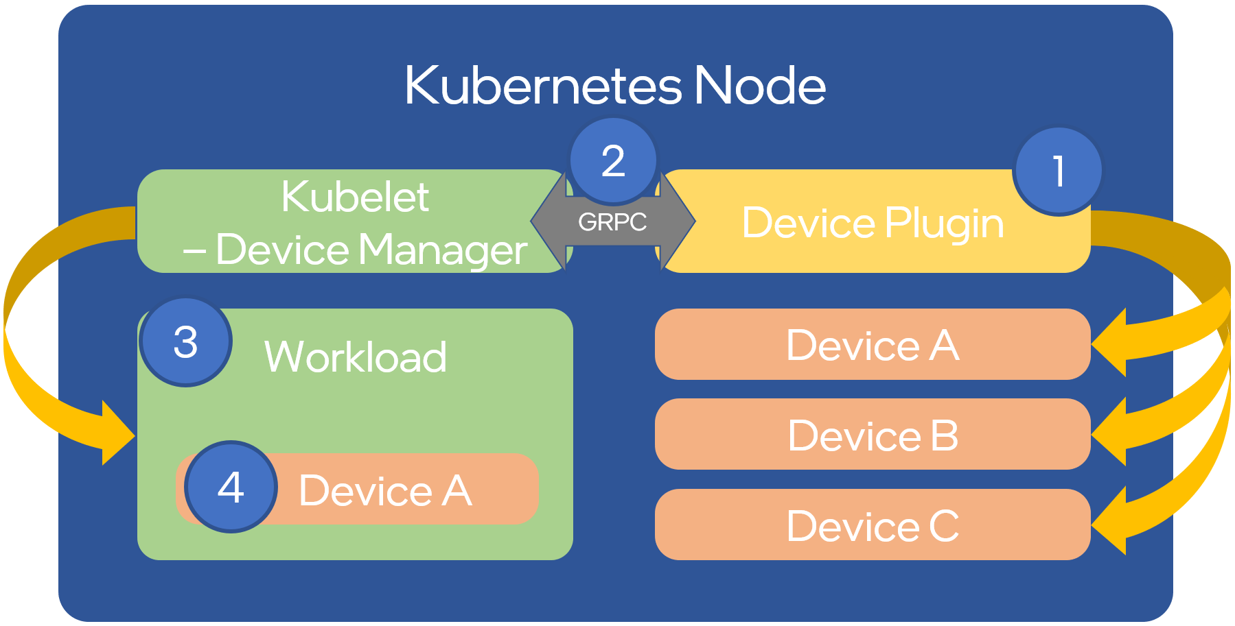

*Figure 35: Kubernetes Device plugin architecture & gRPC communications**[69]*

So, the official Kubernetes Device plugin is now integrated in the NMF Kubernetes ecosystem as a full-blown mechanism to access underlying hardware devices. A generic linux device plugin implementation is adopted for this thesis and used as proof of concept for the access of a camera device. Before testing it with the NanoSat MO Framework services, the plugin functionality is validated using a test device and taking pictures from an app running inside minikube.

### Run final Proof of Concept

In the final proof of concept, we deploy space applications on a k3s cluster upon a Raspberry Pi, acting as a space node, which has computing resources comparable to those of the OpsSat board. In a development workstation, acting as a ground node, all needed ground apps are deployed. A Jenkins set up in a microk8s cluster in a VM is utilized to automate build and deployment of the space apps.

We use an NMF camera space application to capture images through a real camera adapter integrated into the Supervisor service, replacing the previously used mock. Hardware access is managed via Kubernetes device plugin implementation.

Once captured, images are preprocessed onboard using one of two approaches: Sobel filtering for edge detection or K-means clustering for unsupervised segmentation. The processed images are then transmitted via downlink to a ground-based NMF service running on the development workstation, where they are stored.

We validate the full pipeline using this infrastructure and consider the proof of concept successful.

## Design Decisions

As part of the implementation, several key design decisions are made to select between alternative approaches. These decisions are guided by trade-offs involving performance, compatibility, system complexity, and alignment with the project's objectives. The following section outlines the most significant choices and the rationale behind them.

### Kubernetes Flavor selection

After the initial stages of testing and development, the project transitions into the next phase, which focuses on building a proof of concept with advanced infrastructure. The goal is to move beyond basic functionality and develop a setup that better reflects real-world deployment conditions. At this stage, selecting an appropriate Kubernetes distribution becomes a critical decision. Since the time of its creation, Kubernetes has been implemented into a diverse environment of apps, systems and use cases in general, in a multitude of fields; from IoT to data-center domains [70][[71]](https://docs.google.com/document/d/1Smc-PKWU6f6aiMEq3Thkji_85pr9Zaxau-o7KRi5gYI/edit?pli=1&tab=t.0#bookmark=kix.awci4wj60tgw).

Given the project’s constraints and objectives, the use case aligns most closely with the requirements typically found in IoT scenarios. The most complete flavors of Kubernetes used in IoT are microk8s, k3s and k0s. They offer almost the full capability of the Kubernetes API and require minimum resources.

The system specs of OpsSat, the first NanoSat MO Framework implementation mission in space, need to be taken under consideration. According to its official specifications, OpsSat has two Critical Link MityARM 5CSX in cold redundancy (if one fails, the second one is used). These have a Dual-core 800 MHz ARM Cortex-A9 processor, an Altera Cyclone V FPGA, 1 GB DDR3 RAM, and an external mass memory device with 8 GB. [72]

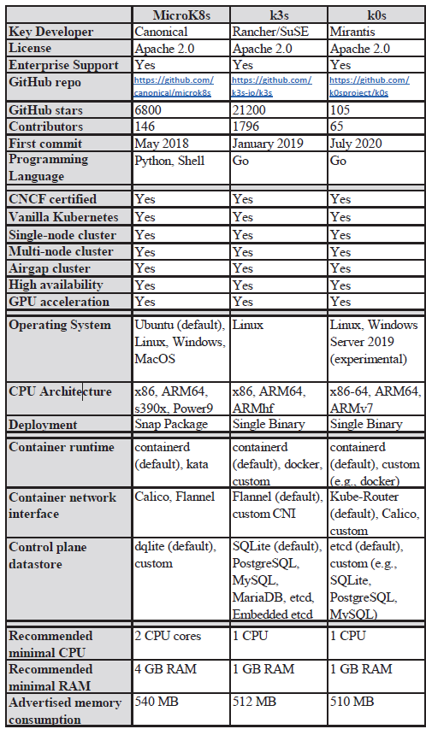

*Table 1: Feature comparison of lightweight Kubernetes distributions* *[73]*

As documented by the comparison depicted above, OpsSat systems don’t provide adequate resources for the microk8s to run smoothly. However, they are more than enough for k3s and k0s, as they have been designed to reduce binary size and memory footprint, targeting resource constrained edge clusters besides developer workstations. Both k3s and k0s support ARM64 system architecture, show high control plane throughput and generally efficient latency and throughput in their overall task completion [[73]](https://docs.google.com/document/d/1Smc-PKWU6f6aiMEq3Thkji_85pr9Zaxau-o7KRi5gYI/edit?pli=1&tab=t.0#bookmark=id.gqx6eh793it3). Bearing in mind that k3s has the biggest community, sufficient documentation and ease of use, it is chosen as the most suitable Kubernetes flavour for this specific scenario.

### Container runtime selection

Docker container runtime and CLI are chosen for local development purposes due to Docker’s ecosystem popularity and ease of use. Instead, containerd is adopted in the final proof of concept infrastructure as the most suitable container runtime, being more lightweight.  
  
Containerd is the low-level container runtime that Docker is built upon. Whereas Docker focuses on providing a streamlined user experience, containerd implements the system daemon that lets Docker actually start and run containers [74].  
  
Containerd focuses on providing a stable foundation for other container tools, but Docker is a complete platform for building and operating containers. It’s a developer-oriented solution that includes many complementary features not found in containerd.

### Jenkins Pipeline: Scheduling, Tarballs & SCP

In our Jenkins-based delivery and deployment setup, standard workflows such as tagging, releasing, and testing remain the same. However, deployment tactics are adapted to meet the unique requirements of space-edge systems [75][76].

Unlike conventional deployments where container images are pulled from an online registry, our Jenkins pipeline builds the images on the ground and then waits for synchronization with the satellite in orbit. When an uplink becomes available, the container images are exported as tarballs and securely transferred using scp command [77]. Once received, the tarballs are unpacked and mounted into the satellite’s local container registry and k3s environment.

Using container tarballs instead of performing docker pull operations provides the following practical advantages for in-orbit deployment:

* Predictable and lower host resource usage: pulling images via Docker registry requires multiple concurrent downloads, decompression, and verification steps, which can spike host RAM and CPU usage. Loading tarballs, by contrast, is a sequential, local operation that avoids these transient resource peaks.
* Optimized data transfer: a single, compressed tarball can be efficiently transmitted improving reliability during short uplink windows.

For file transfer, scp was selected for its simplicity over rsync which needed the software installed on both ends [78]. Meanwhile, CFDP (CCSDS File Delivery Protocol) [79] and the Bundle Protocol [80] are purpose-built for space environments, designed to handle long delays and disruption-tolerant networking. However, these protocols were not integrated into this proof of concept due to the complexity of adoption and integration overhead.

### Raspberry Pi as the PoC infrastructure

The initial point of reference for NMF is the OPS-SAT mission, which utilizes a Cyclone V SoC FPGA board [81][82]. Raspberry Pi is selected for executing this thesis’ running example due to its popularity, simplicity and similarity with Cyclone V in terms of computational resource capabilities (RAM, CPU, storage). Implementing an architecture combining DevOps technologies and principles with space software is under the spotlight, before actually running all those technologies in the real-world underlying infrastructure. Also, gradually it has become a common practice to launch single-board computers like Raspberry Pi and Nvidia Jetson [83] in satellite missions, particularly close to LEO, due to their low cost, availability and increased compute power.

#### E2E Space-Ground Proof Of Concept

The full blown proof of concept is conducted in a Raspberry-Pi (with the role of a satellite) with a similar system specification to Altera Cyclone V used in OPS-SAT (1 GB RAM) and a camera device connected to it. A k3s cluster is set up in Raspberry-pi with the containerized NMF Supervisor and an NMF camera-acquisition space app deployed in it. The deployment was achieved by the use of automated pipelines with helm charts and Jenkins. Then, the NMF Supervisor (with unmocked camera platform service) was utilized for taking snapshots, successfully retrieving live photos from the camera attached to the underlying hardware, through the Kubernetes device plugin integration. These photos were sent to the camera-acquisition space app to be processed further, with image analysis filters and machine learning algorithms. Eventually the images are sent to a ground application running on a development workstation.

This proof of concept architecture was designed having in mind to be as close to a real scenario as possible:

* similar computational resources used
* space-ground communication
* data preprocessing in space as part of edge computing logic
* hardware integration with Kubernetes ecosystem
* CI/CD pipelines provisioned for space environment

#### JDK vs JRE

Maven and JDK-based base image is used to compile and package the Java code in the build stage of the Dockerfile. In the final container image, however, only the JRE (Java Runtime Environment) is included. This is accomplished using a multi-stage Docker build, where compilation tools are confined to the build phase and excluded from the runtime environment.

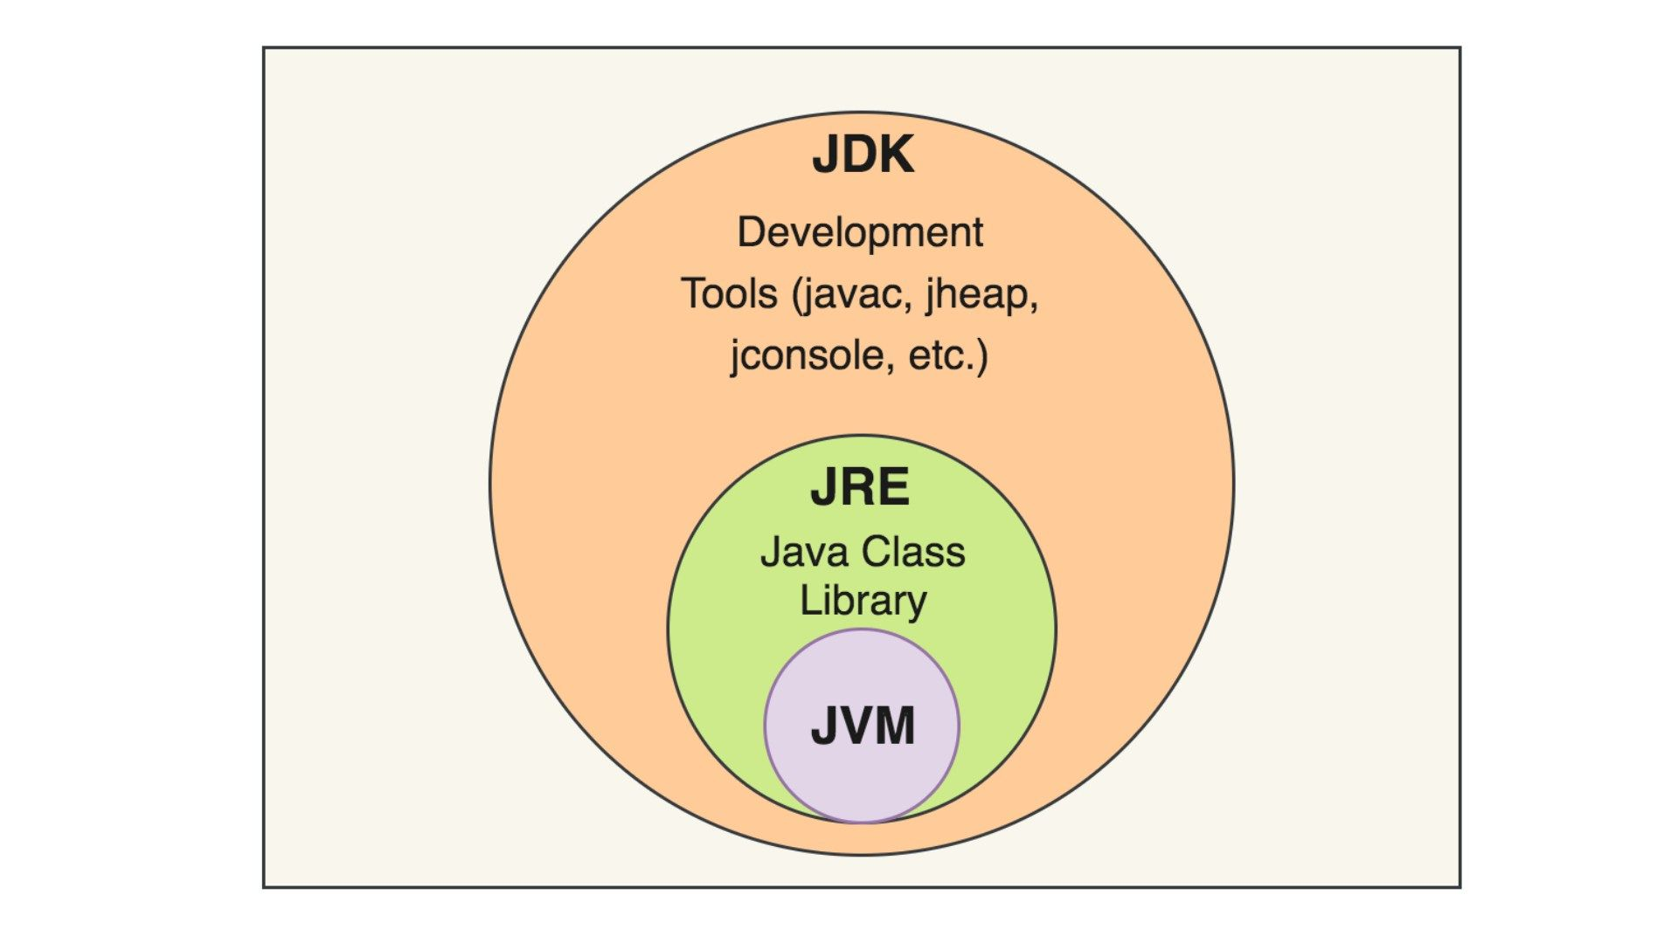

*Figure 36: JDK, JRE, JVM components of Java ecosystem* *[84]*

The JRE includes the JVM, standard class libraries, and supporting files needed to run Java programs. The JDK includes the JRE plus development tools like javac (compiler), javadoc, jdb (debugger). This approach reduces the final image size, enabling faster deployments and more efficient resource utilization during execution [[85]](https://docs.google.com/document/d/1Smc-PKWU6f6aiMEq3Thkji_85pr9Zaxau-o7KRi5gYI/edit?pli=1&tab=t.0#bookmark=id.4jxqu01ve0te).

## Implications and Discussions

* A new version of Nanosat Framework has been released in ESA’s Github repository after the start of the development in the forked Github repository. The forked repository has been updated to retrieve any new changes but certainly some new features or improvements, created by the ESA team, could still be left out. The main goal of this thesis remains intact, as it is to pave the way to the new DevOps era in space through the prism of NMF, white highlighting and documenting the way to do it.
* The selection of a Kubernetes distribution should align with available system resources and specific operational requirements. Simulating an OPS-SAT mission on a resource-constrained Raspberry Pi made k3s an optimal choice due to its lightweight footprint and broad community. However, alternative distributions may be more suitable in different contexts, especially given the fact that these distributions grow and transform over time. k0s could be an ideal alternative in the future, keeping a lightweight footprint while lacking a big support community at the moment. Microk8s supports system architectures like s390x and POWER9 that are not supported by k3s. Also, full Kubernetes (k8s) deployments are preferable for large-scale, resource abundant clusters demanding extensive customization, high availability, and integration with enterprise tooling.
* For the proof of concept, the NMF Supervisor was utilized in hybrid simulator mode, where certain hardware components, such as GPS and ADCS sensors, were simulated giving mocked responses and metrics, while the actual camera device was fully integrated with its corresponding platform service. This setup enabled us to demonstrate end-to-end NMF functionality within a Kubernetes environment without the need to implement full hardware adapters for each device. The hybrid approach was chosen to balance development effort and demonstration scope, focusing on validating system integration rather than exhaustive hardware emulation.
* Raspberry Pi is a good emulation platform for OPS-SAT for software development, NMF integration, and ground-segment testing purposes, but it is not a substitute for real hardware testing or in-orbit operational behavior. It is especially suitable for early-stage development, training, and POCs (like demonstrating NMF functionality in Kubernetes or containerized environments). It is based on Linux-based OS, ARM64 system architecture, utilizing the same range of resources with OPS-SAT’s Cyclone V SoC FPGA and providing interfaces for many IO devices. For sure, further validation is required regarding RaspberryPi’s hardware radiation tolerance and fault tolerance mechanisms required in space. Also, RaspberryPI is probably lacking out of the box support for specific space-grade sensors (ADCS) and doesn’t provide FPGA functionalities.
* Raspberry Pi can be considered conditionally a full example of a satellite on-board computer, particularly in the context of modern, low-cost, LEO missions, prototyping or educational satellites. As the space industry evolves, more small satellites are indeed using commercial off-the-shelf (COTS) hardware like Raspberry Pi, NVIDIA Jetson, or BeagleBone, especially when cost, time-to-launch and flexibility are prioritized. There are real-world examples, like Astro Pi [86], a Raspberry Pi flown to the International Space Station (ISS), used by students for experiments and CubeSats launched from SpaceX with an Nvidia Jetson board for AI-based imaging [87], mission control, or data processing.
* The container image tarballs copied from the Jenkins terrestrial infrastructure could ideally be transferred to the satellite cluster using CCSDS protocols such as CFDP and Bundle protocol. Bundle protocol is a network layer protocol that enables Delay/Disruption-Tolerant Networking (DTN), it forms a store-and-forward overlay network that can move data “bundles” between intermittently connected nodes, an analogy to space IP. CFDP is an application layer protocol for reliable file transfer in space missions, an analogy to space SCP. While CFDP and the Bundle Protocol are well-suited for space communications and disruption-tolerant networking, their integration would have significantly increased system complexity. As a trade-off, these protocols were not adopted for this proof of concept, prioritizing simplicity and rapid demonstration over full DTN capability.

# V. Implementation

## Enhance Platform Services: Implement Raspberry PI USB Camera Adapter

In the NMF Supervisor, the Platform services provide access to a satellite’s hardware (sensors, actuators, etc.) in a standardized, mission-operations compliant way. To make that possible across different kinds of hardware, adapter classes are used as hardware abstraction layers, one adapter per platform service or subsystem.

For our case, a new adapter, FsWebcameraAdapter, was created and used by the Camera platform service of the supervisor to enable interaction with the actual underlying camera hardware of a Raspberry PI. This functionality was implemented using the Java Webcam Capture library [88] together with fswebcam [89], a lightweight webcam handling tool for Unix-like systems.

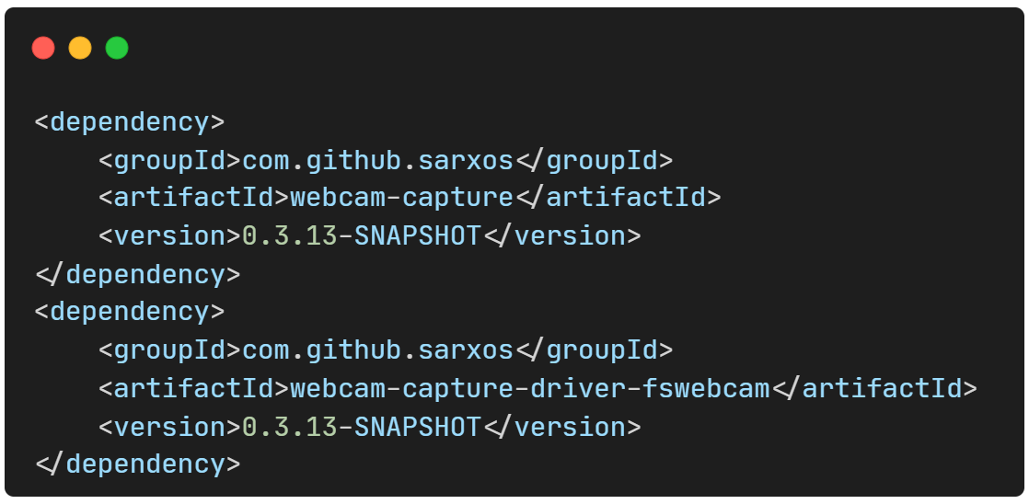

*Code snippet 1: Maven artifacts required for RaspberryPi camera platform service*

For each platform service, an interface defines the fundamental methods and functionalities to be supported. In this context, the FsWebcameraAdapter implements the set of methods inherited from the Supervisor’s Camera Adapter Interface, including operations for obtaining available resolutions and formats, previewing images, and capturing snapshots.

*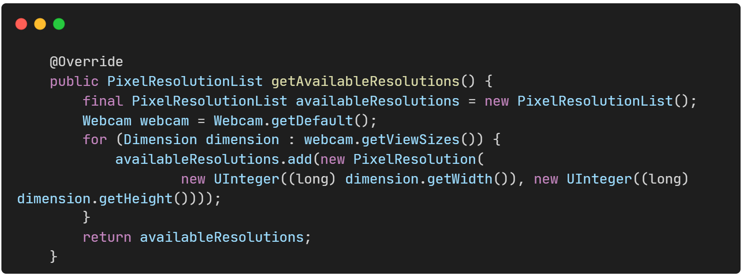Code snippet 2: Get camera’s available resolutions*

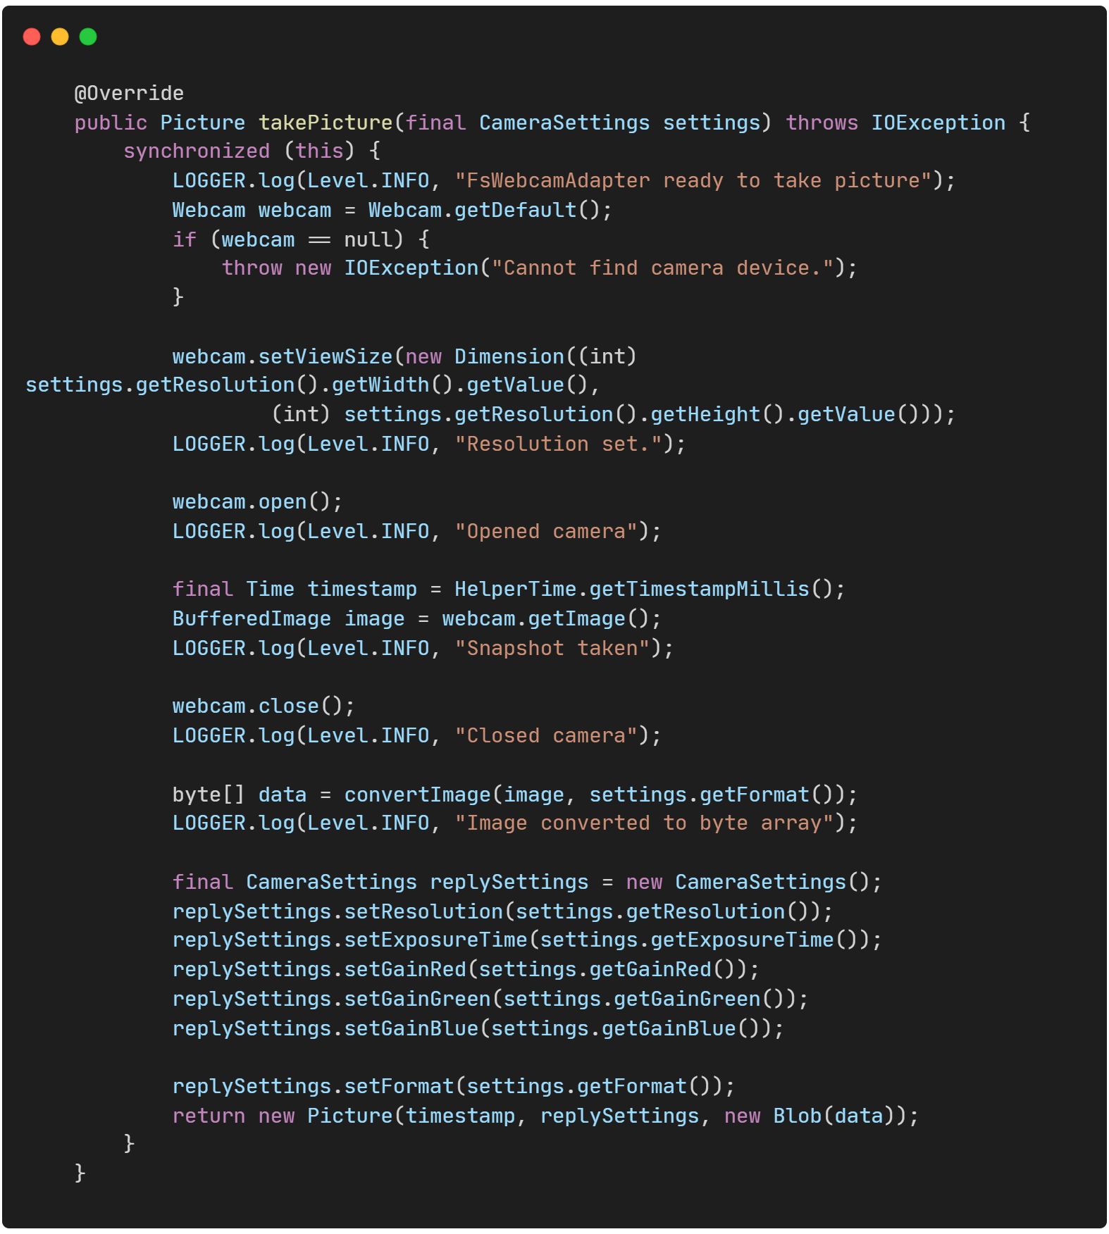

*Code snippet 3: Take a snapshot*

In order to utilize FsWebcamAdapter in the final proof of concept the platforsim.properties configuration file needs to be configured properly, which is used to define simulation parameters for the Platform Services. The Supervisor needs to be executed in hybrid mode and define each adapter class, mocked or real, that is utilized for each platform service. In hybrid mode, the NMF Supervisor uses a mix of real and simulated platform services. That is, the camera subsystem will use a real hardware adapter, while the others are still simulated through the platform simulator.

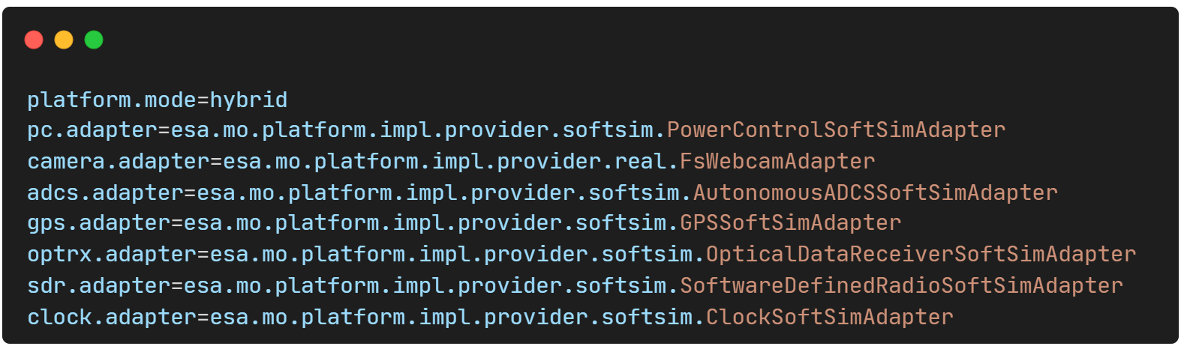

*Code snippet 4: Configuration to use FsWebcamAdapter in Supervisor hybrid mode*

## Enable Running NMF into Kubernetes: k3s, Device plugin & CICD pipelines

### k3s setup

k3s bundles its own specific Kubernetes version with each release. The K3s release version is typically denoted with a postfix like "+k3sX", where "X" is a number. For example, the release v1.32.5+k3s1 uses Kubernetes v1.32.5. The "+k3sX" postfix allows K3s to make additional releases while maintaining semantic versioning. So k3s version later than 1.26 is used in this software solution, in order to utilize the device plugin.

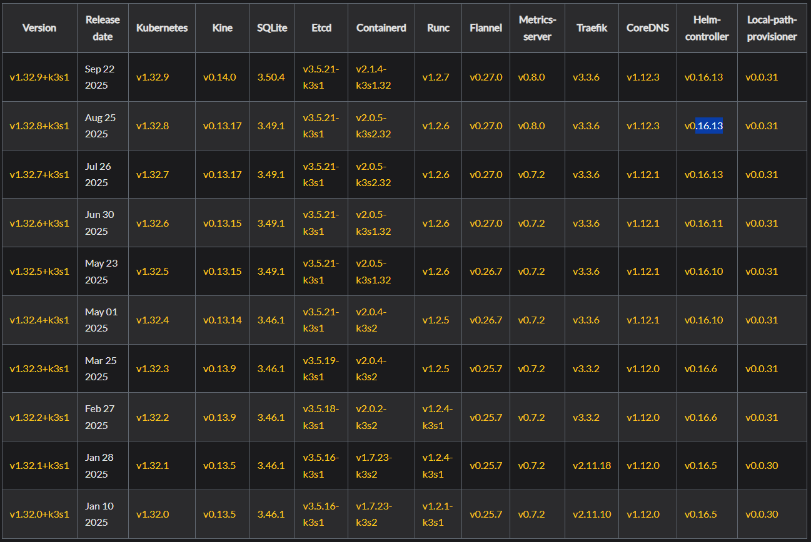

*Table 2: Dependency matrix for k3s version 1.32.X* *[90]*

k3s provides an installation script that is a convenient way to install it as a service on systemd based systems. To install the latest K3s in the Raspberry Pi (for specific version set environmental variable INSTALL_K3S_VERSION=vX.Y.Z+k3s1), the following command is executed: “curl -sfL https://get.k3s.io | sh -”

After running this installation:

* The K3s service will be configured to automatically restart after node reboots or if the process crashes or is killed
* Additional utilities will be installed, including kubectl, crictl, ctr, k3s-killall.sh, and k3s-uninstall.sh
* A kubeconfig file will be written to /etc/rancher/k3s/k3s.yaml and the kubectl installed by K3s will automatically use it

A single-node server installation is a fully-functional Kubernetes cluster, including all the datastore, control-plane, kubelet, and container runtime components necessary to host workload pods. Adding additional server or agent nodes is an option if there is a strict requirement for additional capacity or redundancy to the cluster. However, single-node server installation is considered ideal for this proof of concept.

The last needed provisioning for the k3s installation in a resource restrictive environment is to limit the amount of RAM that can be allocated to it.

A file is created in /etc/systemd/system/k3s-memory-limit.slice:

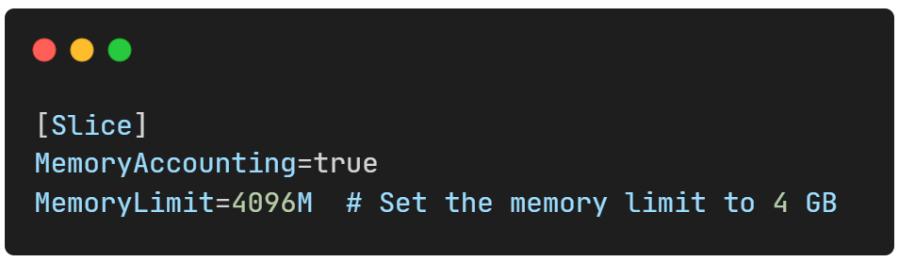

*Code snippet 5: Slice definition in systemd for k3s memory limits*

The k3s service specs under /etc/systemd/system/k3s.service are edited:

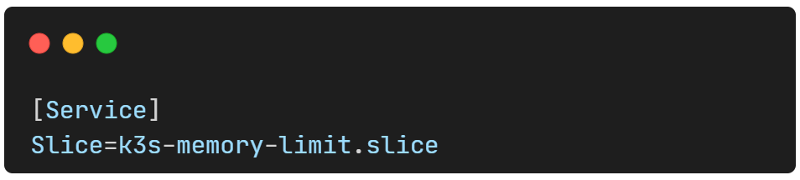

*Code snippet 6: k3s service override assigning k3s to the custom slice*

k3s is reloaded by executing commands a) systemctl daemon-reload, b) systemctl restart k3s

### Enabling Device plugin to mount camera

Enabling hardware device access within the NMF Supervisor’s Platform Services requires the use of the Kubernetes Device Plugin API, the optimal method for exposing such hardware.

A Generic Device Plugin implementation [91], utilizing Kubernetes Device Plugin framework, is adopted. This enables allocating generic Linux devices, such as serial devices or video cameras, to Kubernetes Pods and allows devices that don't require special drivers to be advertised to the cluster and scheduled.

To install the generic-device-plugin a Daemonset manifest [92] is included in the helm chart that defines all the appropriate Linux directory paths in which each device is expected to be available from the host machine. Then in the Supervisor helm chart video device capture allocation is enabled for the Supervisor pod. Thus when referring to the “/dev/video0” directory from within the Supervisor app then the host machine’s published directory is used.

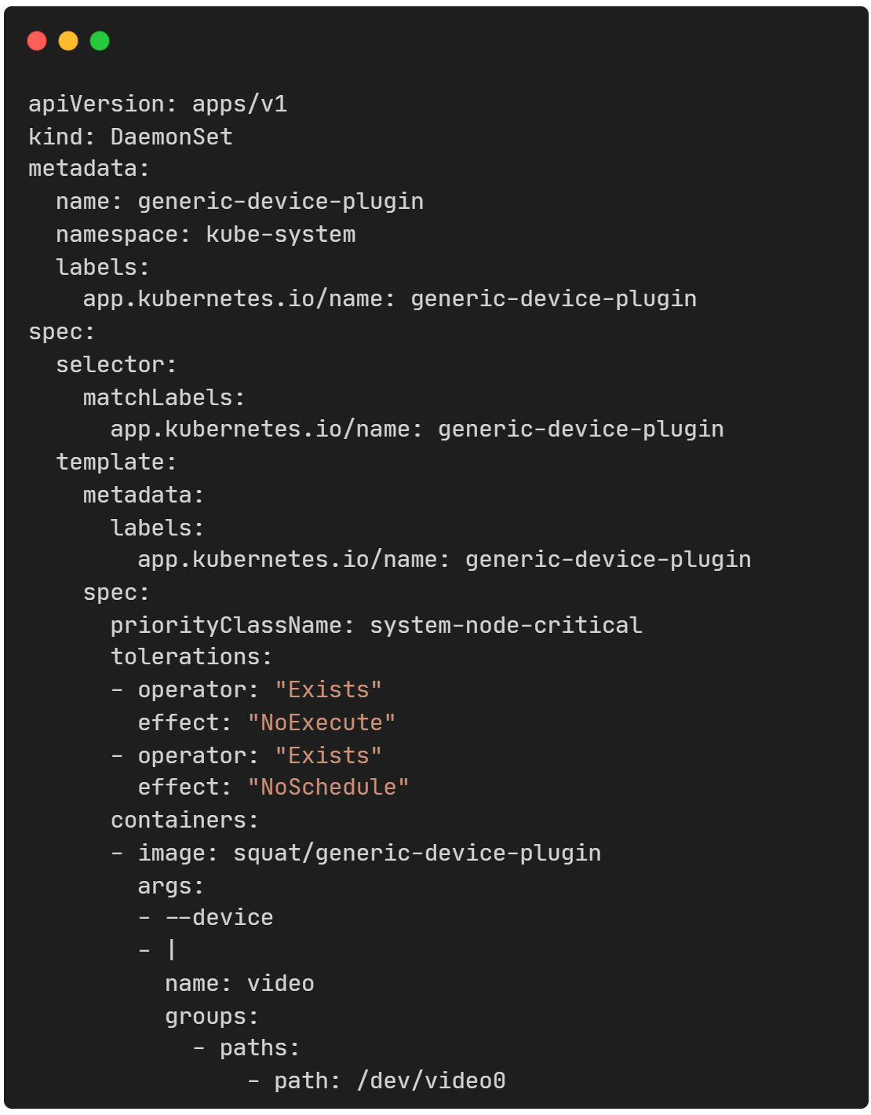

*Code snippet 7: Part of generic device plugin DaemonSet manifest added in helm chart*

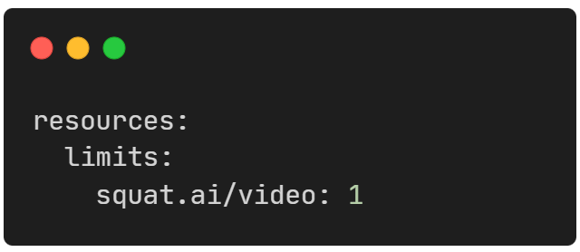

*Code snippet 8: Enable video device capture allocation in Pod manifest*

### CI/CD pipelines

An Ansible role [93] - a reusable automation unit that defines tasks and configurations - is used to install MicroK8s on an Ubuntu virtual machine, where Jenkins will also be deployed. The role is customized to override default settings, specifically modifying the API server’s secure port configuration.

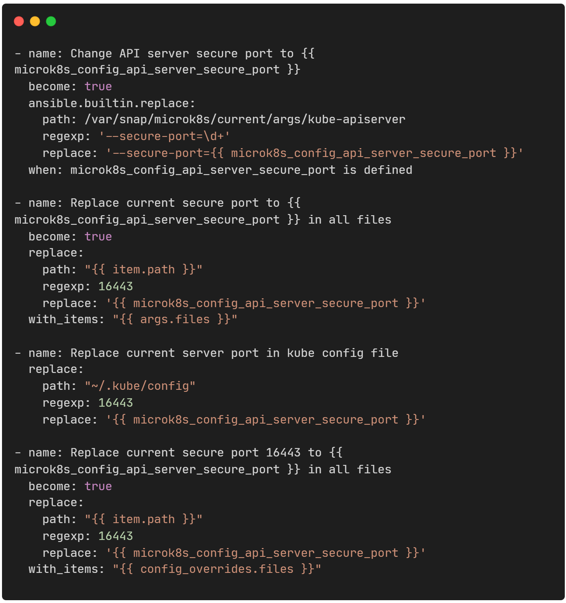

*Code snippet 9: microk8s secure port overridden in Ansible role*

This step requires the prior installation of Ansible package in the VM and execution of a playbook that runs the customized microk8s Ansible role, using the command “ansible-playbook playbook.yml”.

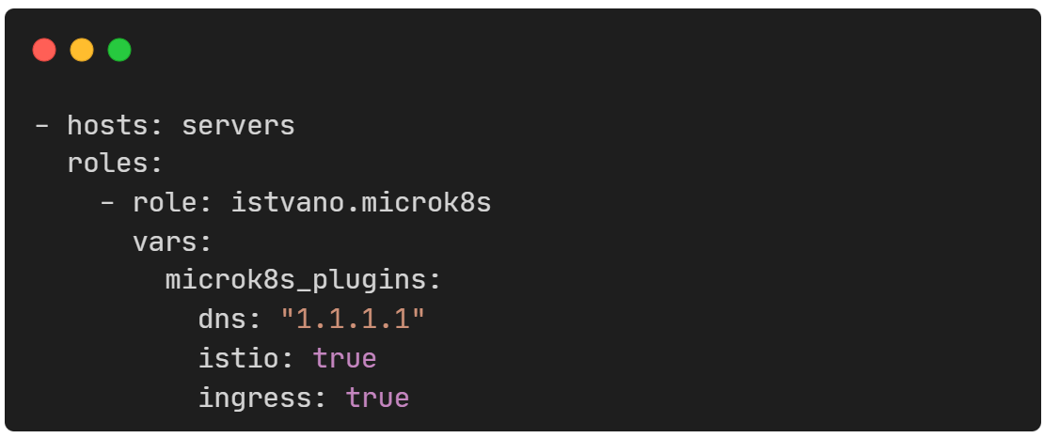

*Code snippet 10: Playbook to run Ansible role for microk8s*

After the microk8s cluster creation, Jenkins is deployed in it using helm charts. The appropriate values.yaml and Jenkinsfile files are provided to define the pipelines for building NMF apps, exporting them as tarballs and scheduling their deployment-transfer to the satellite.

## Packaging and Standardization: Add dockerfiles and Kubernetes Helm Charts

Three distinct Dockerfiles have been created to support the Supervisor, Space, and Ground applications container image creation. Each Dockerfile employs a two-stage approach: the first stage uses a Maven 3.8.1 with JDK 11 image to build fat JARs from the repository, ensuring consistent and reproducible builds. The second stage leverages the Eclipse Temurin JRE 11 (Jammy) distribution as a lightweight runtime environment for the deployed containers.

While all Dockerfiles retain a similar approach, each file incorporates its own set of configuration files, environment variables, and service-specific adjustments, enabling tailored behavior for each component while maintaining a unified build and deployment strategy. All Dockerfiles specify the platform option used to produce container images compatible with ARM64 architecture, thus compatible with Raspberry Pi and Cyclone V SoC FPGA. Instead, in the Supervisor Dockerfile additional libraries required for hardware integration are installed, therefore v4l-utils and fswebcam are included to support the Raspberry Pi FS Camera Adapter.

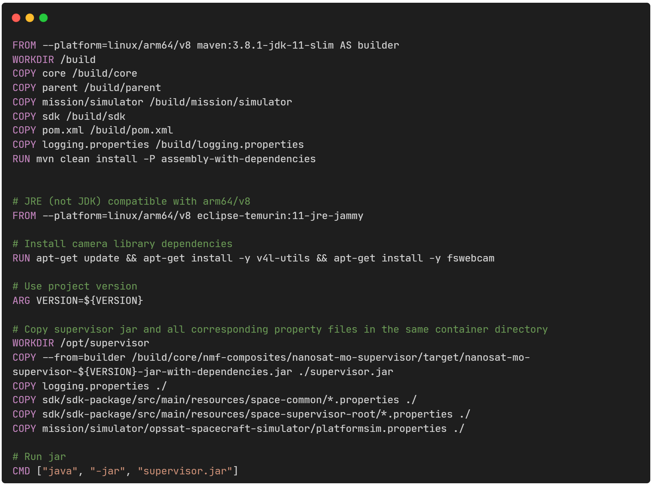

*Code snippet 11: Dockerfile for Supervisor*

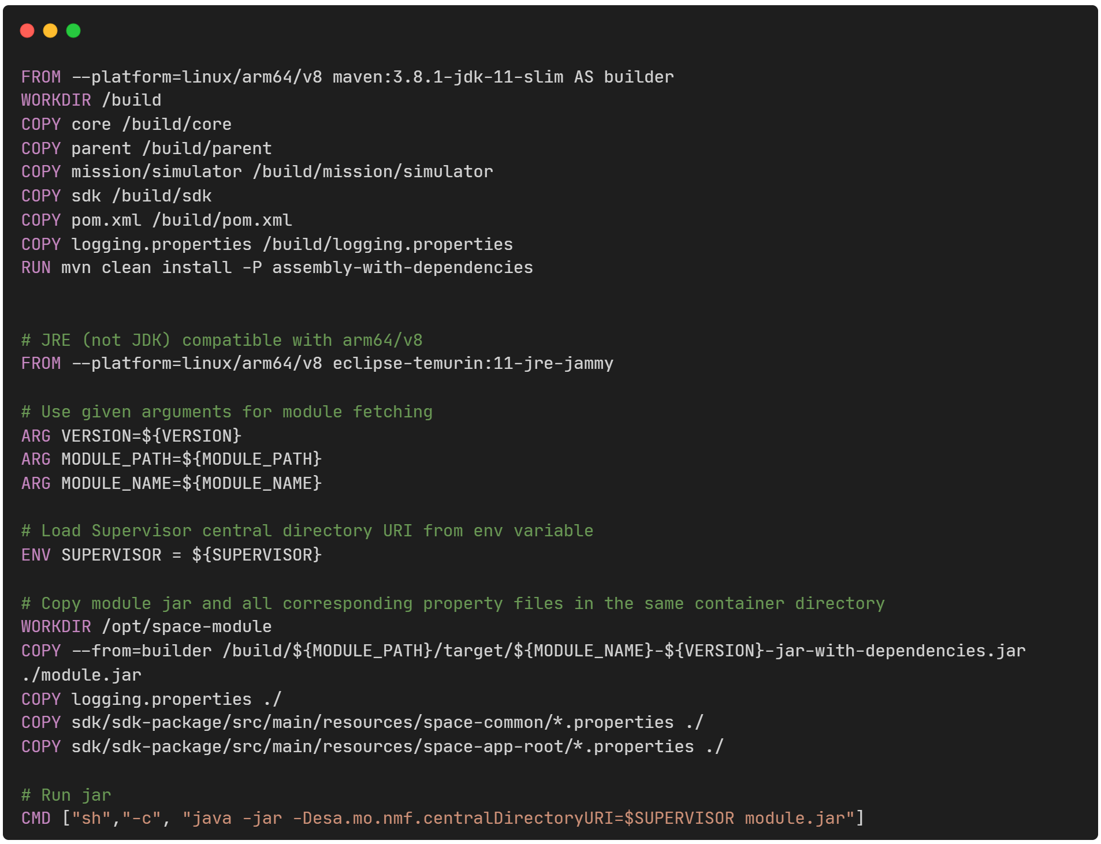

*Code snippet 12: Dockerfile for space app*

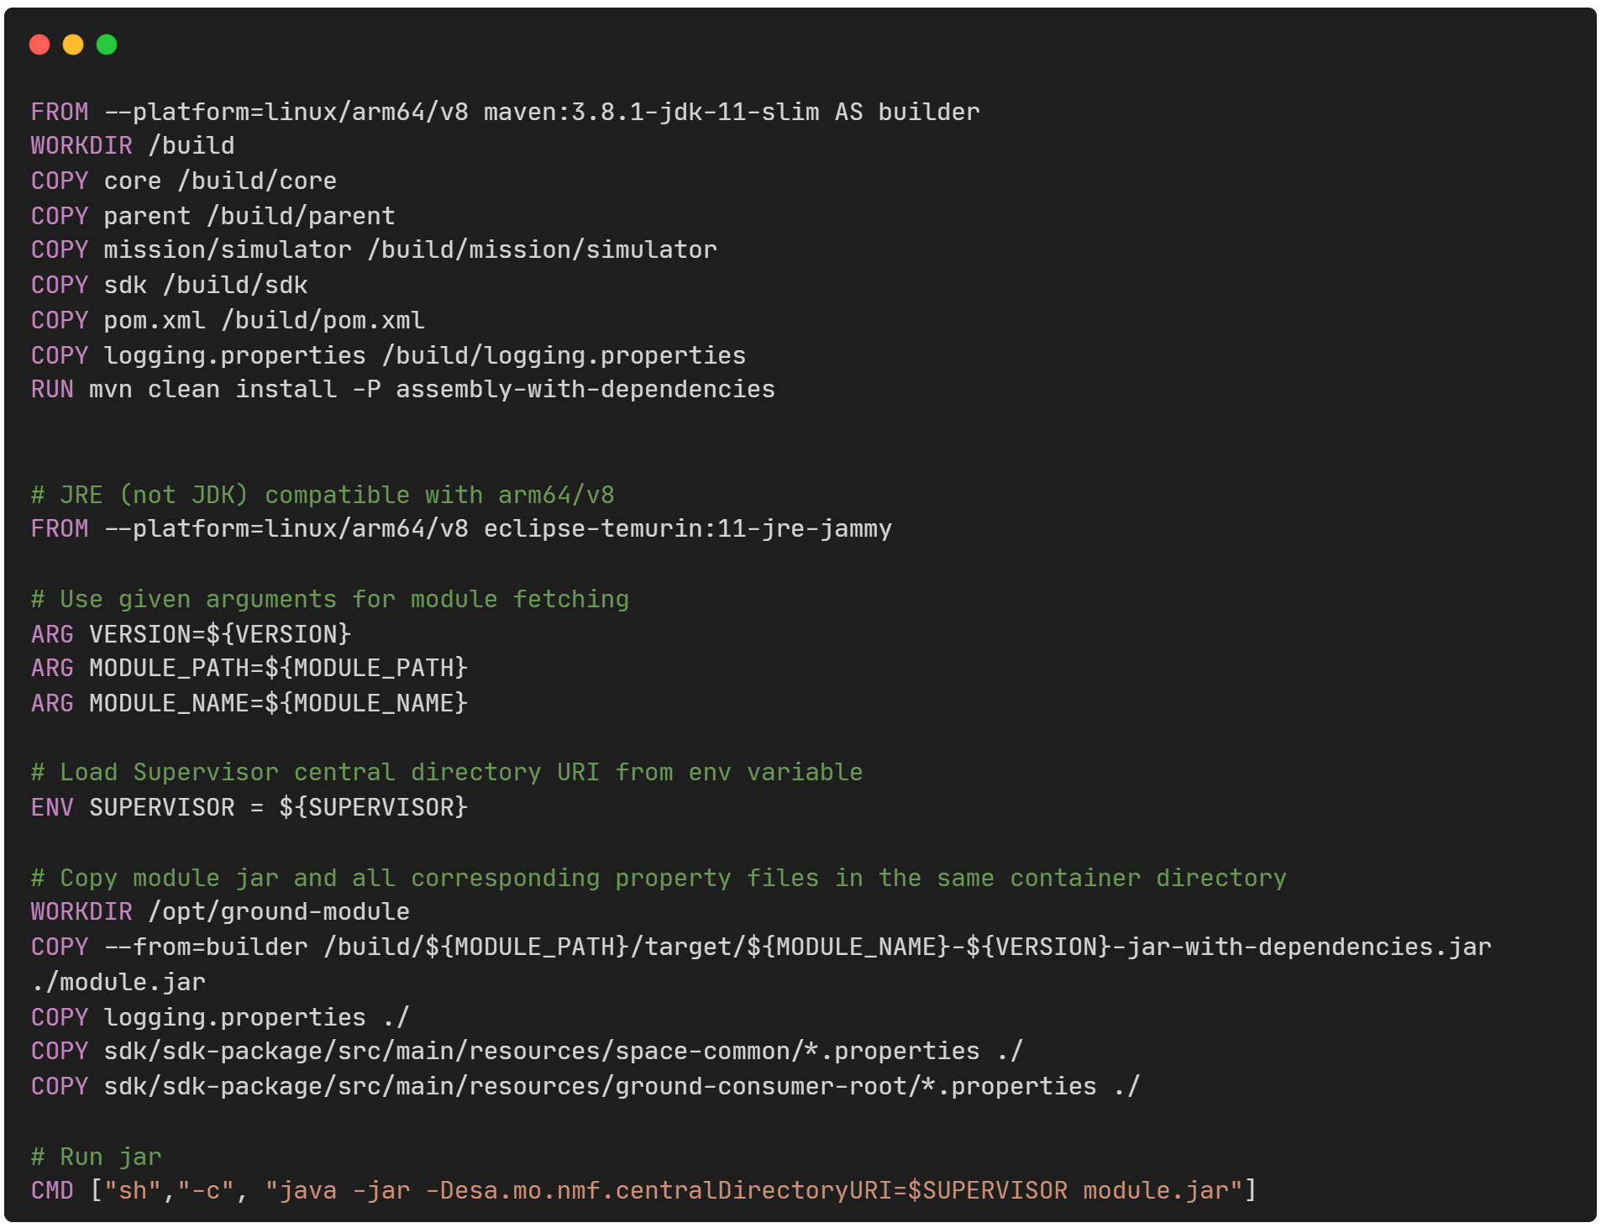

*Code snippet 13: Dockerfile for ground app*

Standardization of the deployment process is further guaranteed through the implementation of Helm charts [94], with two types defined: one tailored to the Supervisor and another shared among the Space applications. Each chart template helps provision the Deployment, ConfigMap, Service (configured as NodePort when publicly exposed), and Horizontal Pod Autoscaler Kubernetes resource for the NMF services. Beyond deployment automation, Helm charts bring version control and reproducibility to the ecosystem, enabling different NMF components to be deployed, updated, or rolled back with minimal effort.

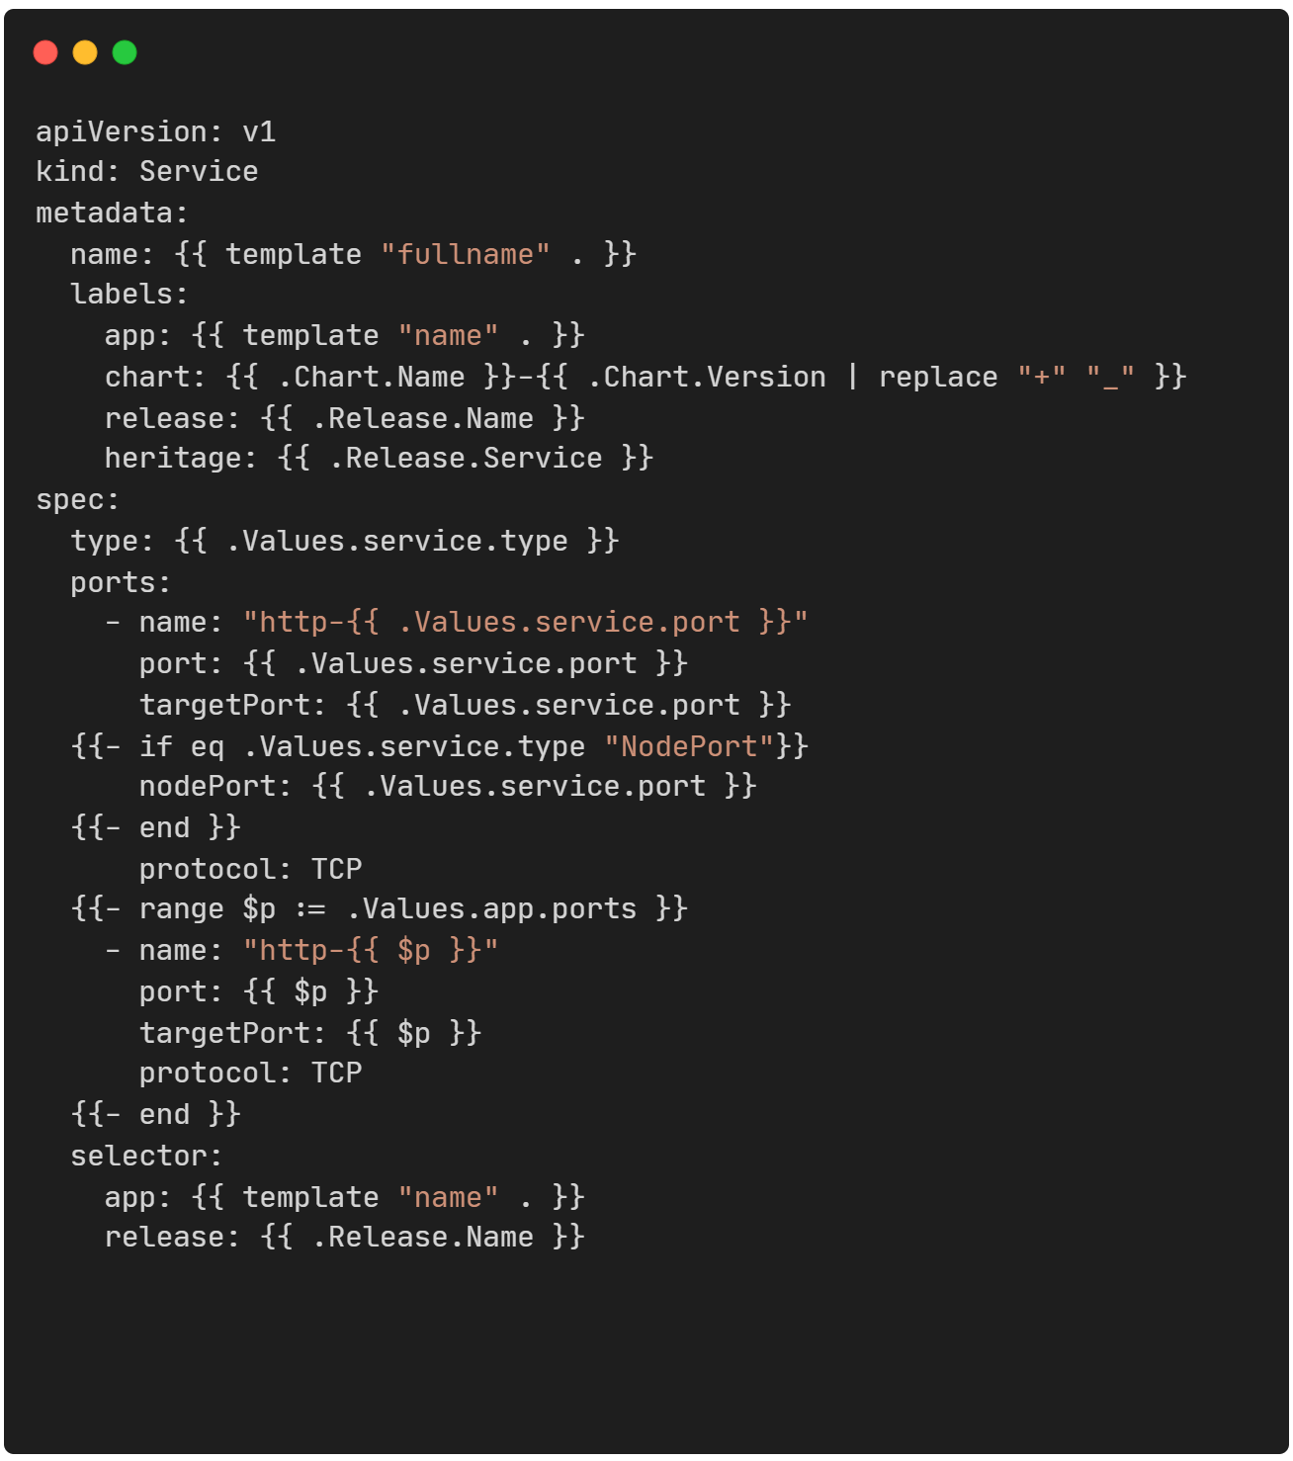

*Code snippet 14: Helm chart template for Service Kubernetes resource with Nodeport default*

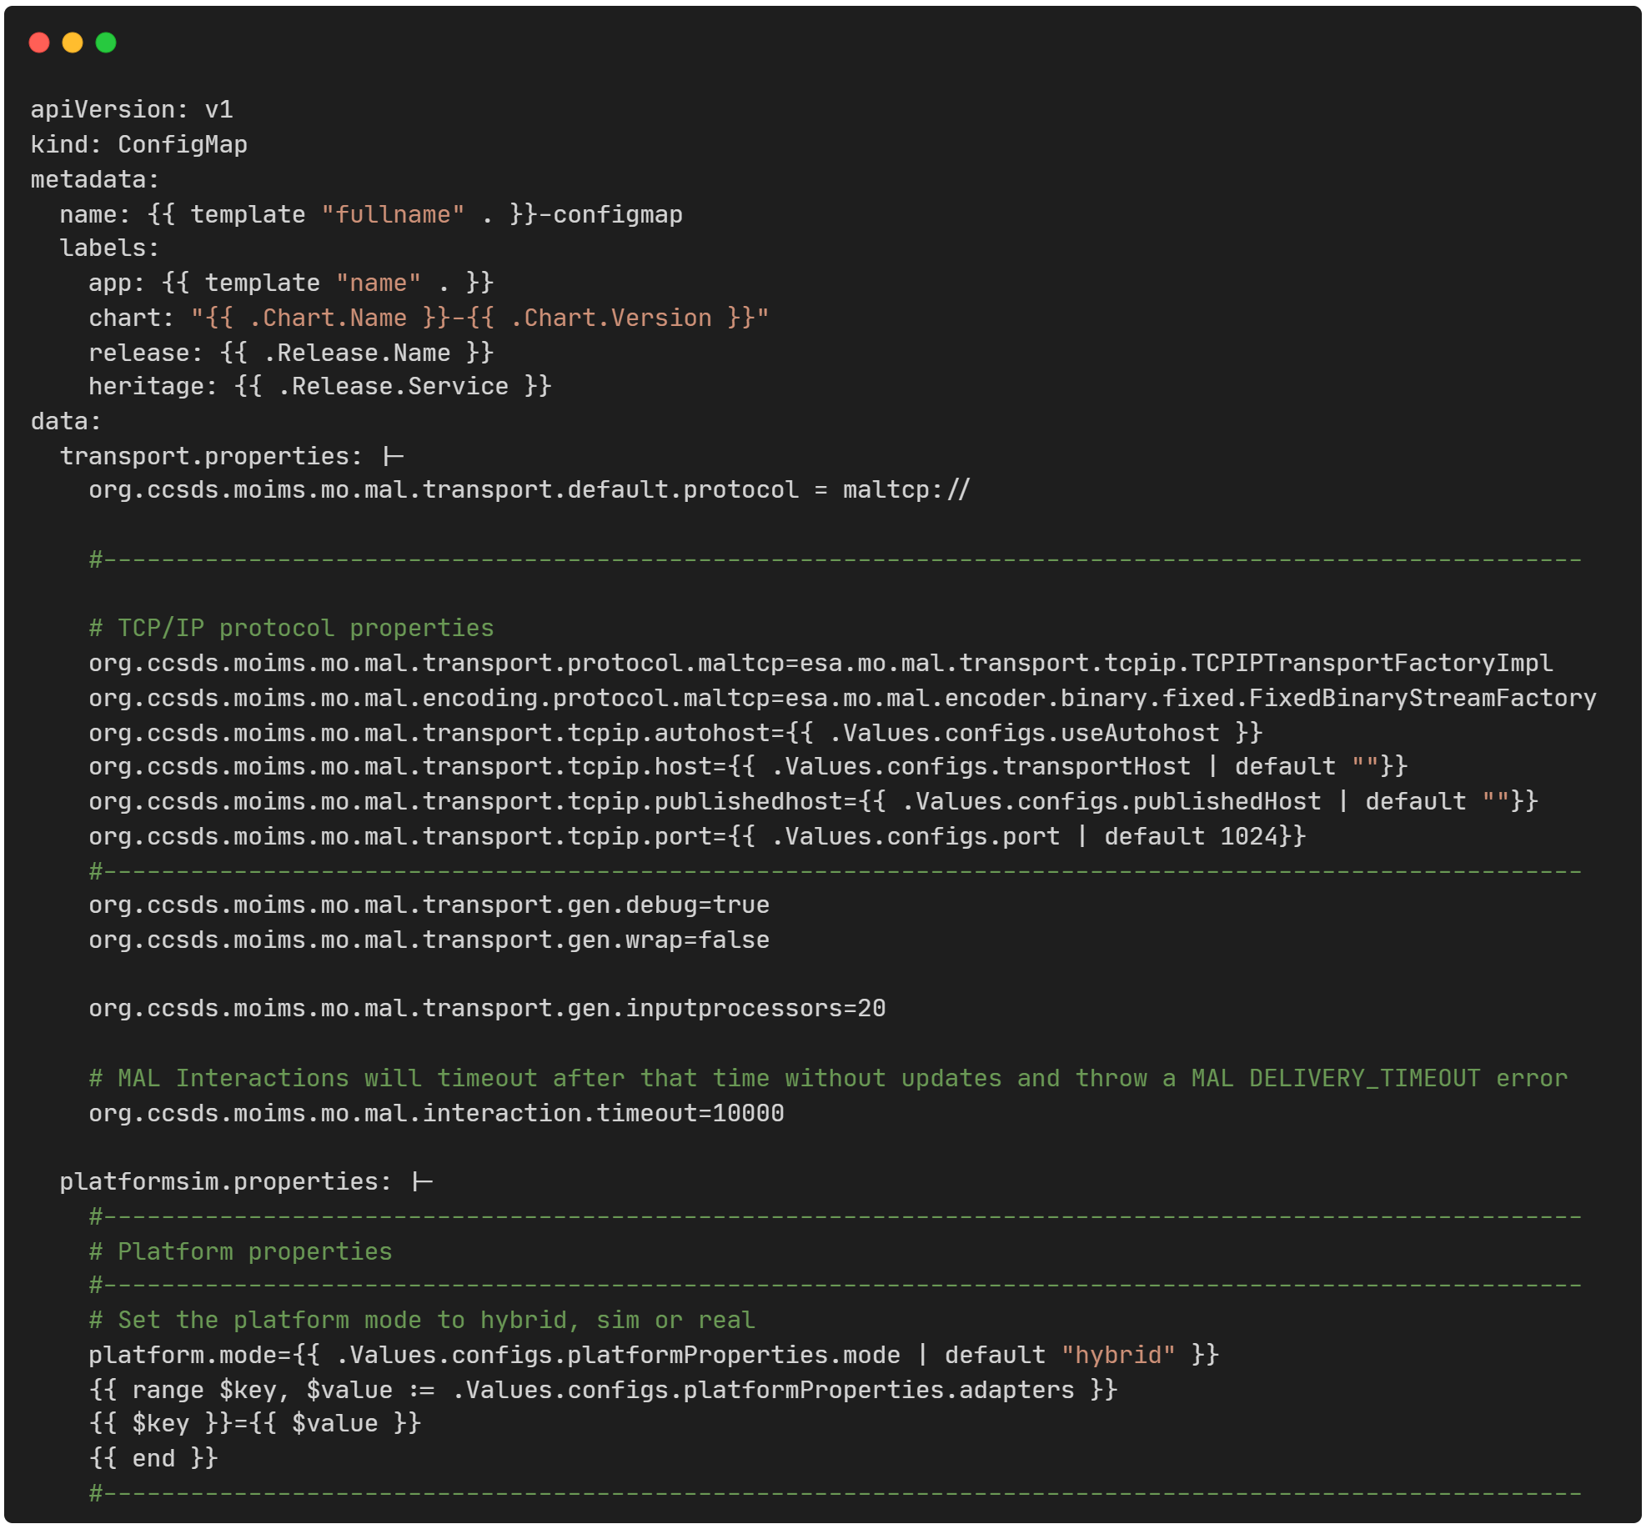

*Code snippet 15: Part of helm chart template for Supervisor Configmap Kubernetes resource*

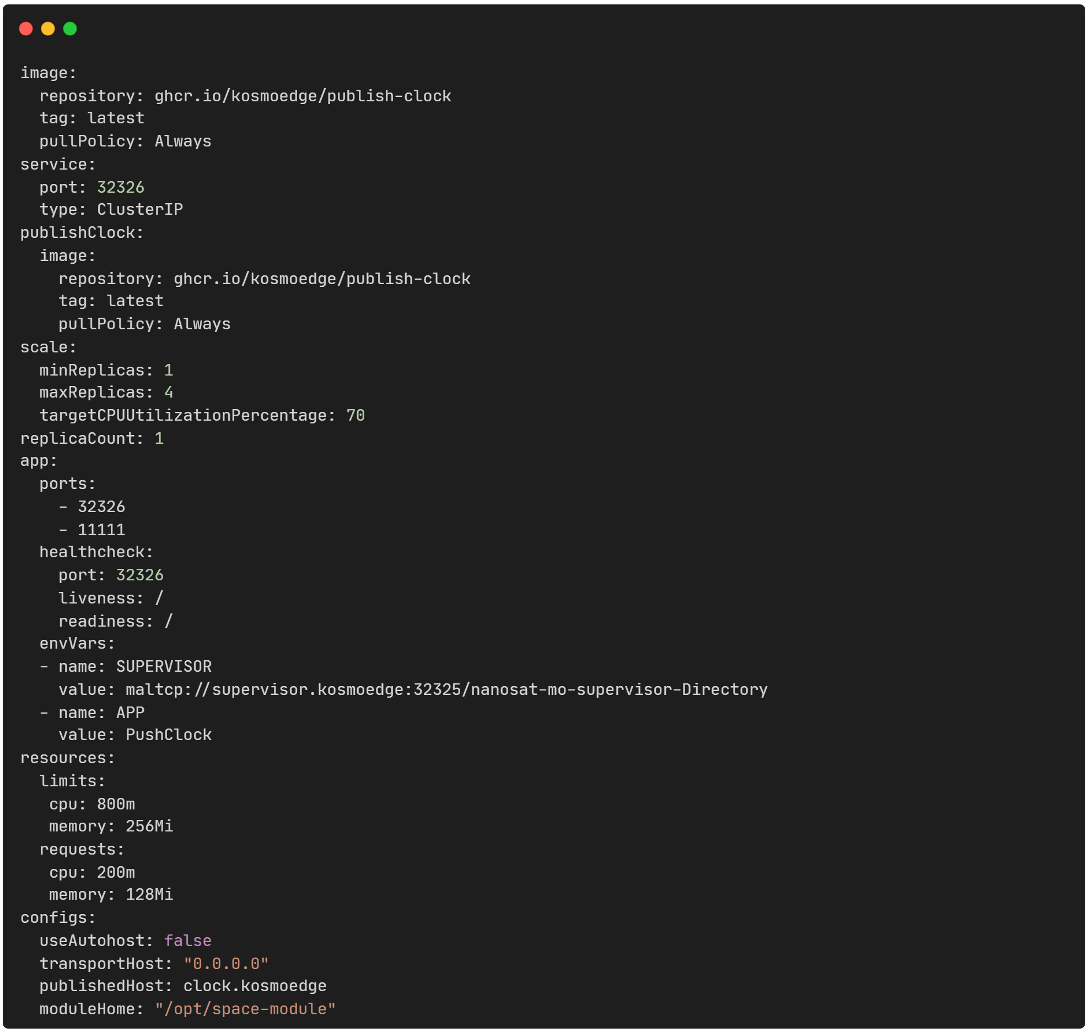

*Code snippet 16: Values.yaml that sets the values for the placeholders in helm templates*

## Development Productivity: Improve Local Development Experience

A Docker Compose file was created to automate the deployment of multiple containers, such as the Supervisor, a Space Camera app and a Space Clock app, thereby significantly improving the local development experience. By launching all services with a single command, the Docker Compose setup ensures a consistent and reproducible environment across different machines and allows developers to test the integration of multiple services.

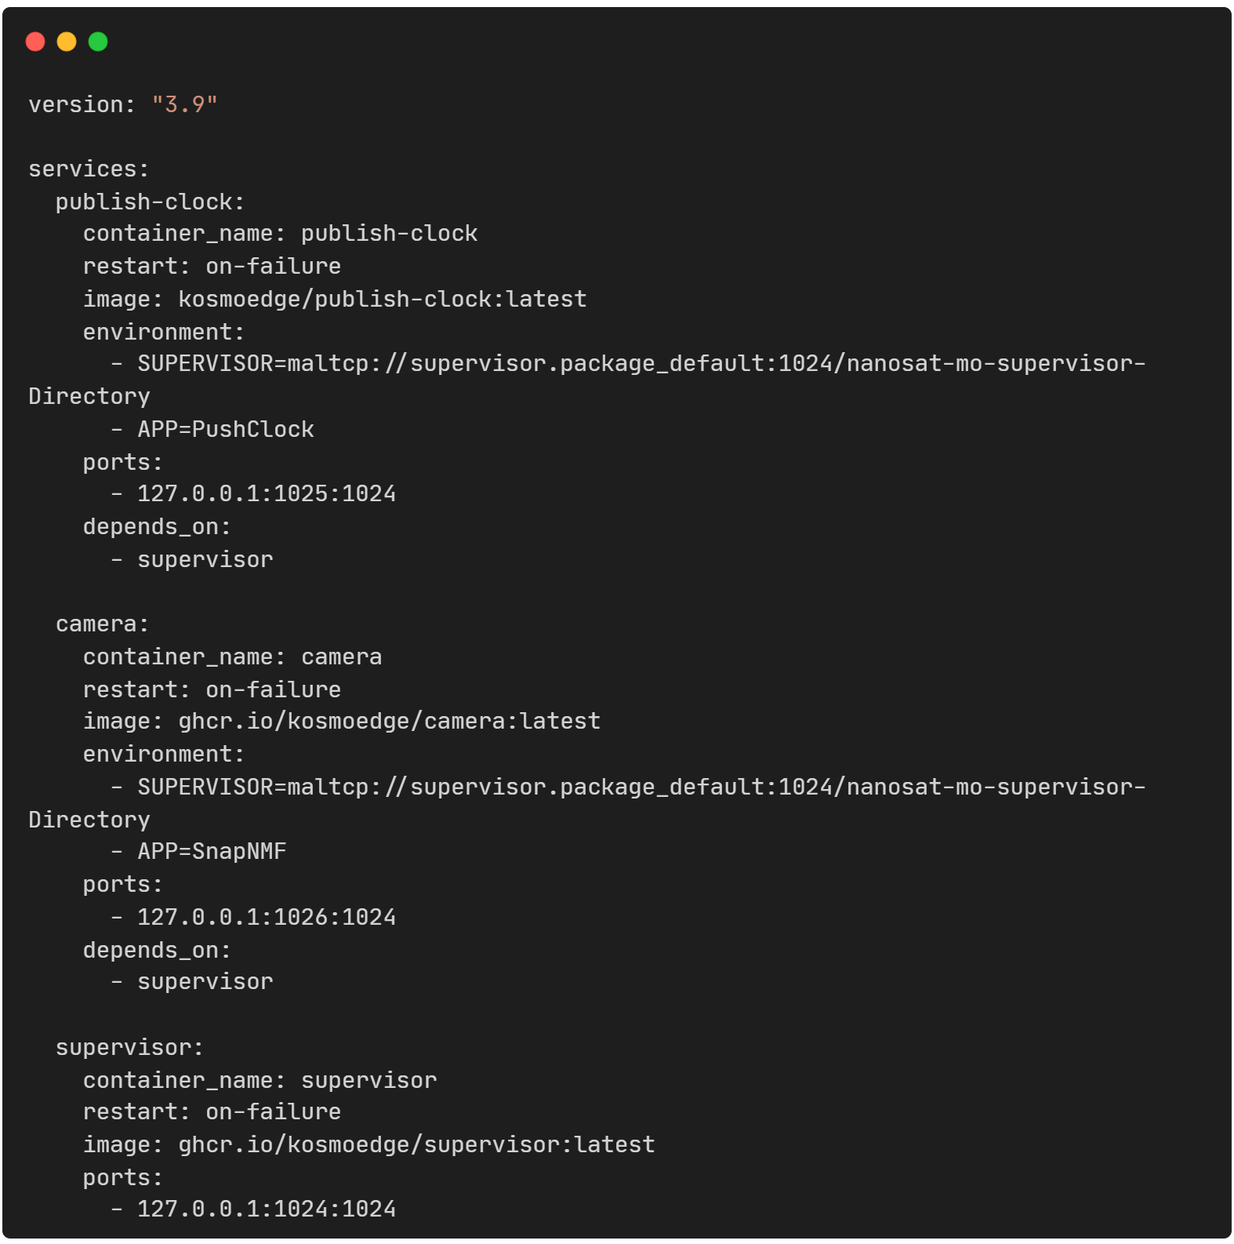

Code snippet 17: docker compose for local multicontainer deployment

Complementing this, a Makefile is provided to further simplify local development by offering streamlined commands to build and push container images to a registry for the Supervisor, Space, and Ground applications. It also includes Maven helper targets for generating “fat-jars” of the compiled services, compiling the consumer test tool, and running the containers via Docker Compose. Together, these files reduce manual setup steps, minimize errors, improve workflow consistency, and enhance productivity, making it easier for developers to focus on building and testing mission-critical components in a controlled, portable environment.

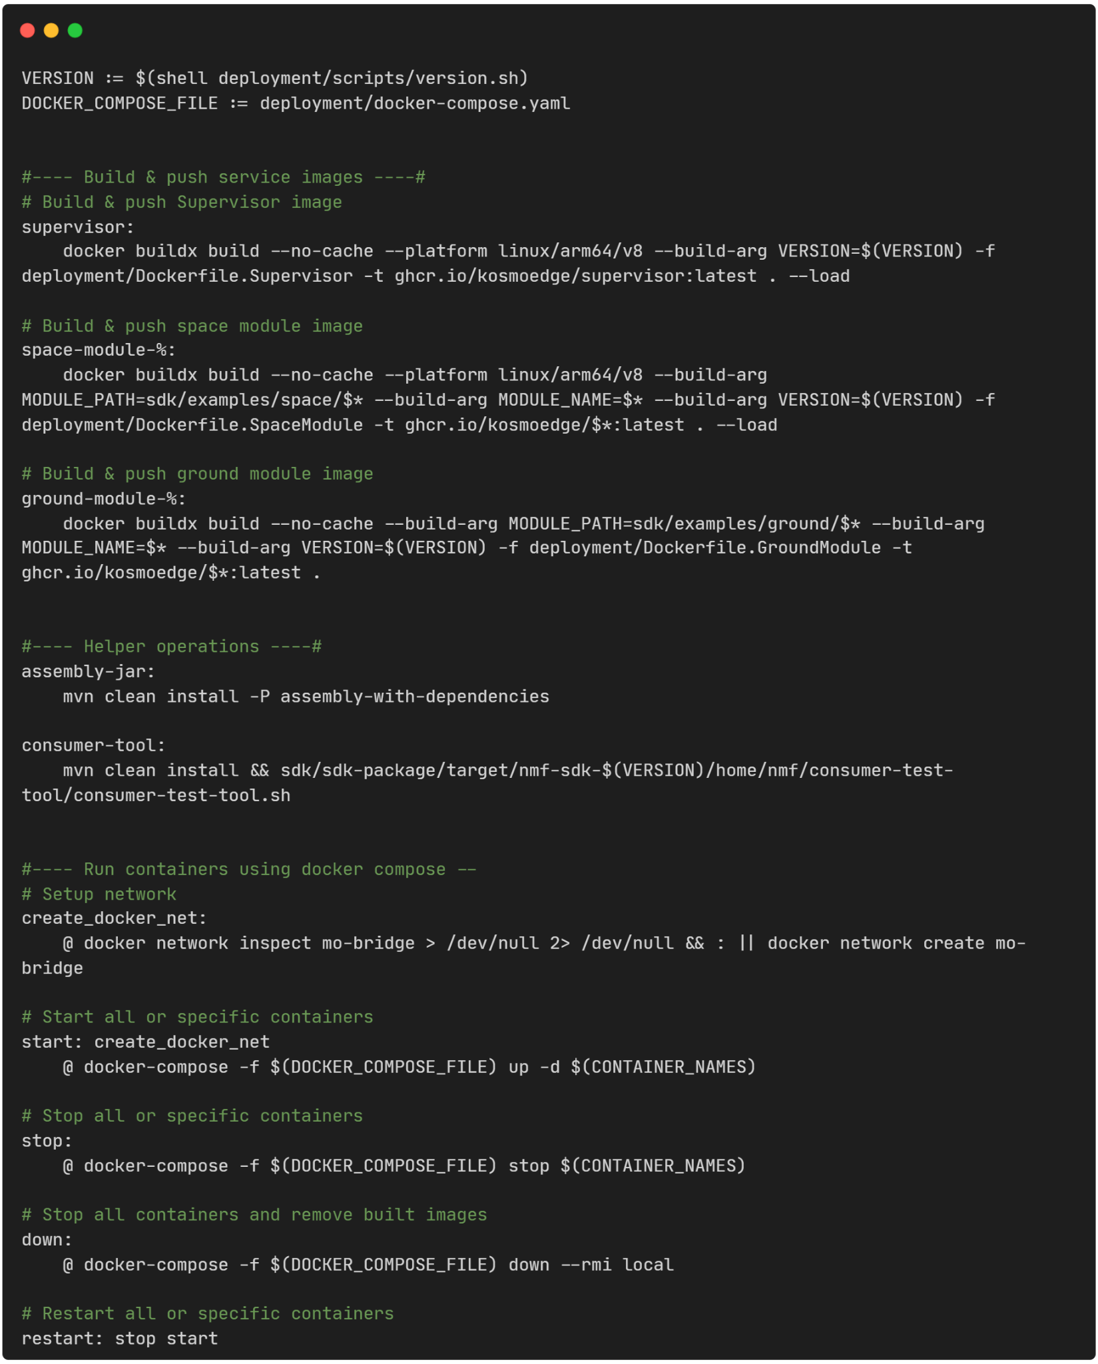

*Code snippet 18: Utilizing Makefile to streamline local development lifecycle*

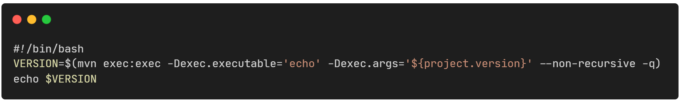

*Code snippet 19: Script to provide dynamic versioning in container image tags*

## End to end image capture, edge processing and ground storage: New NMF Space app & a NMF Ground app creation

In order to showcase an end-to-end system utilizing our new processes and infrastructure two NMF applications have been developed. The proof of concept ecosystem runs on a k3s cluster deployed on a Raspberry Pi, with the NMF Supervisor and NMF Camera Acquisition Space App deployed via Jenkins and Helm charts. The NMF Photo Storage Ground App operates on a development workstation.

1. NMF Space App captures snapshots on request using the Supervisor’s Camera Platform Service, processes the images on-board using Sobel filtering for edge detection, and transmits only the processed results to the ground application. Performing image processing in space significantly reduces data volume, minimizing downlink bandwidth requirements, as edge-filtered data is far lighter than raw imagery. Sobel filtering is selected for its efficiency in semantic edge detection in satellite imagery, keeping essential structural information rather than full images, achieving competitive results to deep learning methods with minimal computational cost [95].
2. NMF Ground App, built with the Spring Boot framework [96], receives the processed images and stores them locally through a configurable listener for incoming image data. It also provides a REST endpoint for communication with the space component.

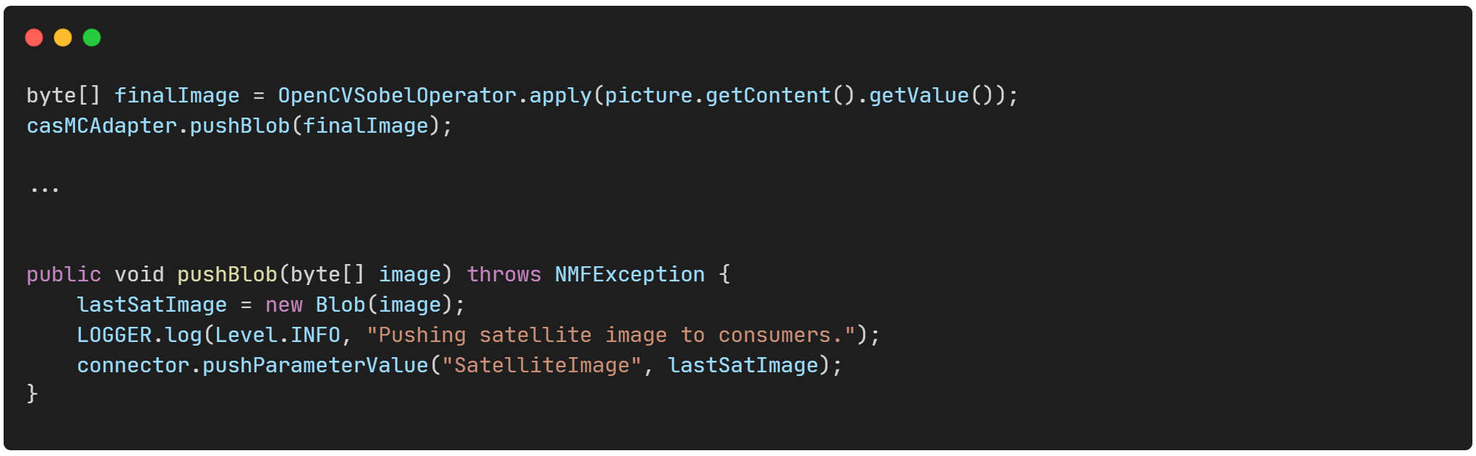

*Code snippet 20: Part of space camera app code to process image and push it downstream*

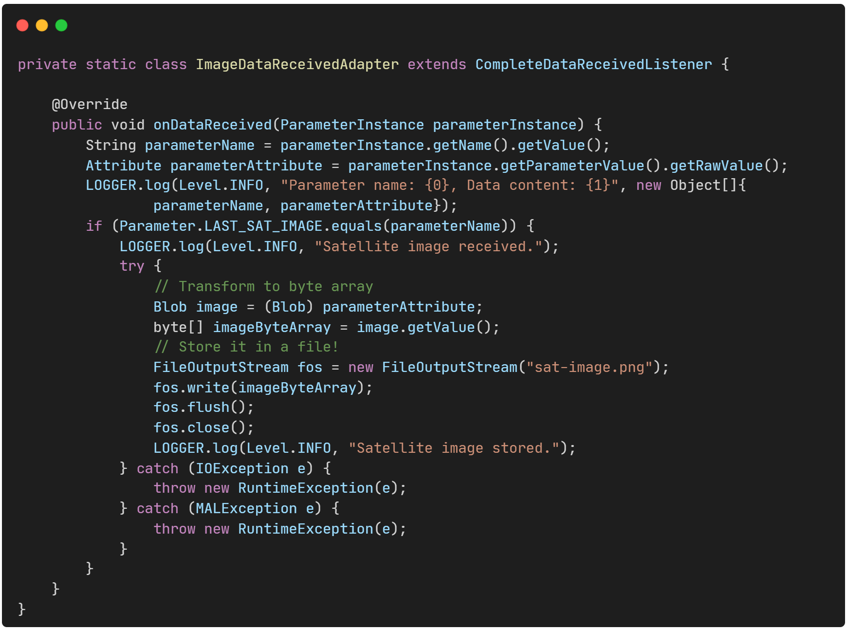

*Code snippet 21: ImageDataReceiverAdapter in ground app listening for incoming images*

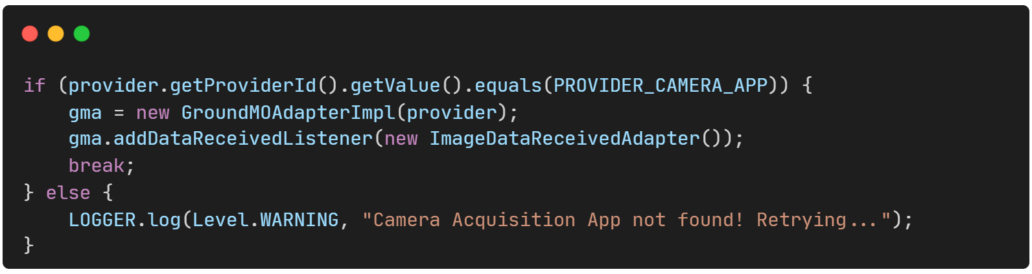

*Code snippet 22: ImageDataReceiverAdapter registration in NMF GroundMOAdapter*

A demo Java & Quarkus [97] based application is developed prior to adopting the final solution [98]. The application exposes a REST endpoint that receives commands to capture camera snapshots and process the images. It serves as a testbed for evaluating different image preprocessing techniques following a space edge computing approach.

Three distinct operators are implemented, each applying a different image processing algorithm:

* OpenCV Sobel Operator: applies Sobel filtering using the OpenCV library [99] to detect intensity gradients and emphasize edges. The operator leverages OpenCV’s optimized convolution routines.
* K-means Operator: based on OpenCV library, performs unsupervised clustering on image pixels based on color or intensity. By partitioning the image into k clusters, this operator reduces image complexity and highlights regions of interest, supporting tasks such as segmentation or object boundary detection [100].
* Native Sobel Operator: implements Sobel filtering directly in Java without third-party dependencies [101].

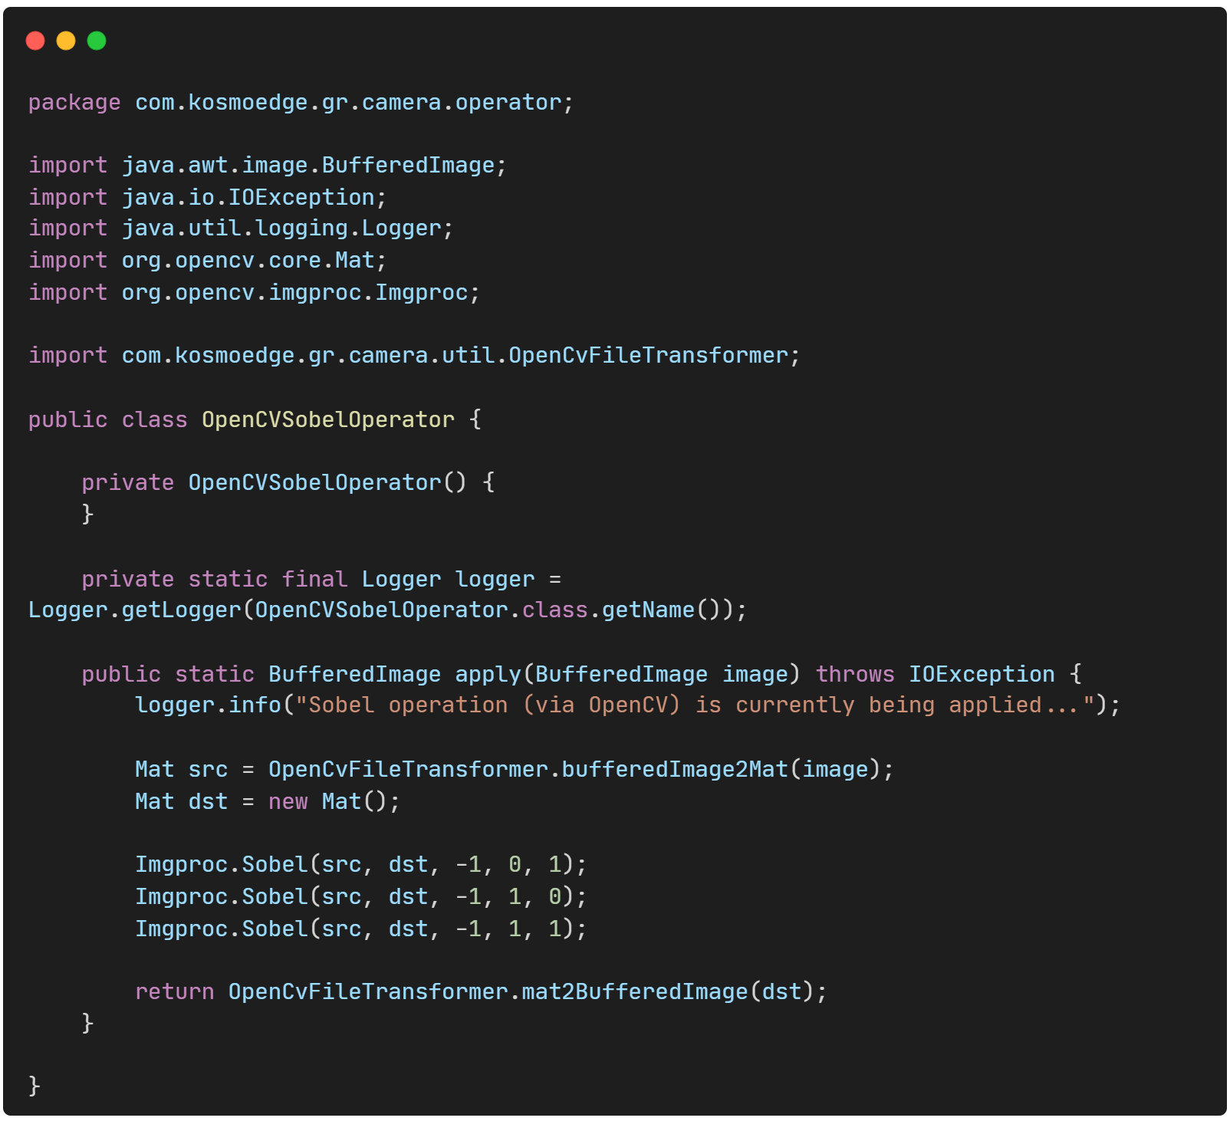

*Code snippet 23: OpenCV Sobel filtering operator*

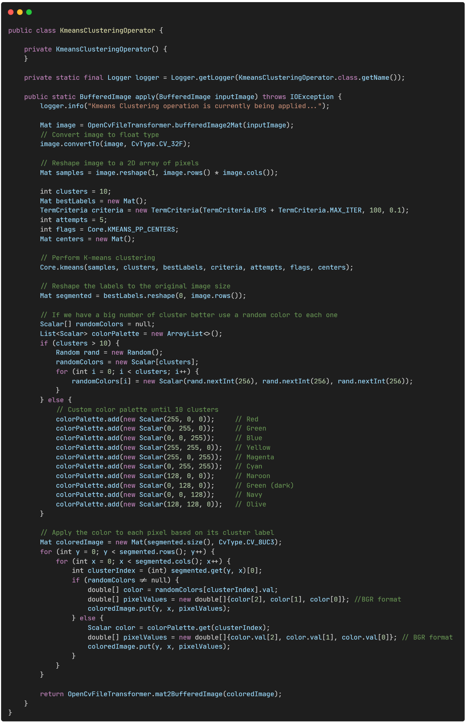

*Code snippet 24: OpenCV K-means clustering operator*

# VI. Evaluation

The expected value of this thesis is multi-dimentional. In general, the main value of this thesis was to open up a new way of thinking about architecture in space software and eventually help us create more scalable infrastructure. From that point of view we will evaluate the work of this thesis on the following:

* the resource utilization and the possible overhead that the proposed setup may or may not have, compared to the conventional architecture
* the new features in terms of productivity and resiliency that we get
* the software architecture break-throughs that the present research provides out of the box to be utilized in future designs

We will go through those aspects one by one and at the end we will have the final evaluation of the outcomes of this thesis.

## Resource Utilization and Performance Comparison to the Conventional Architecture

It is important to understand the costs or gains of the proposed architecture in terms of resources and performance. This way we can better evaluate the value it brings versus the costs.

**Evaluation Setup**

The evaluation process is conducted primarily on a Raspberry Pi, which hosts both a new NMF architecture running on k3s and a conventional NMF installation running in the JVM. Each installation is alternately deactivated while metrics are collected from the other to ensure consistent measurement conditions.

**Collecting metrics**

The system is already loaded (only 2G of total memory), so the use of a full-blown metrics collector is avoided. Instead, a lightweight monitoring tool is preferred to minimize overhead. A possible reduction in granularity is considered acceptable, as the objective is not an in-depth performance analysis but rather a high-level overview of resource utilization during defined test periods and workloads. Thus, the Linux tool vmstat [102] is selected for this goal.

Pros of vmstat:

* Lightweight
* Provides overview of many system aspects
* Easy to run and configure
* Real time data

Cons of vmstat:

* Limited Granularity, not many details about root cause of utilization
* System Specific, no app usage
* Raw output

The command used is vmstat -a -SM -w -t 1 30 | tee vmstat.log. The command options used are:

* **-a**: Activates the "active/inactive" memory reporting. Instead of just showing free and buffer/cache memory, it provides more granular details:
  + **inactive**: The amount of inactive memory, which is memory that has been accessed but hasn't been used recently and can be reclaimed by the kernel without a major performance penalty.
  + **active**: The amount of active memory, which is currently in use and is less likely to be swapped out.
* **-S M**: Specifies the unit for memory reporting. The -S flag changes the scaling, and M sets it to **megabytes**. By default, vmstat uses kilobytes.
* **-w**: Activates wide output, ensuring that columns are not truncated, which is helpful when dealing with larger numbers or multiple data points.
* **-t**: Prepends a **timestamp** to each line of the output, making it useful for analyzing trends over time and correlating performance spikes with specific events.

The metrics are collected every 1 second over a period of 30 seconds. Using the pipe (|) results are exported to the vmstat.log file.

To create the visualization we initially used the [vmstat-visualizer](https://knziiy.net/vmstat-visualizer/) tool. However, this tool did not exactly meet our needs (it worked with specific vmstat flags and did not have a comparison feature). So we created our own cli tool [103] specifically for this thesis.

**Test Scenarios**

We wanted to test the added overhead of our implementation. This is why the basic tests involved running NMF on k3s and on conventional JVM. Also, we ran Raspberry Pi without any NMF payload so we can have a view of our initial resource utilization. Additionally, we tested a case that is enabled with the new architecture of running an NMF app without the presence of the supervisor module at all.

Here are our test cases:

1. Collect metrics when no payload is running
2. Run NMF on k3s and collect metrics for the following scenarios with NMF module:
   1. Normal run, no action
   2. Collect metrics for accessing the camera and taking 3 consecutive jpg snapshots
   3. Run with application stopped (only benchmark supervisor)
   4. Run with NMF application that does not need supervisor (clock) and perform 3 actions with supervisor stopped
3. Run conventional NMF in JVM (without Kubernetes):
   1. Normal run, no action
   2. Collect metrics for accessing the camera and taking 3 consecutive jpg snapshots
   3. only supervisor?

### 

### Collect metrics when no payload is running

In this scenario we wanted to benchmark the Raspberry Pi itself without running any workloads or other actions.

**Raw Metrics**

Here are the raw metrics that we took for this case:

|  |
| --- |

**Graphs**

Below you can check out the graphs for CPU - Memory and Disk and a small comment on the metrics.

*CPU*

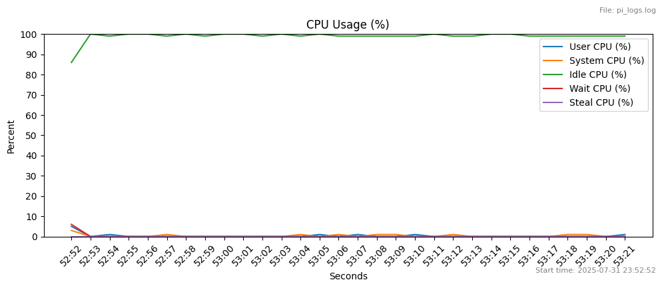

Since most of the time cpu was idle we removed the idle metrics from the graph to see what else we could see.

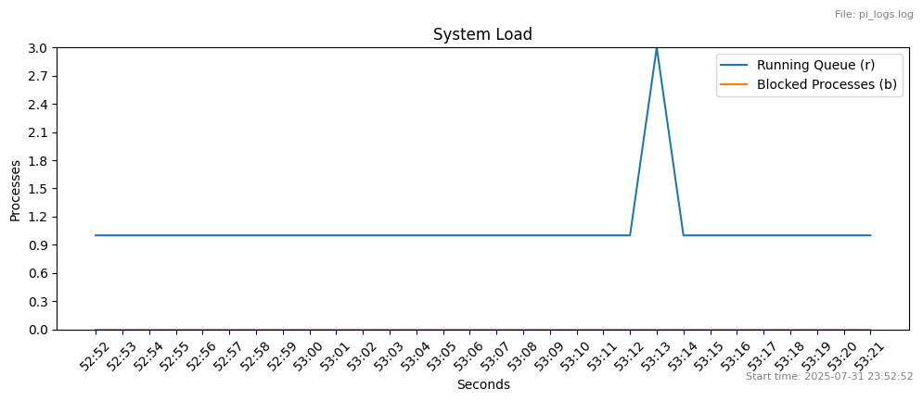

Overall, the CPU is consistently idle, with **99-100% idle time (id)** for most of the period. The user (us) and system (sy) CPU usage is minimal, indicating no significant application or kernel processes are demanding CPU time.

The number of runnable processes (r) is consistently low, with at most 2 processes waiting for CPU time. This confirms that the system is **not under any significant load**.

*Memory*

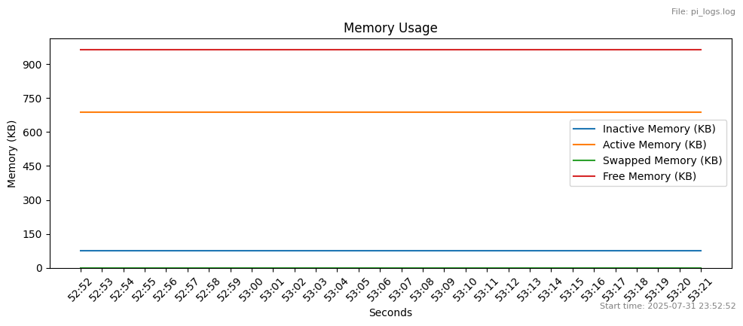

Since most of the memory is in cache, we removed cache from the graph to see if we could get more insights.

Memory usage is **stable** and well-managed. There is a large amount of **free memory (967 MB)**, and no data is being swapped to or from disk (**swpd, si, and so are all zero**). The little swap spike is to compressed memory and not disk.

*Disk*

Here is a breakdown for disk metrics based on disk swap and disk io.

*Swap*

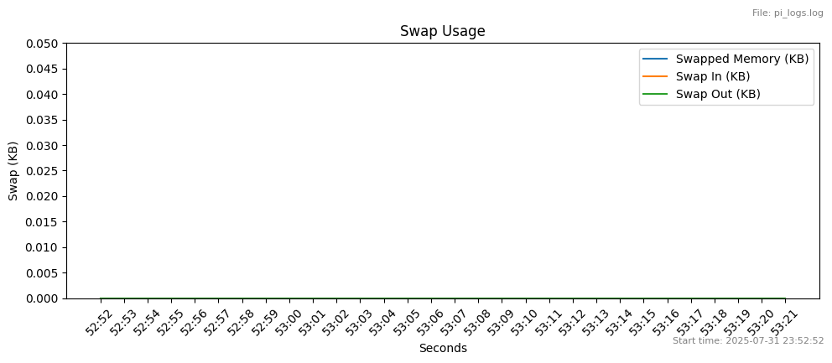

*IO*

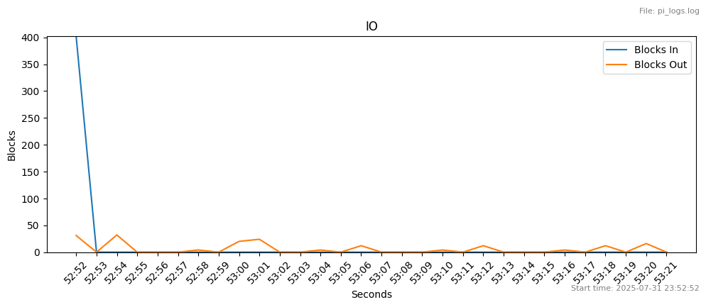

Disk activity is **sporadic and minimal**. While there are a couple of small, brief spikes in block reads (bi) and writes (bo), they are short-lived and do not cause a sustained I/O wait (wa) on the CPU.

In this scenario the system looks to not be using many resources. Although, almost half of the available RAM (1 out of 2GB) is consumed probably from the Pi OS.

### 

### Run NMF on k3s and collect metrics for the following scenarios with NMF module

In this bundle of tests we test the utilization overhead imposed by running k3s and NMF apps on it to the system.

#### Scenario: No Action With K3s

In this scenario we wanted to benchmark the Raspberry Pi with k3s running and the NMF applications deployed but without running any action.

**Raw Metrics**

Here are the raw metrics that we took for this case: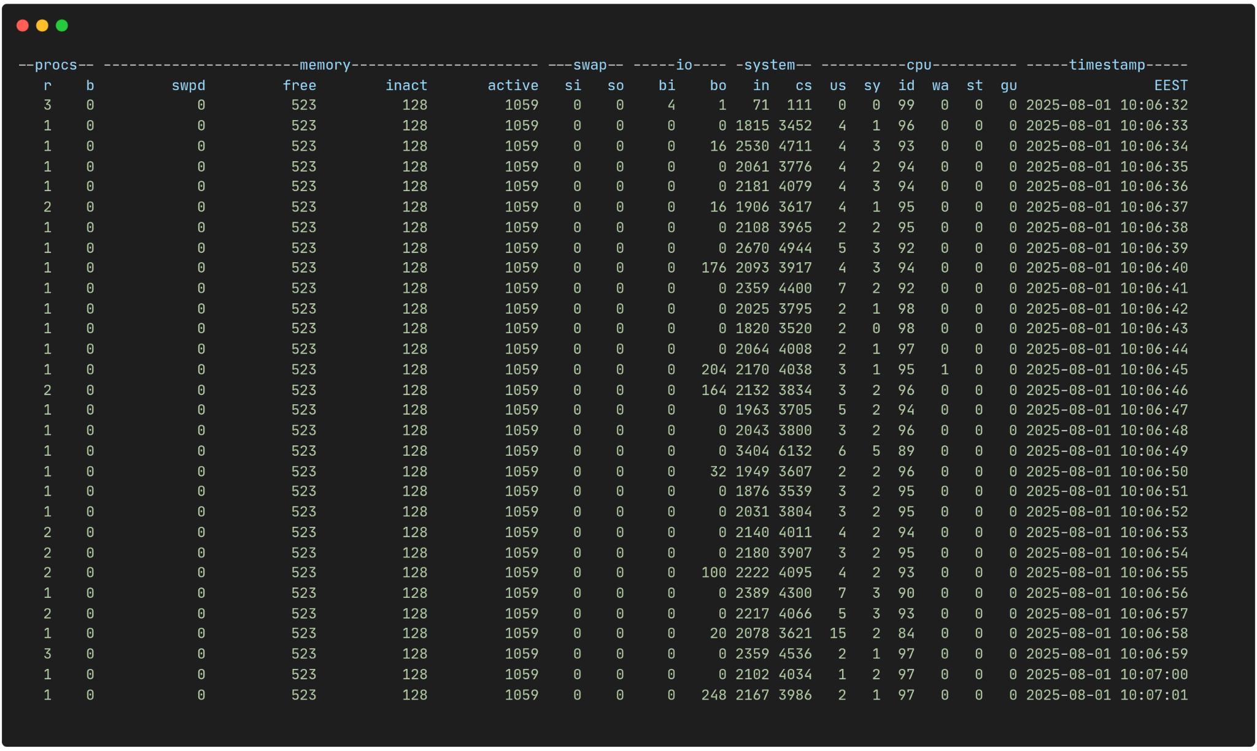

|  |
| --- |

CPU

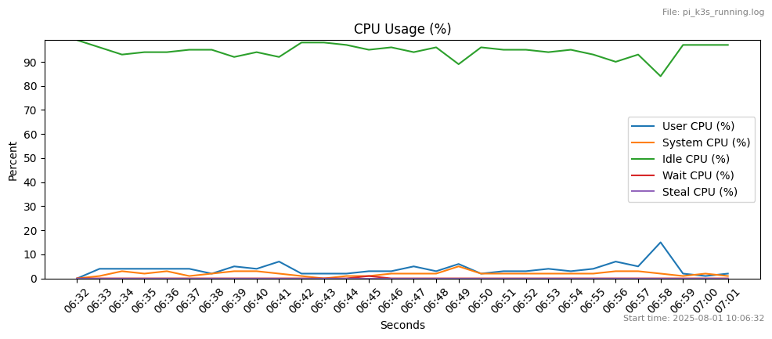

The system is idle for most of the time. Usually remains above 90%. User (us) and system (sy) CPU usage are low, rarely exceeding 7%. There is almost no waiting (wa) or stealing (st).

In the above graph we can see small peaks here and there and it is clear that only in 2 occasions total cpu usage exceeded 10%.

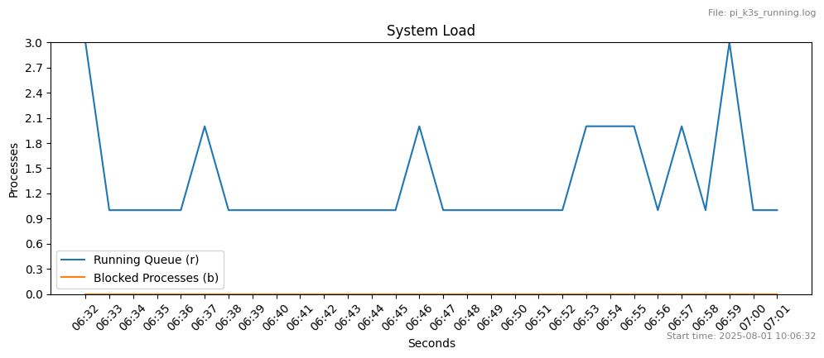

Memory

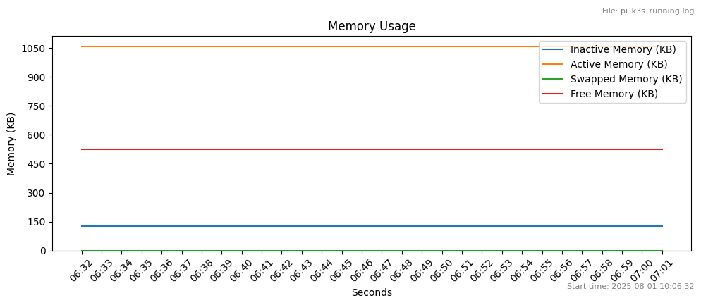

In the above graph we can see that the free memory is around 500Mb so compared to the scenario when no application was running (neither k3s or NMF on it) we have ~400Mb overhead.

Disk

Here is a breakdown for disk metrics based on disk swap and disk io.

*Swap*

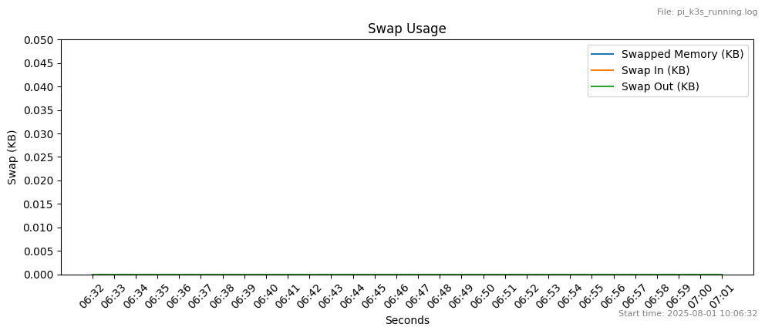

*IO*

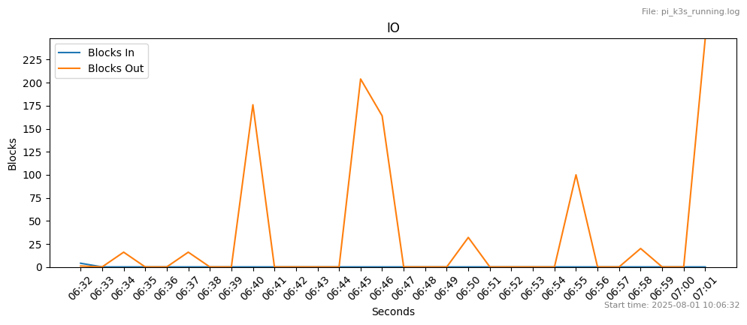

Disk activity remains low. However we can see an increase to the output (~300b) compared to the activity in the first example.

#### Scenario: Take a jpg snapshot with k3s on Raspberry Pi, with client running on workstation

In this scenario we wanted to benchmark the Raspberry Pi with k3s running and the NMF applications deployed but without running any action.

In these measurements the below are depicted:  
1) Consumer test tool connecting to supervisor module (optional, can connect directly to module)

2) The providers are discovered

3) The App’s Action provider is selected

4) The Action “TakeSnap.jpg” is submitted 3 consecutive times

**Raw Metrics**

Here are the raw metrics that we took for this case:

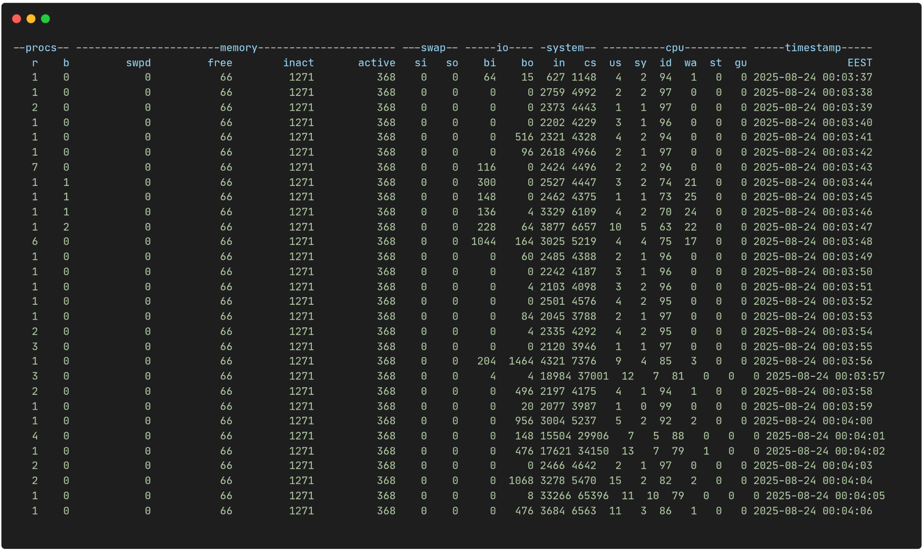

CPU

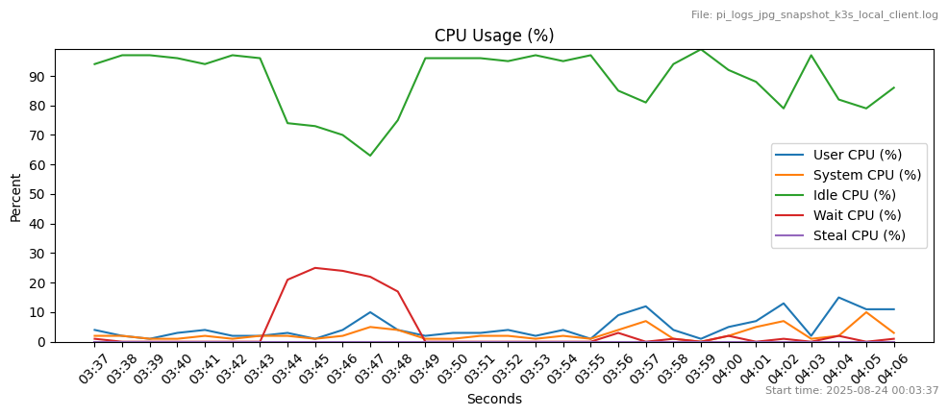

Although the system is mostly idle some spikes of about 20% usage are visible. Some waiting processes also appear during those spikes.

The first spike occurs during the fetch of the provider information from the customer test tool. The rest three depict the three snapshots that were taken. Usage increased close to 40% for the initial provider connection and at about 20% for the snapshots.

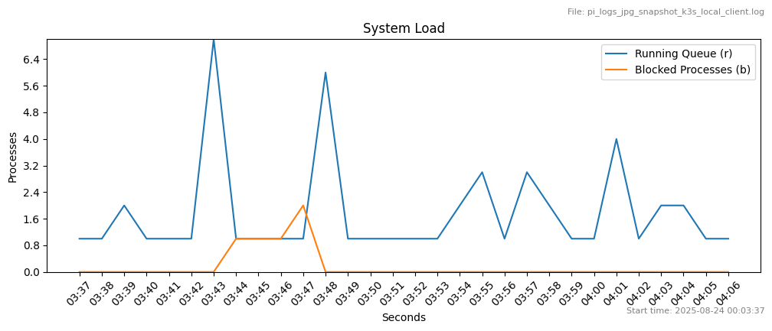

Memory

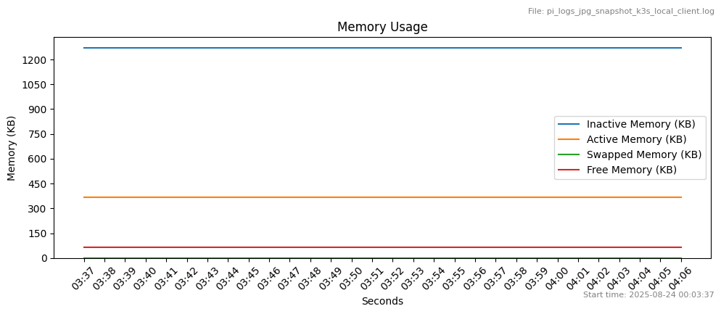

Free memory has dropped a lot. However there is still inactive memory (~1271 MB), while the active memory is stable (~368 MB). This means that the system probably increased cached files ending up in reduced free memory.

Disk

Here is a breakdown for disk metrics based on disk swap and disk io.

Swap

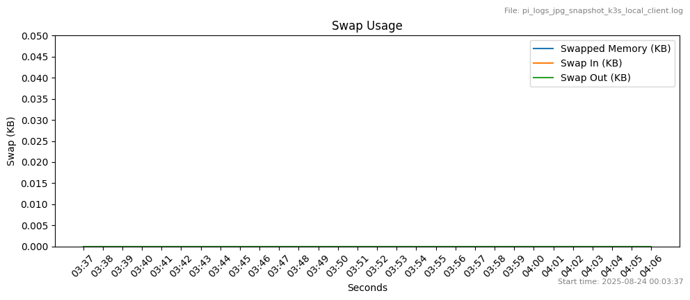

IO

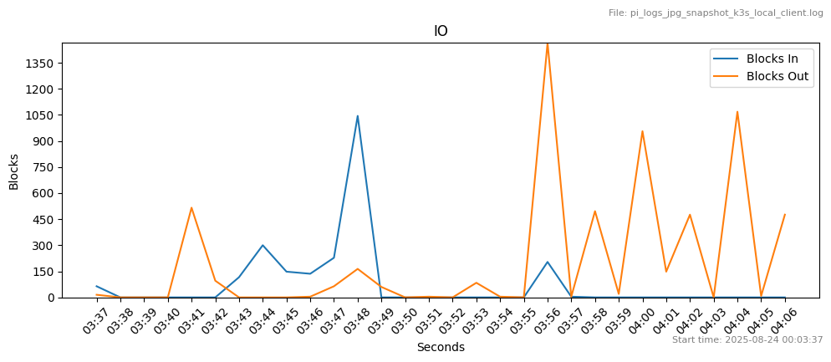

Disk utilization looks healthy. Still no swap, but an increase in input (~200b) and output (~200b) can be observed.

#### Scenario: Run with containers only supervisor

In this scenario we wanted to benchmark the Raspberry Pi kith k3s running. We only run supervisor in order to isolate its contribution to the workload.

**Raw Metrics**

Here are the raw metrics that we took for this case:

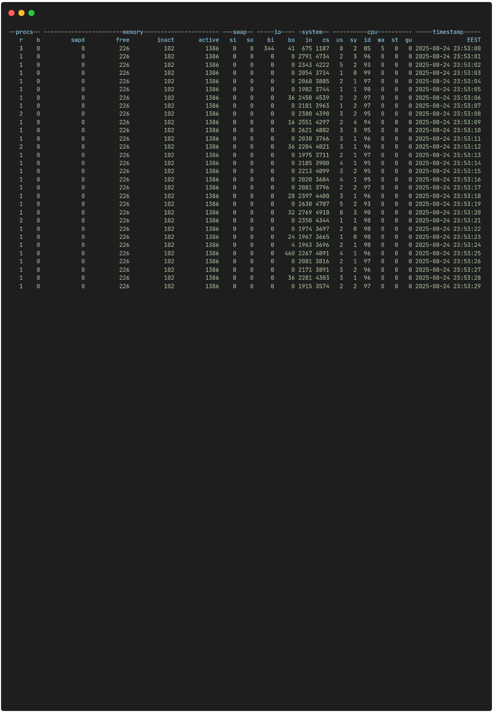

At the system level there is moderate context switching and interrupts since the system is lightly loaded.

CPU

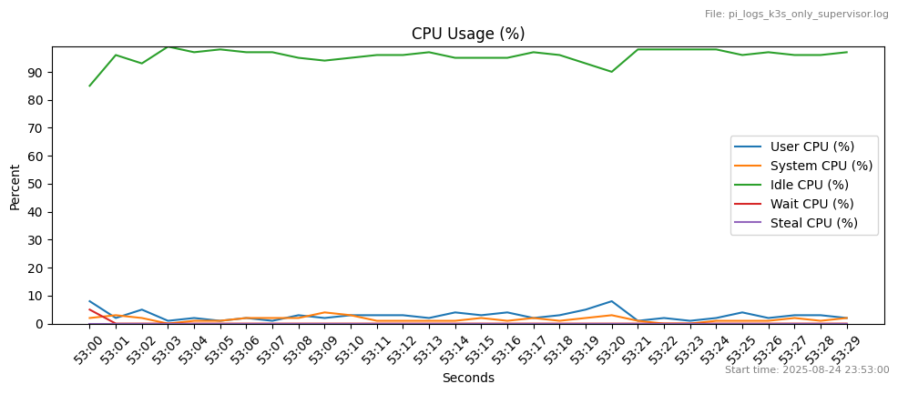

The system remains mostly idle. Small increases in usage, less than 10% occur occasionally.

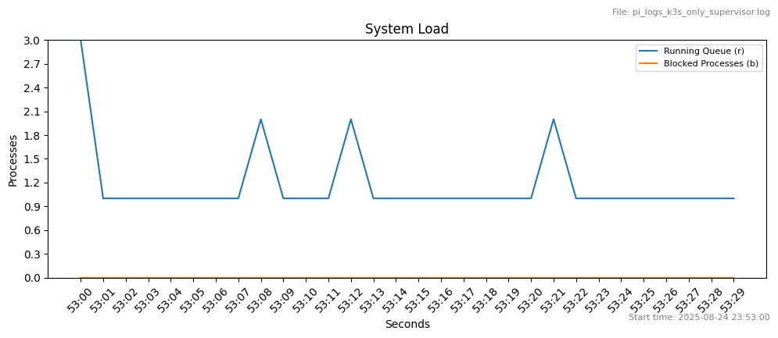

In this graph low usage is clearer with a very low system load, with a few running processes and no blocked one.

Memory

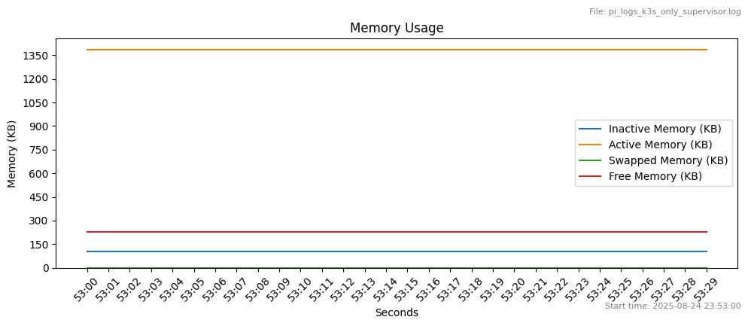

In this graph we can see free memory stable over 200MB.

Disk

Here is a breakdown for disk metrics based on disk swap and disk io.

Swap

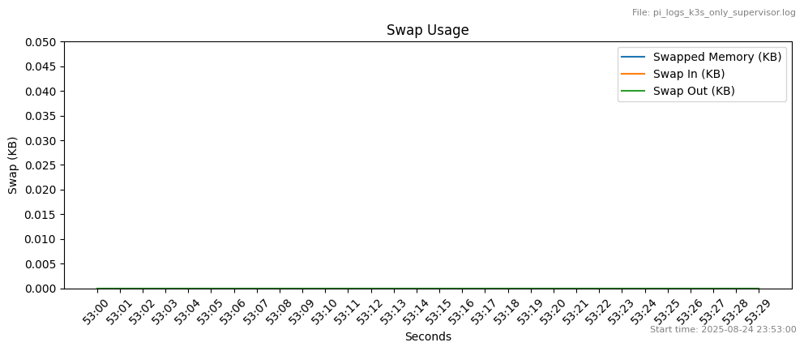

No swap is observed.

IO

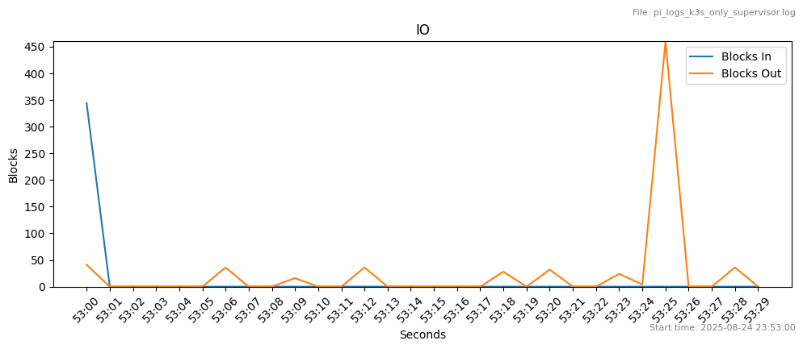

There is low block in and block out and occasionally some events take place.

#### Scenario: Run with containers only app (clock) without supervisor

In this scenario we wanted to benchmark the Raspberry Pi with k3s running. We run an NMF app and make calls to it. However, this app does not require the supervisor to run so in this case we tried to emphasize the impact of the supervisor to the resource utilization.

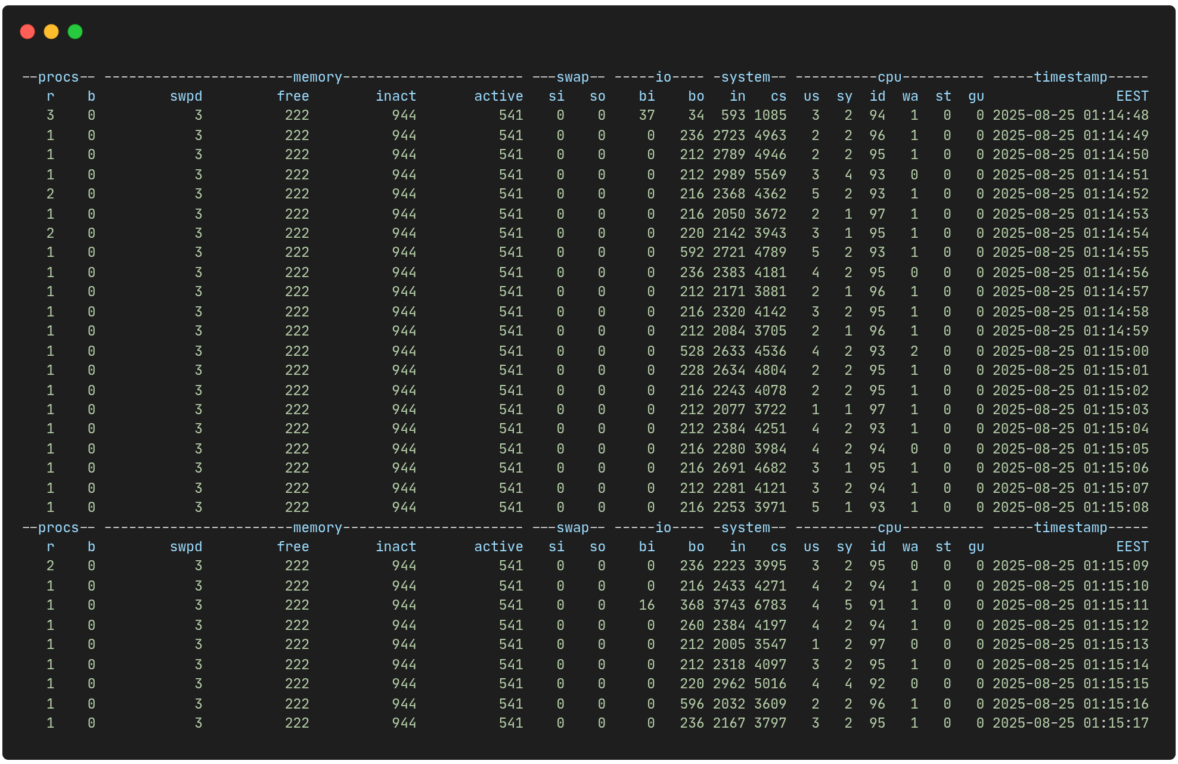

CPU

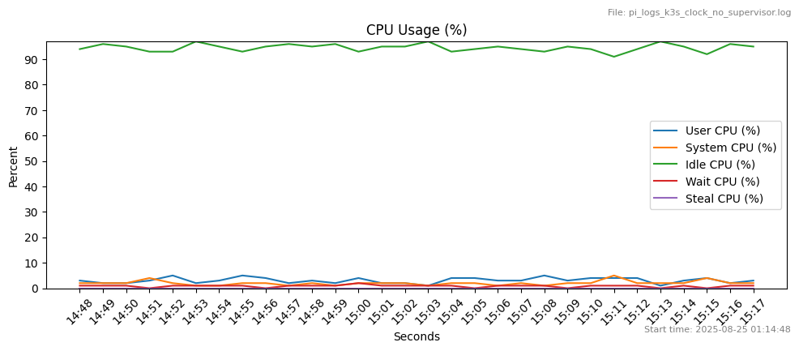

The idle cpu is over 90% all the time. There is some usage on the user and the system level. There are no blocked processes.

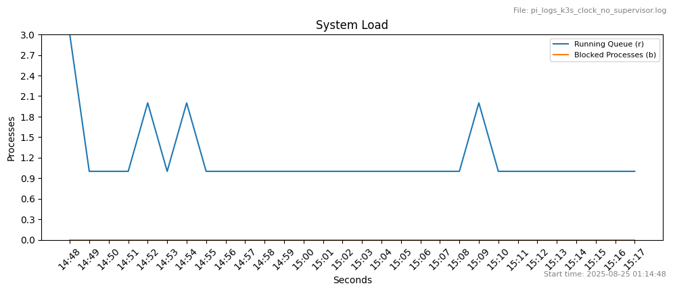

Memory

Free memory is over 200MB while there is active memory ~500MB and the inactive memory is more than 900MB.

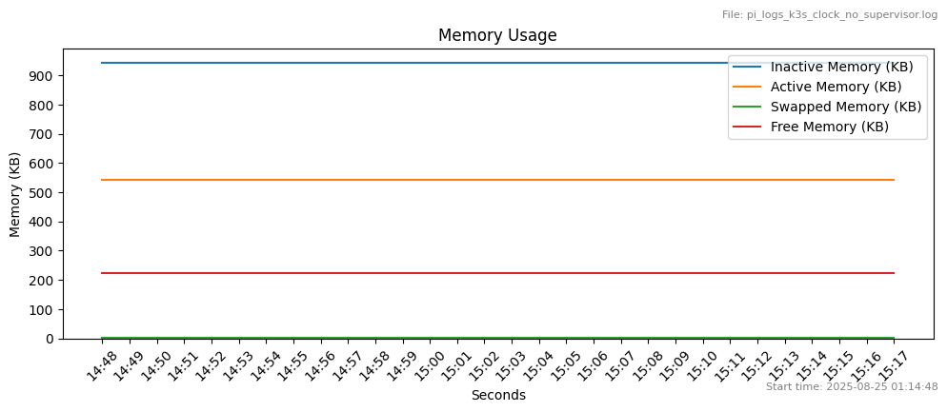

Disk

Here is a breakdown for disk metrics based on disk swap and disk io.

Swap

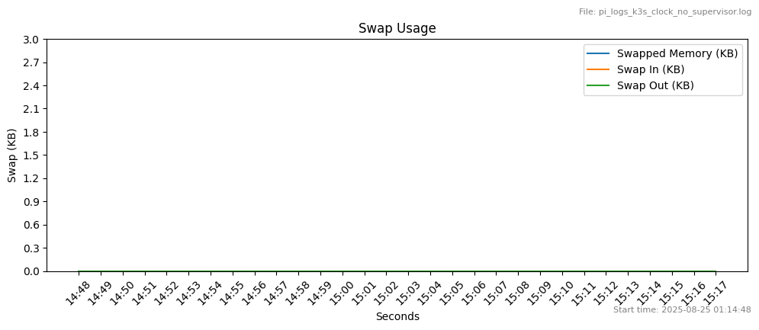

No disk swapping is observed.

IO

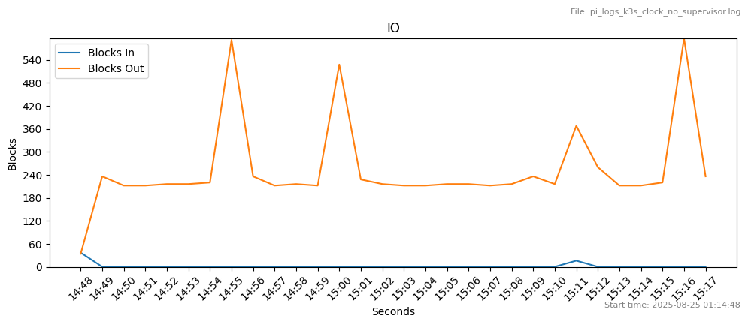

From time to time there is some moderate block output, with minimal block input events.

### Conventional NMF payload on JVM

We created another set of performance tests with the NMF installation running in the conventional way with JVM.

#### Scenario: Only Supervisor Running

This scenario has the supervisor running on its own in JVM using the conventional NMF setup

No other NMF app is running.

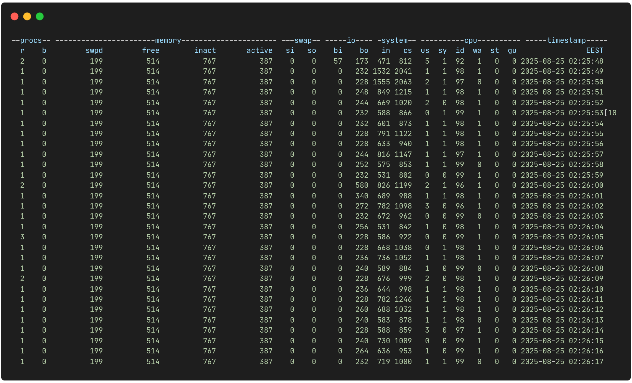

CPU

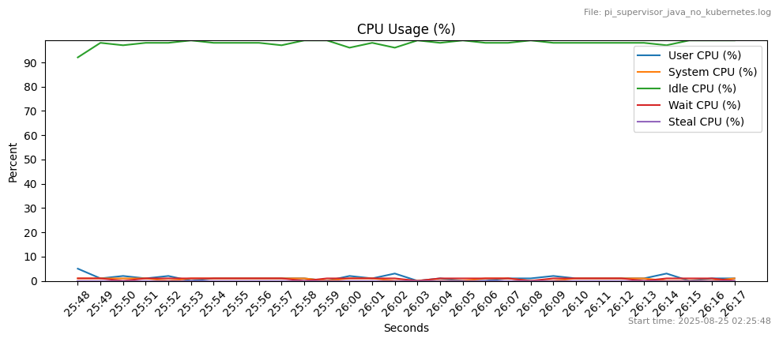

The cpu is idle more than 96% of the time. Rare CPU wait occurs (<1%). System usage is really low.

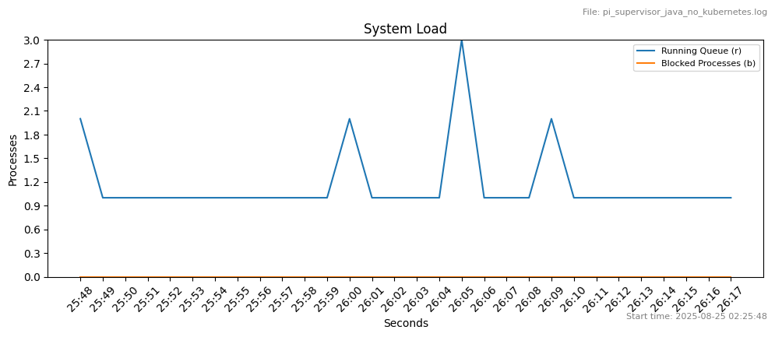

Memory

Some memory swapping (compression) is used. Free memory is above 500MB. While the inactive memory is ~700MB and the active is low ~300MB.

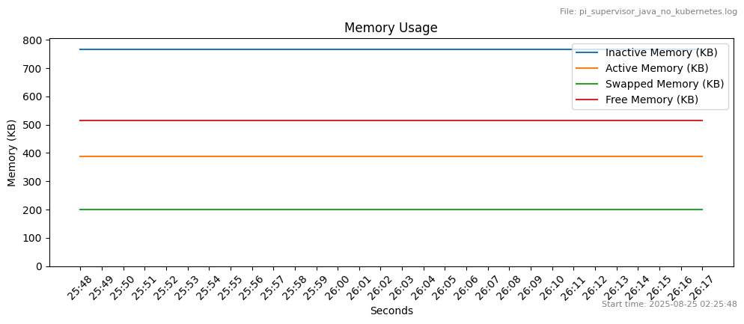

Disk

Here is a breakdown for disk metrics based on disk swap and disk io.

Swap

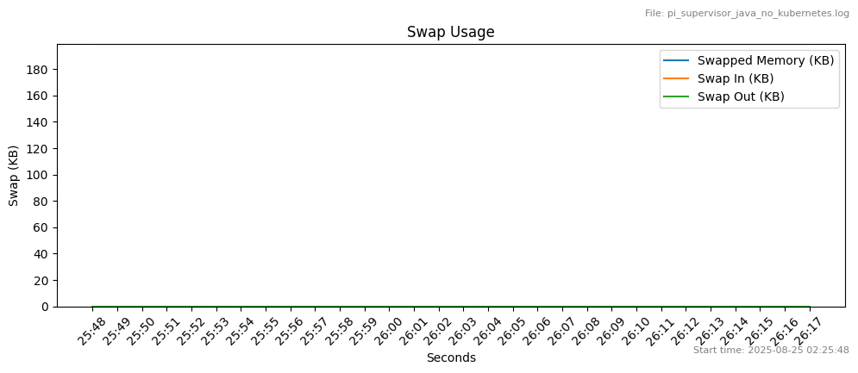

No swap activity (although some swap is in use).

IO

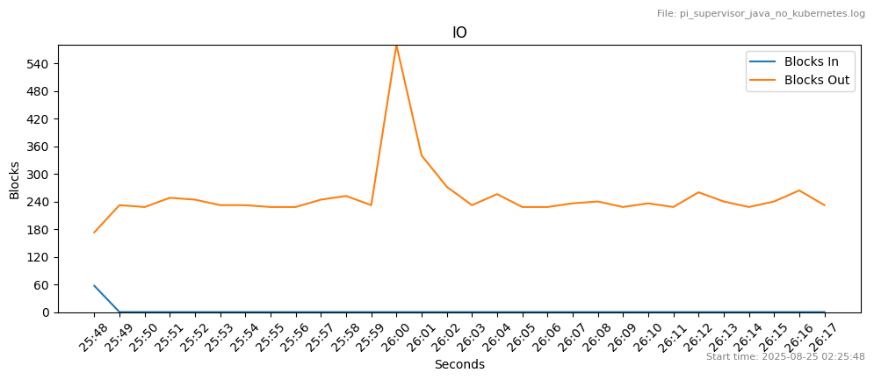

Occasional block output and almost no block input.

#### Scenario: Connect to camera provider and take snaps in jpg

This scenario is the main scenario across system designs. In this scenario the camera app is running via the NMF Supervisor.

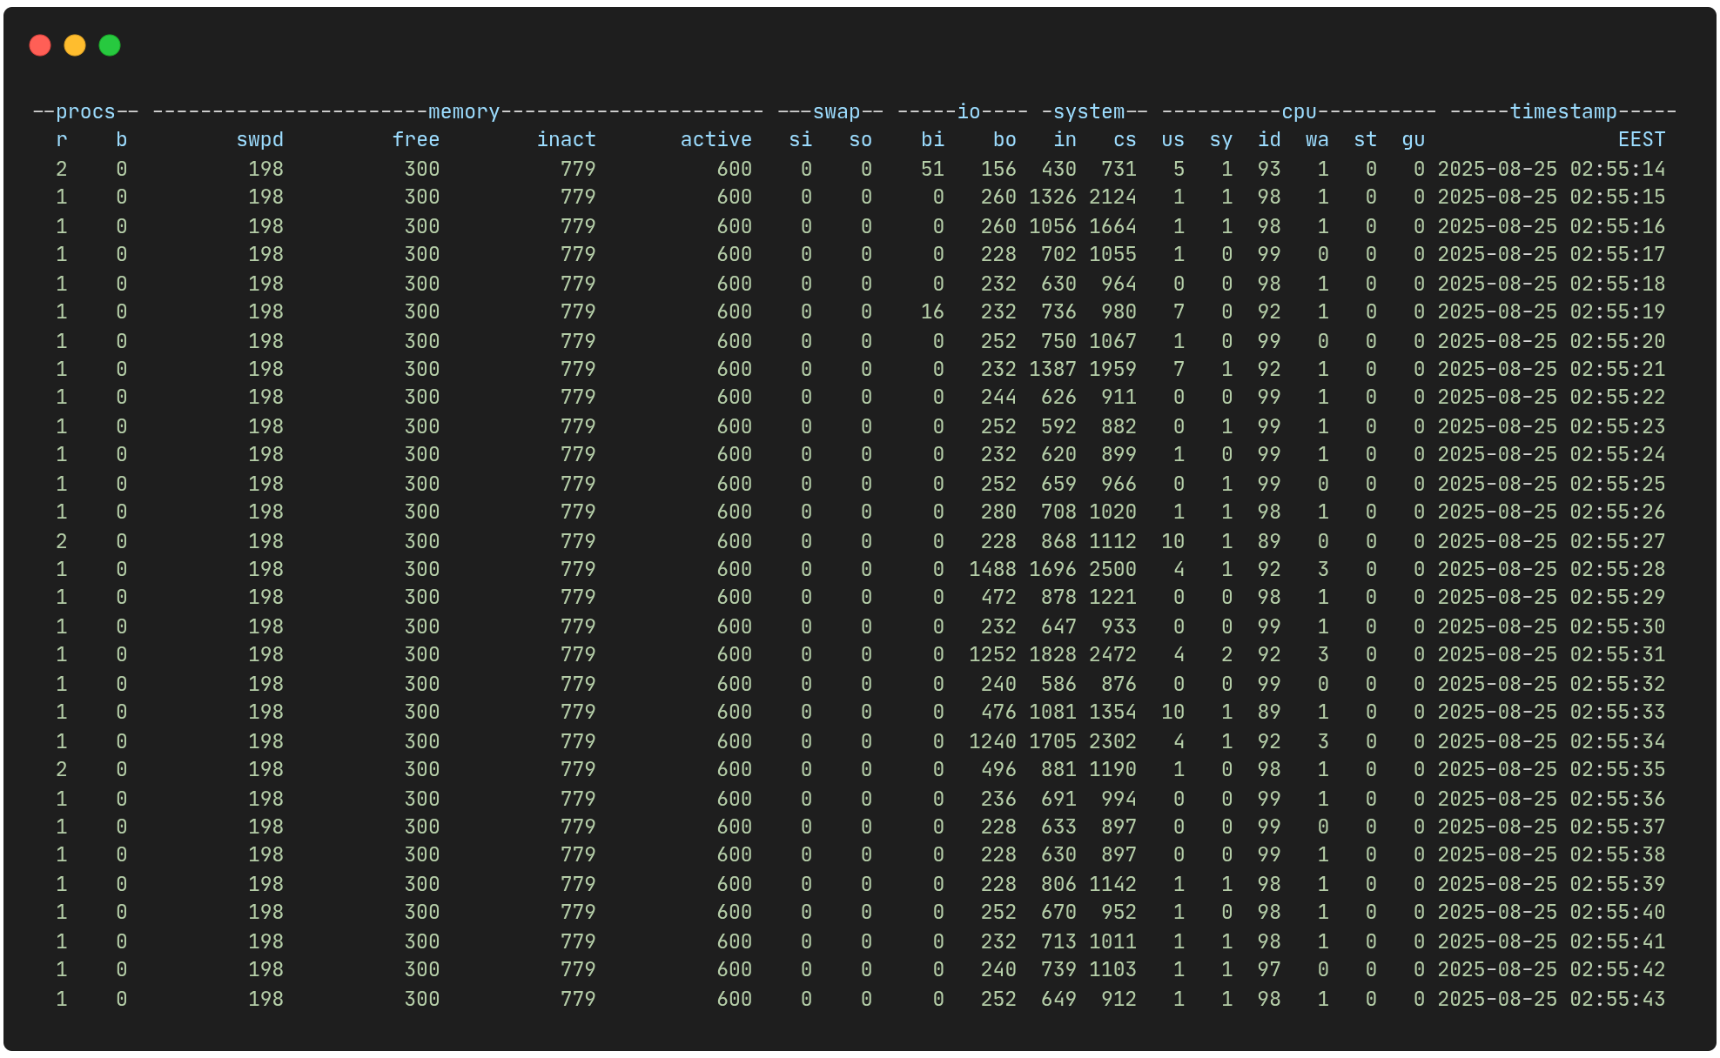

CPU

The user CPU usage occasionally reaches 10%. CPU is mostly (>89%) idle. There is some occasional wait.

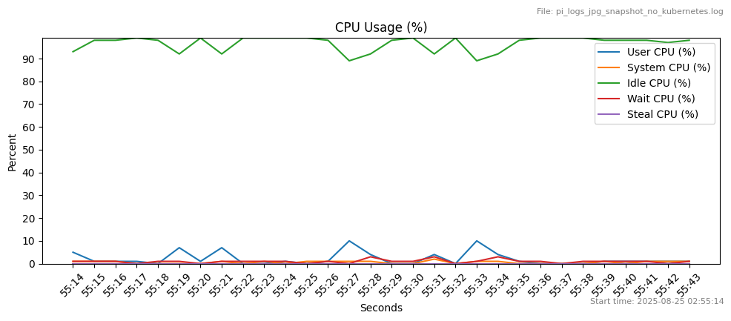

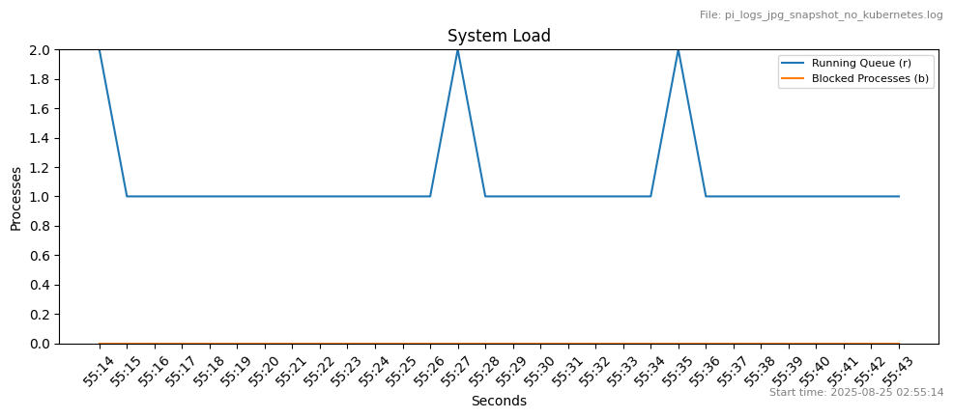

Memory

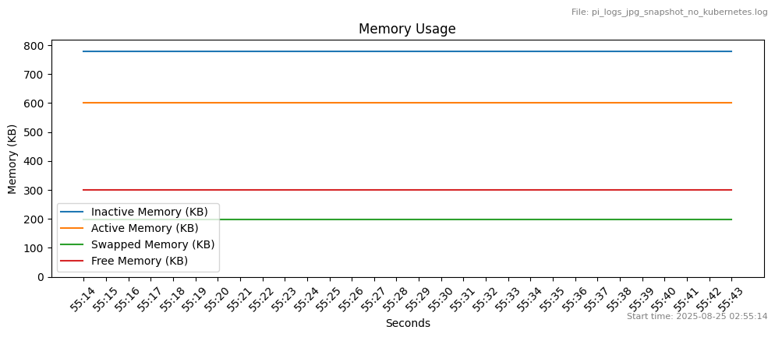

Free memory is stable ~500MB, while the actively used memory is ~400MB and inactive memory is ~700MB. Swap memory compression is close to 200MB.

Disk

Here is a breakdown for disk metrics based on disk swap and disk io.

Swap

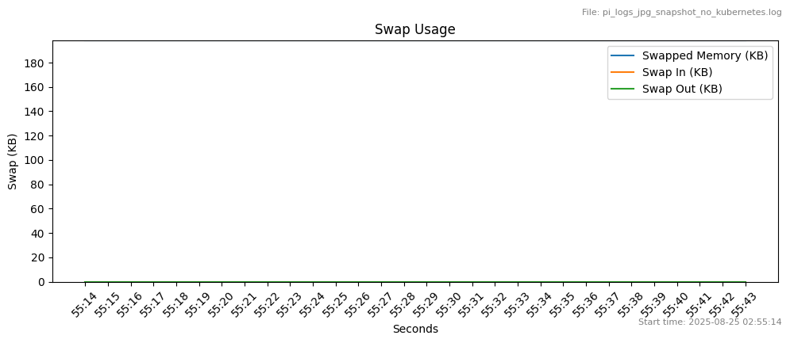

No swap in or swap out is observed.

IO

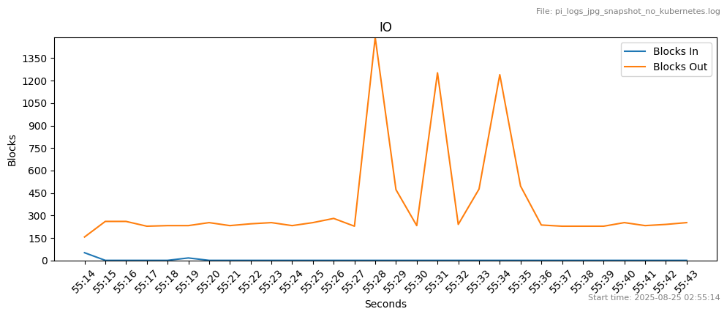

Block output is occasionally high, with momentary spikes up to 1488, while the rest of the time it is moderate above 200.

## Summary

### Comparisons

* CPU k3s only vs only pi

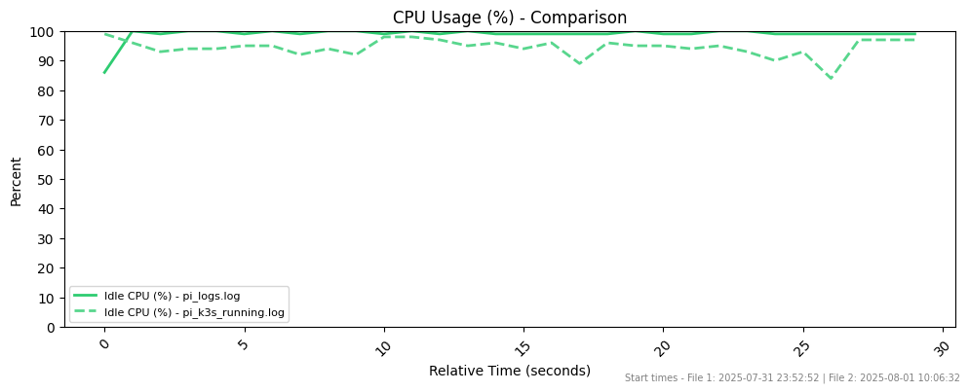

* Free Memory k3s vs only pi

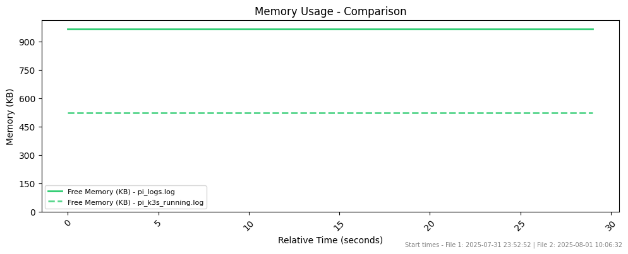

* CPU supervisor on k3s vs nmf conventional supervisor

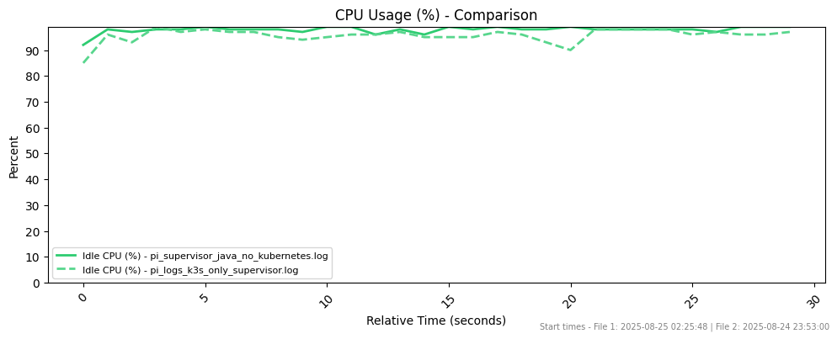

* Mem supervisor on k3s vs nmf convenrional supervisor

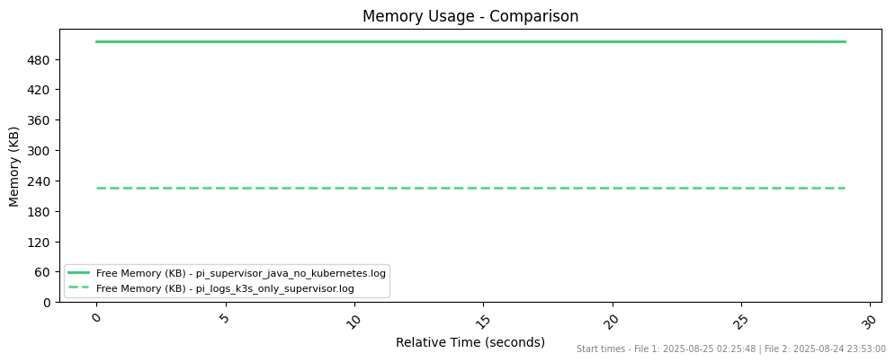

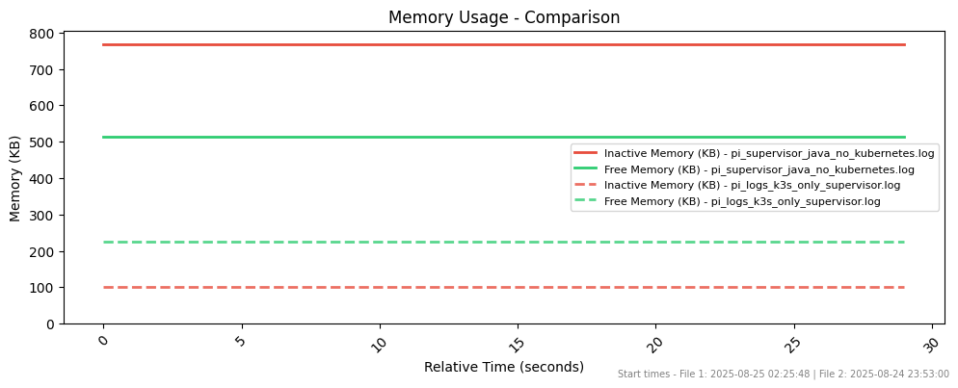

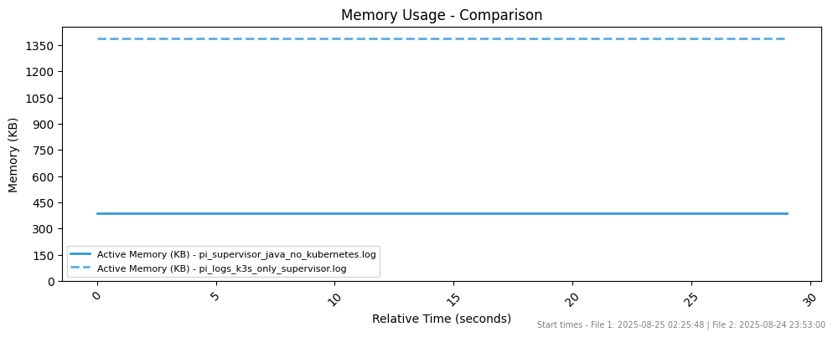

* CPU + Memory k3s only vs clock on k3s

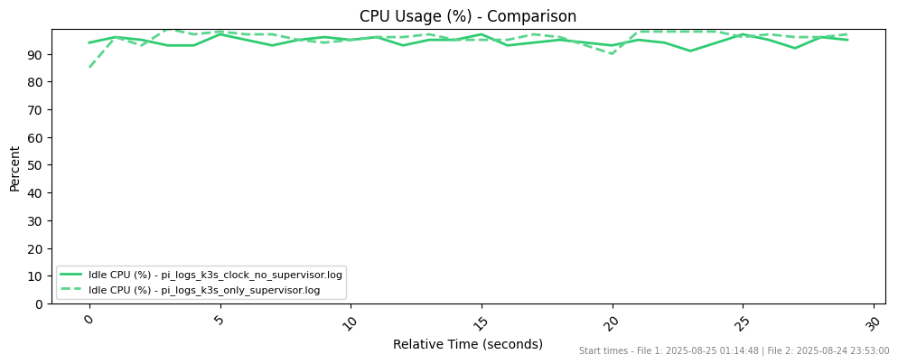

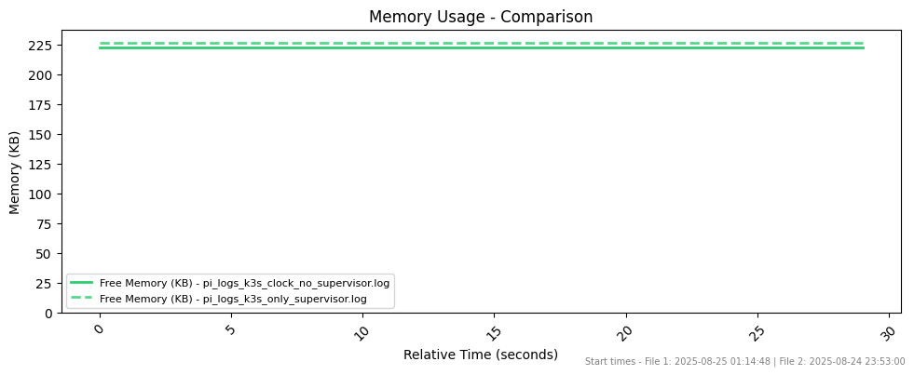

* Snapshot vs Snapshot

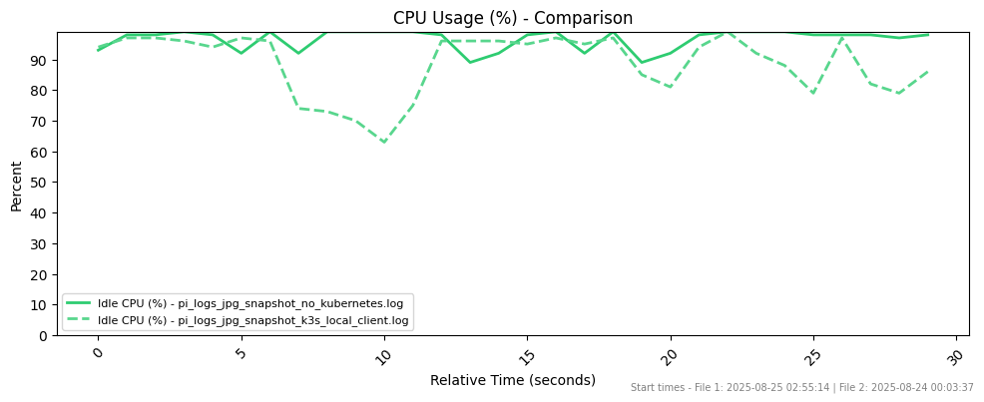

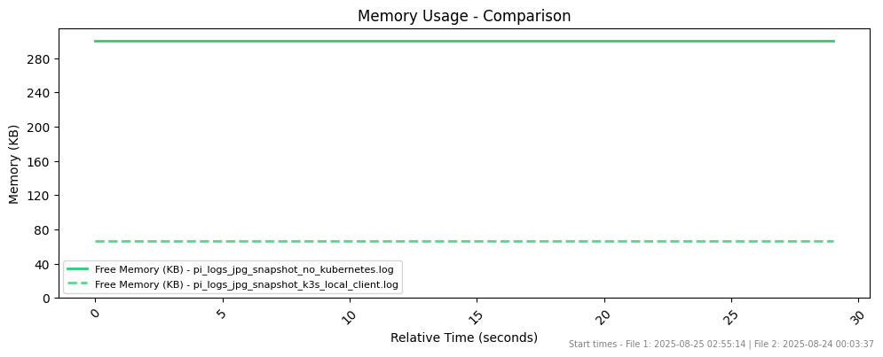

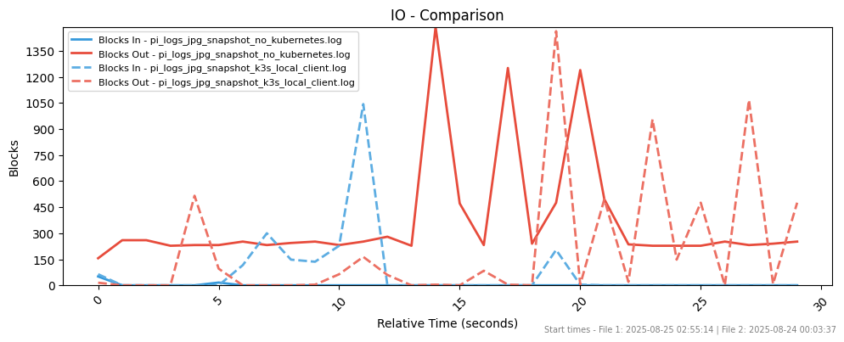

Overhead of Kubernetes becomes much negligible as the number of services grows

Compare Release & Deployment Flows

Original Flow:  
1) To ship an artifact it would have to:

1. compile the jar locally
2. send it to an artifactory registry
3. download the artifact when it is time for deployment
4. connect to supervisor using MalTcp
5. install the new jar running on supervisor
6. start the new app using supervisor
7. monitor the health of the new app and make sure it is up and running
8. In case of rollback the process needs to be rerun with the old version

2) In the new proposed way using DevOps and CI/CD:

1. new tag triggers creation of container (and deployment in continuous deployment)
2. (In continuous delivery) trigger a deployment, deployment is monitored by kubernetes healthchecks and automated rollbacks will take place if it fails

It is clear that in the “happy path” when everything runs smoothly, the operational effort is reduced by more than 75%. The value of CI/CD with Kubernetes skyrockets in case of a failure, where the whole process would have to be re-run from scratch to deploy the old artifact, doubling up the amount of work and attention.

Also in case of failure, if Kubernetes healthchecks could not check out, the downtime would be 0 seconds, whereas the downtime by shipping a faulty version in the old flow would be at least at the scale of minutes (~10) minutes even with the most lightweight jar.

Evaluation of the deployed services with Kubernetes

Comparison of DevOps-enabled space missions with traditional methods, emphasizing the benefits of Kubernetes

* Framework agnostic
* Abstraction
* Scalability
* Admin experience

# VII. Conclusion & Future Work

This thesis addresses the growing disparity between rapid advancements in hardware on board contemporary "New Space" missions and the comparatively stagnant software operations methodologies and technology adoption. Traditional approaches, while functional, lack the agility, automation, and scalability that are standard in modern terrestrial software development. To bridge this gap, this thesis integrates ESA's NMF with the Kubernetes container orchestration platform, effectively introducing the "Space-Age DevOps" paradigm.

Summary of key findings, including contributions to NanoSat MO Framework

Contributions to the field

We consider our primary contribution to be a novel architectural blueprint that refactors NMF from its traditional (but flight-validated) Service-Oriented Architecture into a fully containerized, microservices-based model.

This was achieved through several key steps. NMF services were containerized including necessary network configurations, and provided the first PoC of this framework operating on Kubernetes, using all appropriate DevOps technologies (e.g., Helm, Compose, etc).

A PoC, running on resource-constrained hardware similar to the realistic setting was developed for the validation of the entire workflow, from onboard image capture and edge processing to ground storage, demonstrating a complete end-to-end solution. By facilitating this fusion of space-specific frameworks with mainstream DevOps tools, this thesis enhances mission flexibility, reliability and portability but also enables advanced edge computing capabilities, with a view towards more autonomous, resilient, and powerful satellite operations in the New Space era.

### Future Work

1. Lightweight Supervisor: Supervisor could be stripped of redundant functionalities and act only as Platform Service for accessing hardware
2. PoC with Apps from Different Languages and Frameworks (F’, Python etc)
3. Run on actual OpsSat chipset
4. Kubernetes Operator for managing deployment complexity in an optimized way (start and stop unused services based on schedule, orbit etc and service relations)
5. Run in cluster / satellite constellation (to be handled in the second thesis)
6. ESA needs better documentation and better community work
7. Supervisor could be stripped of redundant functionalities and act only as Platform Service for accessing hardware
8. CFDP as file transfer protocol

### Expected Added Value of the Study

The anticipated contributions and gains resulting from this study are twofold, both within the realm of space exploration and for the broader field of DevOps methodologies.

**1. Advancing Space Exploration with DevOps Principles:**

The incorporation of DevOps principles into the domain of space exploration promises substantial benefits. Traditionally, space missions have adhered to stringent schedules, often characterized by extended development cycles and complex mission operations. The infusion of DevOps practices injects a new level of agility, efficiency, and adaptability into these missions. By embracing automation, continuous integration, and rapid deployment, space missions can respond more dynamically to evolving mission requirements and unforeseen challenges.

Furthermore, the robust monitoring and error-handling capabilities inherent to DevOps practices enhance the reliability and resilience of space systems. In a domain where mission success is paramount, these gains are of immeasurable value. The introduction of DevOps methodologies to space missions fundamentally changes the landscape by enabling space agencies and organizations to iterate, adapt, and innovate more swiftly.

Some of the key advancements provided are:

* Application self healing
* Better compute resource management
* More flexible and resilient infrastructure on board that can support more complex software architectures
* New version deployment for satellite software apps becomes a trivial task.
* Satellite services can be scaled up or down, reducing operation costs (like energy consumption), manually when needed or automatically based on a rule set.
* Better software administration, with integrated monitoring functionalities, easily parameterized and configurable applications.
* Elaborate network and security rules setup.
* Out of the box job scheduling which can be really helpful in correlation with satellite’s orbital characteristics
* Add a technology/language agnostic layer of abstraction, enabling the usage of diverse frameworks for the same satellite.
* Adhering with the industry standards for software development

**2. Extending NanoSat MO Framework to Kubernetes Deployment:**

The extension of the NanoSat MO Framework to a Kubernetes deployment environment marks a transformative step in the transition from Service Oriented Architecture (SOA) to microservices. Kubernetes, renowned for its orchestration and containerization capabilities, provides a versatile platform for the efficient management of satellite microservices.

This integration enables the development and deployment of services with flexibility, facilitating the implementation of mission-critical functions while maintaining compliance with CCSDS standards.

**3. Unlocking New Frontiers in Space:**

The study's contributions extend beyond immediate technological advancements. By merging DevOps methodologies, NanoSat MO Framework, and Kubernetes, it introduces a new paradigm in space exploration. This paradigm shift allows space agencies, research institutions, and commercial entities to explore a broader spectrum of mission possibilities. It encourages the development of more responsive, adaptable, and cost-effective space missions, driving innovation in Earth observation, scientific research, telecommunications, and beyond.

**4. Benefits for DevOps Itself:**

The interaction between DevOps principles and the unique needs of the space domain offers reciprocal benefits. DevOps practices, honed in the fast-paced world of software development, face new challenges in space, where resource consumption, reliability, fault tolerance, and mission-critical operations are paramount. The adaptation of DevOps to space missions fosters the refinement of DevOps methodologies, encouraging the creation of specialized practices that cater to the distinct demands of space.

This collaboration between DevOps and space exploration enhances the versatility of DevOps methodologies, rendering them adaptable to a broader range of industries and applications. **It elevates DevOps from a software-centric practice to a cross-disciplinary approach**, promoting its relevance in fields characterized by diverse requirements and stringent constraints.

Concluding remarks

# IX. References

1. Coelho, Cesar Bichinho Whittle, et al. "NanoSat MO Framework: Drill down your nanosatellite's platform using CCSDS Mission Operations services." Proc. International Astronautical Congress. 2017. <https://www.researchgate.net/publication/320267505_NanoSat_MO_Framework_Drill_down_your_nanosatellite's_platform_using_CCSDS_Mission_Operations_services>

1. <https://www.designgurus.io/blog/monolithic-service-oriented-microservice-architecture>

1. <https://learn.microsoft.com/en-us/azure/developer/java/containers/overview>

1. <https://www.datadoghq.com/blog/java-on-containers/>

1. <https://softwaremill.com/jvm-and-kubernetes-walk-into-a-bar/>

1. <https://github.com/kosmoedge/kosmoedge-docs/blob/main/docs/nmf-network-howto-k8s.md>

1. <https://www.rancher.com/assets/pdf/government/SUSE_RGS_and_Booz_Allen_FINAL_RGS_Version.pdf>

1. <https://sanjimoh.medium.com/putting-kubernetes-in-space-e0918a3dce26>

1. <https://kubeedge.io/case-studies/satellite>

1. <https://kccnceu2022.sched.com/event/yuEH/keynote-incremental-deep-learning-for-satellite-with-kubeedge-and-mindspore-xiaoman-hu-community-operation-director-zhipeng-huang-director-of-ai-open-source-yue-bao-software-engineer-huawei>

1. <https://tfir.io/ibm-open-sources-space-situational-awareness-kubesat-projects/>

1. <https://github.com/IBM/spacetech-kubesat>

1. <https://github.com/project-akri/akri>

1. <https://www.youtube.com/watch?v=mcKNistZkrY>

1. <https://nasa.github.io/fprime/>

1. <http://unikernel.org/>

1. <https://github.com/cetic/unikernels>

1. <https://parsimoni.co/>

1. [http://electronicspecifier.com/industries/security/industry-s-first-commercial-unikernel-with-posix-compatibility](http://electronicspecifier.com/industries/security/industry-s-first-commercial-unikernel-with-posix-compatibility?utm_source=chatgpt.com)

1. <https://moewex.github.io/academic/publication/2021-leo/2021-leo.pdf>

1. <https://reliasoftware.com/blog/what-is-devops>

1. <https://www.geeksforgeeks.org/devops-lifecycle/>

1. <https://kubernetes.io/docs/concepts/overview/>

1. <https://www.mirantis.com/cloud-native-concepts/getting-started-with-kubernetes/what-is-kubernetes/>

1. <https://faun.pub/why-you-should-use-kubernetes-bf395bef52de>

1. <https://medium.com/@himanshusangshetty/kubernetes-architecture-and-components-explained-e489e98db15d>

1. <https://spacelift.io/blog/kubernetes-control-plane>

1. <https://jvns.ca/blog/2017/06/04/learning-about-kubernetes/>

1. <https://medium.com/devops-mojo/kubernetes-architecture-overview-introduction-to-k8s-architecture-and-understanding-k8s-cluster-components-90e11eb34ccd>

1. <https://www.ijirmps.org/papers/2021/6/232138.pdf>

1. <https://ieeexplore.ieee.org/document/9776450>

1. <https://docs.docker.com/compose/>

1. <https://builder.aws.com/content/2qi9qQstGnCWguDzgLg1NgP8lBF/file-structure-of-docker-composeyml-file>

1. [researchgate.net/figure/Classification-of-small-satellites-The-nanosatellite-example-shows-a-3U-CubeSat_fig2_343821902](http://researchgate.net/figure/Classification-of-small-satellites-The-nanosatellite-example-shows-a-3U-CubeSat_fig2_343821902)

1. <https://eos.com/blog/small-satellites>

1. <https://www.nasa.gov/what-are-smallsats-and-cubesats/>

1. <https://www.researchgate.net/publication/359254168_E-design_and_manufacturing_approach_for_Cubesat_solar_panel_deployment_mechanism>

1. <https://brycetech.com/reports/report-documents/smallsats-2025/>

1. <https://www.nanosats.eu/sat/ops-sat>

1. <https://www.nanosats.eu/sat/phi-sat-2>

1. <https://ccsds.org/>

1. <https://www.researchgate.net/publication/303098729_Retire_Legacy_Technology_with_the_CCSDS_MO_Services>

1. <https://arc.aiaa.org/doi/10.2514/6.2009-6718>

1. <https://github.com/esa/nanosat-mo-framework/blob/ops-sat/sdk/sdk-package/src/main/resources/docs/Dissertation__Cesar_Coelho.pdf>

1. Coelho, César, Otto Koudelka, and Mario Merri. "NanoSat MO framework: When OBSW turns into apps." 2017 IEEE Aerospace Conference. IEEE, 2017 <https://www.researchgate.net/publication/316588347_NanoSat_MO_framework_When_OBSW_turns_into_apps>

1. NanoSat MO Framework: Achieving On-board Software Portability

1. Coelho, César, et al. "OPS-SAT Experiments’ Software Management with the NanoSat MO Framework." AIAA SPACE 2016. 2016. 5301 <https://arc.aiaa.org/doi/abs/10.2514/6.2016-5301>

1. OPS-SAT: Operational Concept for ESA’S First Mission Dedicated to Operational Technology <https://www.researchgate.net/publication/303098634_OPS-SAT_Operational_Concept_for_ESA'S_First_Mission_Dedicated_to_Operational_Technology>

1. OPS-SAT Software Simulator <https://github.com/esa/nanosat-mo-framework/blob/ops-sat/sdk/sdk-package/src/main/resources/docs/Software_Simulator_Master_Thesis.pdf>

1. <https://medium.com/@the_daft_introvert/inter-process-communication-in-operating-systems-a-comprehensive-guide-with-real-life-examples-and-c508cf3bfb1a>

1. <https://en.wikipedia.org/wiki/Edge_computing>

1. <https://www.kratosdefense.com/constellations/articles/how-edge-computing-is-changing-space-from-terminal-to-satellite>

1. <https://k3s.io/>

1. What Is Jenkins and How Does it Work? Intro and Tutorial <https://codefresh.io/learn/jenkins/>

1. Microk8s: The effortless Kubernetes Zero-ops, pure-upstream, HA Kubernetes, from developer workstations to production <https://microk8s.io/>

1. Setting up Jenkins on MicroK8s <https://dev.to/psfeng/setting-up-jenkins-on-microk8s-4b8a>

1. How Ansible works <https://www.redhat.com/en/ansible-collaborative/how-ansible-works>

1. ESA’s NanoSat MO Framework Github repository <https://github.com/esa/nanosat-mo-framework>

1. CCSDS MO services - ESA's Java implementation Github repository <https://github.com/esa/mo-services-java>

1. NanoSat MO Framework - mission tailoring for OPS-SAT Github repository <https://github.com/esa/nmf-mission-ops-sat>

1. CCSDS MO documentation, examples, tutorials in ESA’s Github repository <https://github.com/esa/CCSDS_MO>

1. [Minikube docs](https://minikube.sigs.k8s.io/docs/)

1. Overview of the TCP/IP Networking Model <https://info-savvy.com/overview-of-the-tcp-ip-networking-model/>

1. NodePort in Kuberenetes <https://zesty.co/finops-glossary/nodeport-in-kubernetes-a-glossary-overview/>

1. Kubernetes Pod Security Standards <https://kubernetes.io/docs/concepts/security/pod-security-standards/>

1. NVIDIA device plugin for Kubernetes Github repo <https://github.com/NVIDIA/k8s-device-plugin>

1. <https://kubernetes.io/docs/concepts/extend-kubernetes/compute-storage-net/device-plugins/>

1. Kubernetes 1.26: Device Manager graduates to GA <https://kubernetes.io/blog/2022/12/19/devicemanager-ga/>

1. <https://kubernetes.web.cern.ch/blog/2023/03/17/efficient-access-to-shared-gpu-resources-part-2/>

1. [Kubernetes Everywhere Enables Simplified Heterogeneous Deployment: Edge, Prem, Cloud, September 24, 2021, Mikhail Kozorovitskiy](https://www.suse.com/c/rancher_blog/kubernetes-everywhere-enables-simplified-heterogeneous-deployment-edge-prem-cloud/) [suse.com](http://suse.com)

1. [Kubernetes for IoT: Bringing the Best of Edge and Cloud Computing, Piyush Agrawal 2024](https://www.i2k2.com/blog/kubernetes-for-iot-bringing-the-best-of-edge-and-cloud-computing/)

1. <https://en.wikipedia.org/wiki/OPS-SAT>

1. <https://programming-group.com/assets/pdf/papers/2023_Lightweight-Kubernetes-Distributions.pdf>

1. Containerd vs. Docker: Container Runtimes Comparison <https://spacelift.io/blog/containerd-vs-docker>

1. Efficient Container Deployment in Edge Computing Platforms <https://www.researchgate.net/publication/335471071_Efficient_Container_Deployment_in_Edge_Computing_Platforms>

1. balenaCloud: code deployment to devices grouped in a fleet <https://docs.balena.io/learn/deploy/deployment/>

1. Bash scp Command - Secure Copy <https://www.w3schools.com/bash/bash_scp.php>

1. How To Use Rsync to Sync Local and Remote Directories <https://www.digitalocean.com/community/tutorials/how-to-use-rsync-to-sync-local-and-remote-directories>

1. CCSDS FILE DELIVERY PROTOCOL (CFDP) <https://ccsds.org/Pubs/727x0b5e1.pdf>

1. CCSDS BUNDLE PROTOCOL SPECIFICATION <https://ccsds.org/Pubs/734x2b1.pdf>

1. Cyclone® V FPGA and SoC FPGA <https://www.altera.com/products/fpga/cyclone/v>

1. OPS-SAT: Designing a Mission from the Ground Upwards <https://www.researchgate.net/publication/303098768_OPS-SAT_Designing_a_Mission_from_the_Ground_Upwards>

1. Near-Real-Time Fire Detection Leveraging Edge AI in Space: Transforming Thermal Earth Observation with NVIDIA <https://www.nvidia.com/en-us/on-demand/session/gtc25-s72067/>

1. Understanding the difference between JDK, JRE, and JVM

<https://www.boardinfinity.com/blog/understanding-the-difference-between-jdk-jre-and-jvm/>

1. Best Practices to Build a Java Container with Docker <https://www.dsinnovators.com/blogs/java-container-with-docker>

1. Astro Pi: a Raspberry Pi used on the ISS for student-led science and coding experiments <https://astro-pi.org/>

1. SpaceX to launch 1st space-hardened Nvidia AI GPU on upcoming rideshare mission <https://www.space.com/ai-nvidia-gpu-spacex-launch-transporter-11>

1. Webcam Capture Java library utilizing build-in or external webcam <https://github.com/sarxos/webcam-capture>

1. fswebcam - Small and simple webcam library for *nix <https://manpages.ubuntu.com/manpages/bionic/man1/fswebcam.1.html>

1. Release notes for k3s v1.32.X <https://docs.k3s.io/release-notes/v1.32.X>

1. generic-device-plugin Github Repository <https://github.com/squat/generic-device-plugin>

1. Generic device plugin DaemonSet basic manifest <https://raw.githubusercontent.com/squat/generic-device-plugin/main/manifests/generic-device-plugin.yaml>

1. Ansible role to install microk8s on ubuntu <https://github.com/istvano/ansible_role_microk8s>

1. NMF helm charts Github repository <https://github.com/kosmoedge/deployments/tree/main/helm-charts/src>

1. Edge Detection for Satellite Images without Deep Networks <https://arxiv.org/pdf/2105.12633>

1. Springboot Framework <https://spring.io/projects/spring-boot/>

1. Quarkus - Supersonic Subatomic Java <https://quarkus.io/>

1. A Java-Quarkus REST app taking snapshots from the available cameras and applying image processing <https://github.com/kosmoedge/camera-app-demo>

1. Edge Detection Using OpenCV <https://opencv.org/blog/edge-detection-using-opencv/>
2. A low complexity hardware architecture of K-means algorithm for real-time satellite image segmentation <https://researcher.manipal.edu/en/publications/a-low-complexity-hardware-architecture-of-k-means-algorithm-for-r/?utm_source=chatgpt.com>

1. Sobel vs. Canny Edge Detection Techniques: Step by Step Implementation <https://medium.com/@haidarlina4/sobel-vs-canny-edge-detection-techniques-step-by-step-implementation-11ae6103a56a>

1. Linux commands: exploring virtual memory with vmstat <https://www.redhat.com/en/blog/linux-commands-vmstat>

1. Vmstat Visualizer <https://github.com/kosmoedge/vmstat-visualizer>

1. <https://github.com/esa/nanosat-mo-framework/blob/dev/sdk/sdk-package/src/main/resources/docs/NMF_Design_Documents/NMF_SDD.pdf>